Windows Opensimulator Grid Server  
  
December 16, 2021



**Outworldz**

**Outworldz, LLC. ©AGPL 3.0**

Contents

Startup - Starting up the System the First Time 1

Setup Your Viewer: 3

Running the Grid manually 5

APACHE Webserver 6

Web Port 6

Enable Apache Web Server 6

Content ManageR 6

Apache & Search setup 7

Enable Search 8

Events 8

Search for Objects 8

Places search: 9

Land Sales: 9

Backup Settings 10

CheckBoxes 10

Backup Strategies 11

Region Level OAR 11

Grid level IAR 11

Grid level SQL 11

UUID: 11

Backup - Autobackup 12

Settings 12

Ban Lists 14

Getting Ban Data 14

Grid Ban 14

IP Ban 14

MAC Address Ban 15

Viewer Ban 15

Copybot Viewers 15

Bird Module 16

Global Settings 16

Console Commands 17

Security 19

Bird Prims 19

Network Traffic 19

Statistics 19

Running DreamGrid On A Server 20

Log Into Your Server 20

Firewall Rules 23

Sharing Files To And From Your Server 26

Backups: 28

Cache 28

Flotsam Cache Settings 30

Settings 30

Database Settings 31

Robust Database: 31

Local Region Database: 31

Running MySQL as a Service 32

MySQL Crashes: 33

My database still did not start! 33

Starting Over with a Blank Database 33

Diva Web Control Panel 35

Wifi Admin USER 36

User Levels 37

Confirmation Required to Log In: 37

SMTP Email 38

Theme 39

Viewer Splash Screen URL: 39

Greeting 39

Friendly Name 39

Default Avatars: 39

Customizing your theme 40

Changing the HTML 41

Hypergrid and Domain Name Setup 42

DNS name 42

Running on the LAN only 42

DynDNS Password 42

Enable Hypergrid 43

Enable My Suitcase 43

Next Name 43

Test DNS 43

Troubleshooting Network: 43

Easy Free Database 46

URL 46

Response 46

FIREWALL 47

Advanced settings screen: 48

Flotsam Cache Settings 54

Flotsam asset cache 54

General principles 54

FSAssets Settings 55

Migration 55

Grid Type 57

Grid Server with Robust 57

Region Server 58

OSGrid Server 59

Hypergrid.org Server 60

Metropolis Server 61

Shoutcast And Icecast Server 62

Troubleshooting: 62

How to Broadcast Music: 63

WINAMP 63

Shoutcast Control Panel 66

Setting up the in-world radio 67

MIXXX 69

Special instructions for MP3 files: 69

Running Mixxx 69

Mixx Setup 70

Troubleshooting: 71

Port Forwards: 71

JOOMLA/JOPENSIM UPDATE 73

How to Update: 73

Joomla and jOpensim 74

Restore data 78

Backups: 81

Update: 82

jOpensim Money 82

References: 83

Landscaping 84

Menu: 84

Terrain Section 85

Land Types 85

Load IAR 86

Links: 87

Load OAR 88

Options: 90

-merge 91

--displacement 91

--force-terrain 92

--force-parcels 92

--default-user "<first-name> <last-name>" 92

Links: 92

Logging 93

LSL Scripting 99

Maps 101

Manual regeneration 103

Migration From Dreamworld To Dreamgrid 104

Region Files 104

Modules 106

Moving a DreamGrid 108

Method 1 108

Method 2 108

Method 3 108

Running DreamGrid On A Server 109

Log Into Your Server 109

Firewall Rules 112

Sharing Files To And From Your Server 115

Plant Editor 117

Trees and Plants 117

Plant Editor 118

Port Settings and UPnP 119

Port Forwards: 119

Troubleshooting Ports 120

IceCast/Shoutcast Ports 121

Loopback: 121

Publicity 124

Region Panel 125

Region Basics 125

Options 126

Map Overrides 127

Physics Overrides 129

Script Overrides 130

Permission Overrides 131

Publicity Overrides 132

Modules 133

CPU 134

**“Real Time,” vs High, or using “low”** 134

Buttons 137

Refresh Button 137

Details Button 137

Icons Button 138

Avatars Button 138

Users Button 138

Add Button 138

Run All Button 138

Stop All Button 139

Restart Button 139

Import Button 139

File Folder Arrangement 139

Clicking a Region 139

View Console Button 140

Start Button 140

Restart Button 140

Stop Button 140

Teleport Button 140

Send Alert Message Button 140

Load Region OAR Button 140

Save Region OAR button 140

View Log Button 140

View Map Button 141

Edit Button 141

Region Stats 141

Regions 144

Restart and Startup Settings 145

Save IAR 147

Switches 148

**Examples** 148

Saving an entire user's inventory 148

Script Settings 149

Allow LSL to contact the server: 149

Robust and Server Type 150

Grid Server with Robust 150

Region Server 150

OsGrid Region Server 151

Hypergrid.org Region Server 151

Smart Start 152

Enable Smart Start 152

Choose a Parking Region 153

Region Setup 153

Automatic Fill 154

Streaming MP3 files in Opensim 155

Streaming MOVIE files in Opensim 157

Terrain 162

Menu: 162

Terrain Section 163

Land Types 163

Tides Module 164

Terms of Service 167

Troubleshooting 167

Try This First: 168

Try This Next 168

Password Reset 168

Troubleshooting the Network. 168

Step-By-Step 169

Flaky Teleports 171

The URL I use to Test port forwards: 171

Test Private Loopback: 172

Test Public Loopback 172

How to Get on The Hypergrid 172

UPnP Not Working? 172

Firewall 172

Updater: 173

Help with Opensim Crashes: 173

My database still did not start. 173

Starting Over with A Blank Database 173

Ports 174

Running Manually 174

Run as A Service 175

How to Compile DreamGrid 175

License Agreement: 184

Data Collection Policy **Error! Bookmark not defined.**

Publicity - **Error! Bookmark not defined.**

DNS - The DYN DNS system stores public IP addresses and your domain name as is necessary to run the DNS system. **Error! Bookmark not defined.**

# Startup - Starting up the System the First Time

You can install DreamGrid by saving ”DreamGridInstaller.exe” in an empty folder and running it.

Or you can install DreamGrid by unzipping the zip file into a new, blank folder.

Then click “Start.exe”. You may get a popup warning. All my binary code is digitally signed and is cryptographically verified to protect you and to assure you that the code you get is what is originally authored. It is virus-free and has no ads. It should say "Verified Publisher: Outworldz, LLC”.

Click [Start] in the top left of the menu:



This box will appear for you to claim ownership of the Grid.

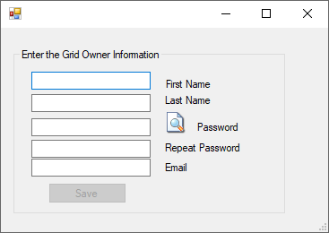  
  
Use a unique, new long password as this is the avatar that owns the grid.

Another DOS box will appear. This will be your first region. The region is named "Welcome".  You can change this name later. The system will ask you for an estate name.  You can just press enter to name it “My Estate”, or type in a new name.

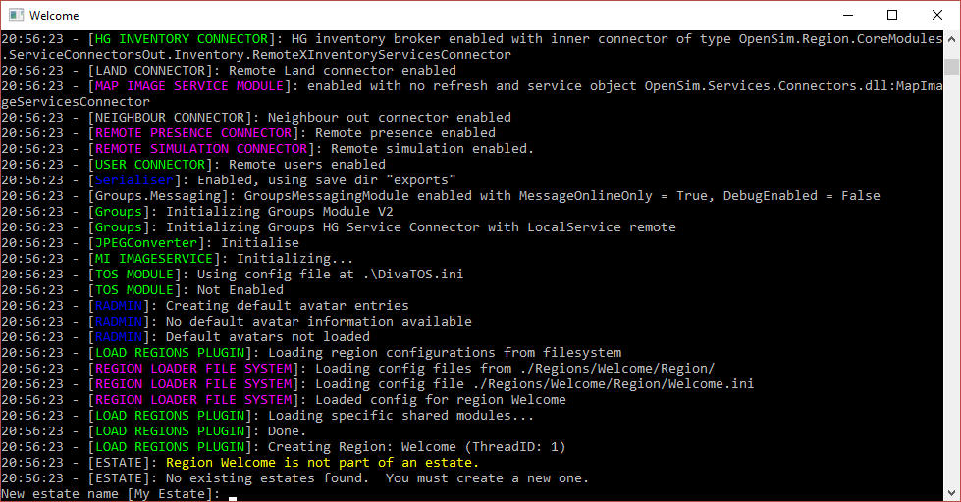

It will then ask you for the owner’s name of this region.   **Use the same name that you first entered.**

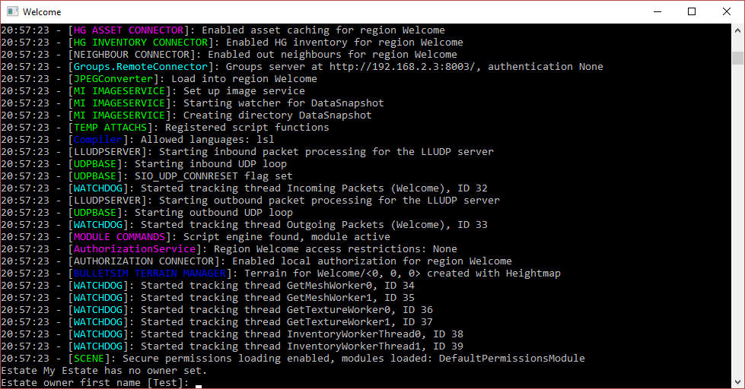

The system will eventually tell you "INITIALIZATION COMPLETE FOR Welcome - LOGINS ENABLED"/

## Setup Your Viewer:

Click the first item in the Help menu - Show Hypergrid address. It may print a name, or an IP address.

If it is an IP Address, your system will only run on your local area network at this time. The Hypergrid will not be available until you set up the router. See the help section at the bottom of this article on Ports and Loopback.



The system will print the address.

Download the Firestorm viewer for Opensim. You can get it from <https://www.firestormviewer.org/>

Launch the viewer and go to the Viewer Preferences menu (Ctrl-P).

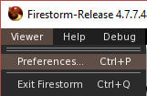

Go to the Opensim Grid manager screen:

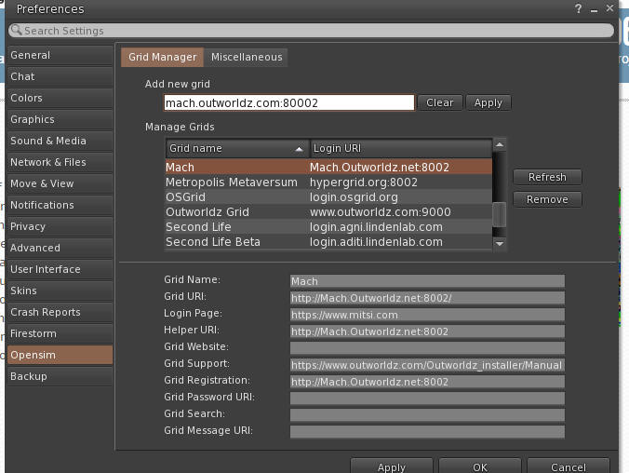

Add the http:// + IP address it showed in Blue, + :8002 to the Firestorm or other viewers "Add new Grid" field and click "Apply".

You should now be able to select your new DreamGrid in the Viewers pulldown for grid login and log in with the same First and Last Name and password you originally entered. You should then appear in an empty sim on a small 1X1 flat island named Welcome.

If this does not work, please use the troubleshooting link at the bottom of this help file.

# Running the Grid manually

After the first run of DreamGrid, you can run Opensim, MySQL, and Robust without it.

The batch file **Go.bat** starts a command prompt with an instance of Opensim in it (an instance is a set of sims). The batch file launches Opensim with the settings it needs for the INI files and the Log file.

Step 1: Navigate to Outworldzfiles\ mysql\bin and run “StartManually.bat”. This will boot Mysql. StopMysql.bat is there which wil gracefully stop MySQL. You can also run (as an Administrator) InstallAsAService.bat so you do not need to start/stop MySQL. It will install itself in Services.msc and start when Windows runs.

StartManually.bat

Do not close the MySQL box. Use this batch file:

StopManually.bat

Step 2.  Run “Outworldzfiles\Opensim\RunRobust.bat” which starts Robust

RunRobust.bat

Step 3.  Run Outworldzfiles\Opensim\go.bat, which starts any region by Instance (Dos Box) Name.

go Welcome

This is the batch file "StartManually.bat" which does multiple items in sequence:

@remarkable batch file to start DreamGrid manually.  
cd mysql\bin   
start startmanually.bat   
cd opensim   
call runrobust.bat   
call go Welcome   
*call go AnotherRegion  
add more region names here*

# APACHE Webserver

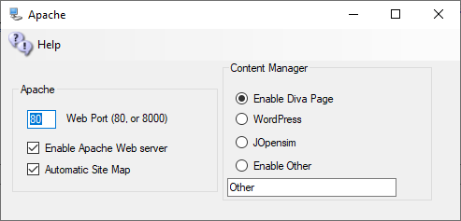

You may optionally set up an Apache Web server with PHP7, WordPress, Joomla/jOpensim, or other Content Management (CMS) systems. The default purpose of Apache/PHP is to serve a detailed map, object search and other useful functions. It is optional. You may disable it and still run Opensimulator. If you do not need the extra maps or JOpenSim, then you can leave Apache & PHP disabled.

## Web Port

Defaults to 80. If your ISP blocks port 80, try 8000. You may need to open this port in your PC’s firewall.

## Enable Apache Web Server

The checkbox for [Enable Apache Web Server] must be set so the web server and PHP will work.

When enabled a map will appear at your URL on port 80. You can hover on any square and see its size, location, name, and other details. Apache will then start when your PC is booted. No DOS boxes will appear. The advantage is less clutter and 24-hour operation of the web server. But if you run from another folder, the server will still attempt to run from the original folder.

Manually disable Apache as a Service:

1. Type this in your Windows Search: **cmd**
2. Right click the Command Prompt App and select "Run as Administrator".
3. Now type this in the command prompt:
4. sc delete ApacheHTTPServer<enter>
5. Change to the folder for OutworldzFiles\Apache\bin.
6. Type this in the same admin-level prompt.
7. httpd -k install<enter>
8. net start ApacheHTTPServer<enter>

That should get it all going again.

## Content ManageR

A **content management system** (**CMS**) is computer software used to manage the creation and modification of digital content. CMS’s are typically used for enterprise content management (ECM) and **web** content management (WCM)

For the default web page, use Diva. See the Diva Wifi Management Web Page section in this manual.



**Enable WordPress** will redirect all traffic to the home page to the WordPress folder in Outworldzfiles\Apache\htdocs\WordPress. You must install Wordpress there. Instructions are located in that folder.

**Enable jOpensim** will redirect all traffic to the home page to the JOpensim folder in Outworldzfiles\Apache\htdocs\JOpensim. Instructions are located in that folder.

Enable Other will redirect all traffic to the Other folder in Outworldzfiles\Apache\htdocs\other. You can make a different folder.

## Apache & Search setup

In each of the respective OpenSim viewers available, such as Firestorm, Singularity, etc... You have a Search feature. It might look like this inside each respective viewer:

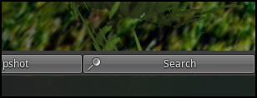

This brings up the following dialog with the respective search categories:

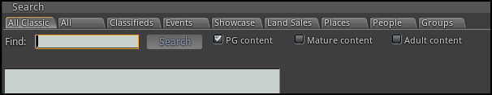

## Enable Search

If enabled, any regions or prims marked in the viewer for *Show In Search* will be registered and indexed by the <https://hyperica.com> server, and is thus available for anyone to look at. Turning off your system will remove it from search, as will unchecking this box.

## Events

By just clicking on the Search button without specifying a search term you will see all events that are up and coming

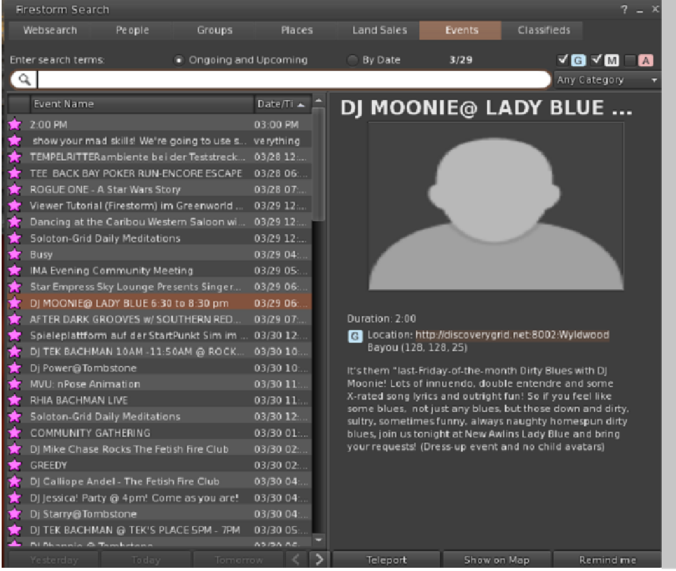

## Search for Objects

This viewer screen lets you search for objects marked as “Show in Search”. There is a search button ‘magnifying glass’ at lower left to refine your search. You can select 100, 250, or 500 rows. You can sort by any column header by clicking the title.

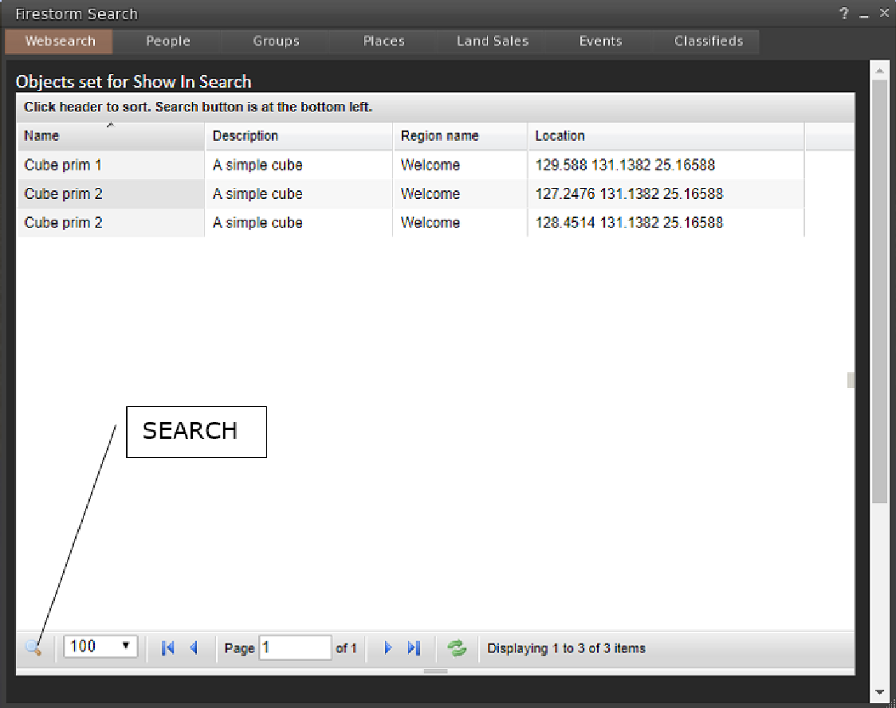

## Places search:

Any parcel marked as “Show in Search” is located in this viewer screen.

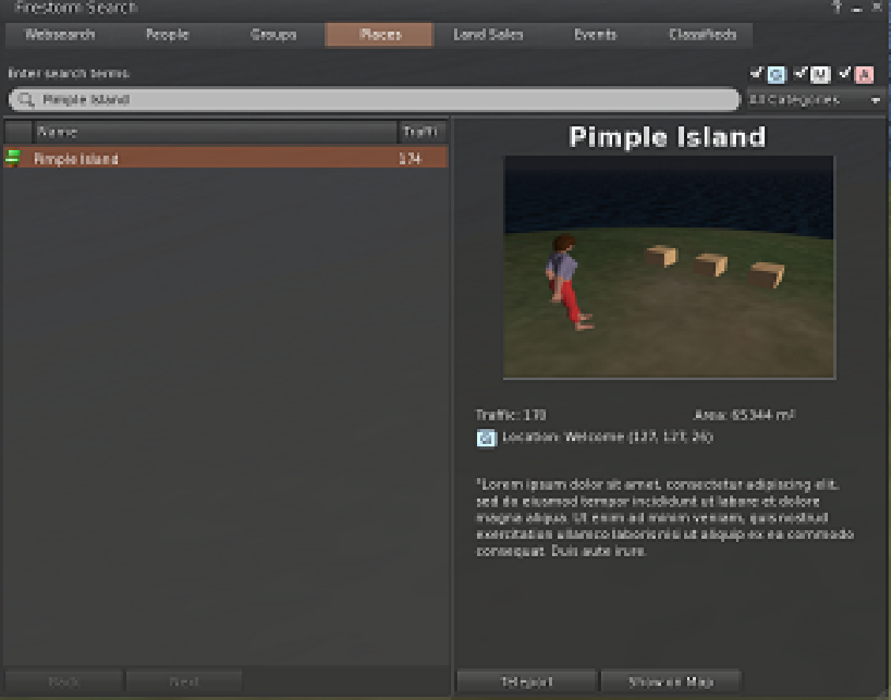

## Land Sales:

Parcels marked for-sale and “Show in Search” can be located in this screen:

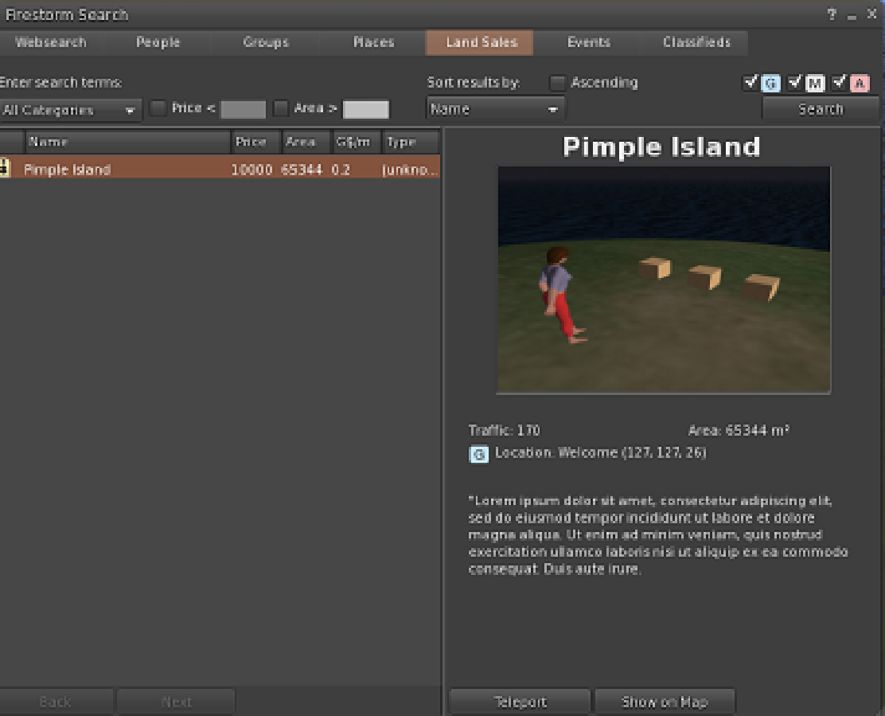

# Backup Settings

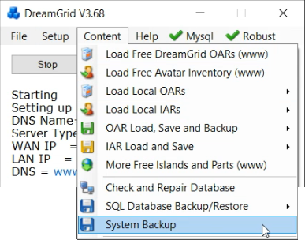

A manual backup uses a lot of disk space, but it backs up all critical files quickly and in a usable form. It will save the selected items in the AUTOBACKUP folder.   
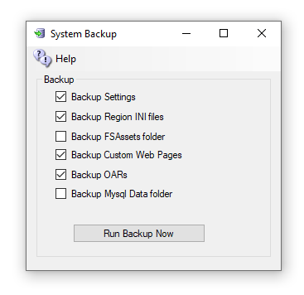  
  
Some of these boxes may be grayed out or uncheckable because the you or the system has not installed that service.

## CheckBoxes

**Backup Settings -** saves Settings.ini and XYSettings.ini files in a zip. Setting.ini contains all grid settings. XYSettings.ini contains the last positions of all windows. It can be deleted.

**Backup Region INI files -** All Useful Region.ini files and the directory Structure from Opensim\bin\Regions are saved into a zip. The useful ones are in the bin\Region\DosBoxName\Region\folder

**Backup FSassets Folder -** If you are running the FSAssets system, this contains just the assets of the database. You still need to backup MySQL.

**Backup Custom Web Pages -** This backs up two folders in bin\WifiPages-Custom and WifiPages-Custom in case you have made changes.

**Backup OARs -** runs all regions that enabled and saves an OAR from each with the name, date and time in Autobackup.

**Backup MySQL\Data**: This Zip holds the robust.sql and opensim.sql files that make up the entire database.

## Backup Strategies

There are multiple kinds of backups. Backups are at the region level, or at the grid level, which includes regions.  Also remember there are always two or more databases on a grid: the grid's robust database, and the regions Opensim database. There can be more than one Opensim database, as a grid can consists of more than one machine.

## Region Level OAR

OARs can be created on the fly - look in Content Save Oars and you can do them all with one click.  You can also set up OARS to be created on a schedule. - 24 hours is an excellent choice.

## Grid level IAR

IARS are more difficult and are more time consuming, as you need the password.   But you should make them on occasion anyway.  Just in case. They take a long time and can lag a grid when running.  If you are on OsGrid or Metro, I HIGHLY RECOMMEND you get an IAR backup often!  I have at different times lost data at both these major grids.

## Grid level SQL

SQL backup is also slow, but very thorough. It saves outfits, logins, and usernames; everything but region UUID's and settings.  With this you can fix problems in MySQL that are known to develop.   This is sort of a monthly thing to do.

## UUID:

Keep a copy of your UUID. This is available in your Profile. If you must start over, at least your new avatars will have the same UUID and will own everything you created.

# Backup - Autobackup

The AutoBackup module periodically saves data to a folder.

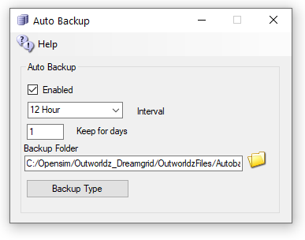

When AutoBackup is enabled, Opensim will make various backups of each region. For example, Opensim will make OAR after Opensim has run for **Interval** time. If there are checkboxes set in the [Backup Type], then those files will be backup up, too. The files will appear in the Outworldzfiles\AutoBackup folder.

**Keep for Days** will delete any OAR or zip older than this period of time.

**Save To Folder:** You can click on “AutoBackup” folder name, or the folder Icon, and set a different location.

**CAUTION:** These backups can take a great deal of room! **It is critical to save them to a different drive** so that a full drive does not crash your Database and Opensim system. DreamGrid will check for free disk space and warn you if you are low. It will attempt to freeze all Opensim Region activity if disk space gets low. If the disk space is > 50 MB, it will resume operation.

## Settings

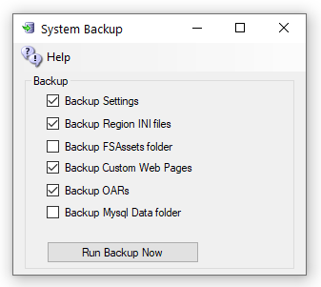

* **Backup Settings** saves the Settings.INI files in a Zip.
* **Backup Region INI files** saves all Region INI files from OutworldzFiles\Opensim\Bin\Regions to a Zip.
* **Backup FSAssets folder** will make a copy of all the the (Very Large) FSassets folder.
* **Backup Custom Web Pages** are the two Wifi-Custom folders.
* **Backup MySql Data Folder** will back up the main database. You need a copy of FSassets, too!

Robocopy: The system runs robocopy, a built in DOS program for FSassets. It follows two rules for visibility that you set for Regions, such as Always Show or Never Show. It runs with the following switches:

/E - Everything including empty folders.

/M –Modified files are copied that have the A bit set, then clears the bit.

/TBD - Wait for share names to be defined by the network.

/IM - Include Modified files that have modified times.

/J – Use Unbuffered IO for large files.

Robocopy will also add this LFSM switch on Windows 10. It will not do so on Server or Windows 7.  
  
/LFSM:50M – Will operate in low free space mode, enabling copy pause and resume. Robocopy will pause whenever a file copy would cause the destination volume's free space to go below 50 Megabytes.

Links:

<http://opensimulator.org/wiki/Load_Oar_0.9.0%2B>

# Ban Lists

Bans can be set for Grids, IP addresses, Viewers, and MAC addresses. MAC addresses are a serial number found in Ethernet cards. These bans shut off incoming traffic by using Opensim Robust capabilities, and by adding entries to the Windows Firewall. They are not a total solution but can work in many cases. This may not be effective as the login name can be changed, the Viewer Name can be tweaked, they may have another PC with a different MAC or they may have changes it, and the IP may change by the ISP or come from a VPN. People who bypass this DRM restriction are breaking into a computer, which is a felony, so penalties far beyond copyright laws could apply.

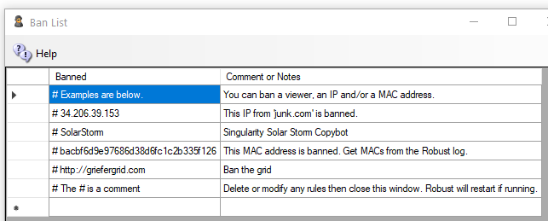

**Note that # is a Comment**

Settings go into effect when you save the screen after making changes. For OsGrid, Metro and region servers, only IP bans will work since no robust is running on your Region server.

## Getting Ban Data

You can get the Login Name and Grid http://name:port, IP address, and MAC address of people from the Robust log as it happens. You can also look in the menu system at Help ->View Logs->Robust to view the log with Baretail.exe.

**Its is best to run the Robust log with log level set to INFO.**

A typical Robust Log entry would be as follows: (highlights are mine)

INFO (104) - OpenSim.Services.HypergridService.GatekeeperService [GATEKEEPER SERVICE]: Login request for Jo.Blow@ **www.xyz.com**:8002 @ http://www.xyz.com:8002/ (3be47575-06dd-46b0-8637-87a8967c432c) at ab8d7770-3782-21e4-8c41-1813211c9b88 using viewer **Firestorm-Releasex64 5.2.8.58205**, channel Firestorm-Releasex64, IP **52.8.203.221**, Mac **d5af8bee7e6a265c41e729416d570f57**, Id0 dac5b5d03d9bbe2225d2c91c3238d59f, Teleport Flags: ViaLogin. From region Her Place (2c53df18-143f-4340-ae73-f2885d9694d8) @ <http://grid.nope.com:8002/>

## Grid Ban

To ban the grid that the avatar who originally logged on, add [**http://www.xyz.com**:8002](http://www.xyz.com:8002). The “http://” and “:port” number is required.

To ban the grid that the avatar teleported from (not necessarily her home grid) , add [**http://grid.nope.com**:8002](http://grid.nope.com:8002). The “http://” and “:port” number is required.

## IP Ban

To ban an IP, add the IP like this: 52.8.203.221. You can also add a /24 to the end to ban all IP addresses in the same range of 256 IP addresses. Use IP “52.8.203.0/24” to ban all users from IP 52.8.203.0 to IP 52.8.203.255.

## MAC Address Ban

To ban a PC by the Ethernet card MAC address, add the MAC address from the robust log: “**d5af8bee7e6a265c41e729416d570f57**”.

## Viewer Ban

To ban a specific viewer, add the name and Revision. “Firestorm-Releasex64 5.2.8.58205”. To ban all version 5 Firestorms, add “Firestorm-Releasex64 5”.

## Copybot Viewers

To ban old copybot viewers such as Darkstorm, add “Firestorm-Releasex64 5.0.11”. These old viewers are rarely in use, except by copybotters.

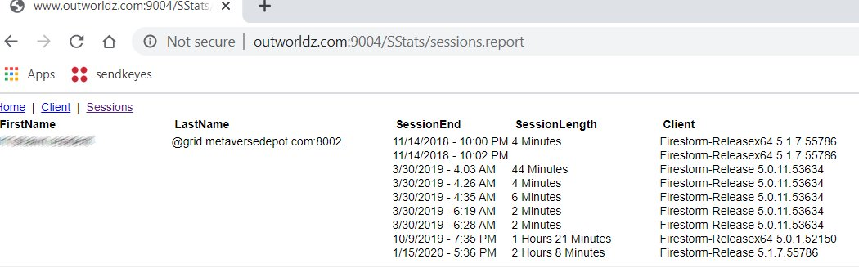

There are several ways get data to ban by viewer. One way is to look in the Stats for your Welcome region. Another is to copy and paste it from the robust screen, or robust.log. Click your Welcome region in the Regions menu, then select the Statistics Button. This screen shows the “Sessions” tab, so you can see if someone is still using an old viewer recently. If so, they are a candidate to be a copybotter.

There is a Analyze Log button in the Log settings that will show you all MAC and Disk ID0’s that were seen.

# Bird Module

The bird module makes flocks of birds possible.

You will need a bird. There is a button at the top of the Setup Page that will ask you for your Avatar Name and password. It will load a pair of Seagulls into your inventory.

You should log in and rez "SeaGull1" on the ground in one or more of your regions.



You will need to enable the bird module in each region's control panel.

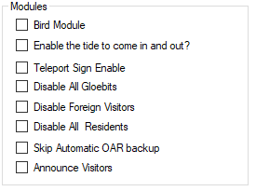

Check this Box to Enable Birds in this region

## Global Settings

There are many settings for the Bird Module. You can use the defaults. You must also click Enable and reboot the grid. Birds must also be enabled in each Region. See each Region’s edit screen for the checkbox.

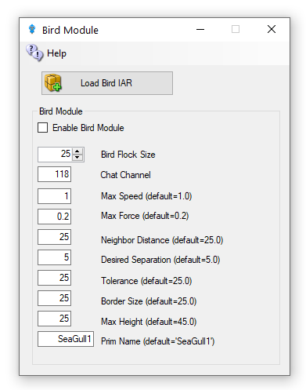

* + - Enable Bird Module: Determines whether the module does anything.
    - BirdsFlockSize = 50: The number of birds to flock
    - BirdsMaxFlockSize = 100: The maximum flock size that can be created (keeps things sane)
    - BirdsMaxSpeed = 3: How far each bird can travel per update. An update is 11 FPS
    - BirdsMaxForce = 0.25: The maximum acceleration allowed to the current velocity of the bird
    - BirdsNeighbourDistance = 25: Max distance for other birds to be considered in the same flock as others
    - BirdsTolerance = 5: How close to the edges of things can we get without being worried
    - BirdsBorderSize = 5: How close to the edge of a region can we get?
    - BirdsMaxHeight = 25: How high are we allowed to flock
    - BirdsUpdateEveryNFrames = 1: Update bird positions every N simulator frames
    - BirdsPrim = SeaGull1: By default, the module will create a flock of plain wooden spheres, however this can be overridden to the name of an existing prim that needs to already exist in the scene - i.e., be rezzed in the region.

## Console Commands

The following commands can be issued on the Console or via in-world chat or scripted chat on the Chat Channel to control the birds at runtime:

* birds-stop or /118 stop   
  stop all birds flocking
* birds-start or /118 start   
  start all birds flocking
* birds-enable or /118 enable   
  enable the flocking simulation if disabled and rez new birds
* birds-disable or /118 disable   
  stop all birds and remove them from the scene
* birds-prim <name> or /118 prim <name> changes the name of the bird prim that it loads
* framerate <num>   
  only update the flock positions every frame, only useful for photography and debugging bird behavior.

These commands are great for playing with the flock dynamics in real time:

* birds-size or /118 size   
  change the size of the flock
* birds-speed or /118 speed   
  change the maximum velocity each bird may achieve
* birds-force or /118 force   
  change the maximum force each bird may accelerate
* birds-distance or /118 distance   
  change the maximum distance that other birds are to be considered in the same flock as us
* birds-separation or /118 separation   
  sets how far away from other birds we would like to stay
* birds-tolerance or /118 tolerance   
  sets how close to the edges of things can we get without being worried. If distance is less than separation, then the birds will never flock. The other way around and they will always eventually form one or more flocks.

## Security

By default, anyone can send commands to the module from within a script or via the in-world chat on the 'BirdsChatChannel' channel. You should use a high negative value for this channel if you want to allow script access, but not in-world chat.

## Bird Prims

Any currently rezzed in-scene-object can be used as the bird prim. However, fps is very much affected by the complexity of the entity to use. It is easier to throw a single prim (or sculpty) around the scene than it is to throw the constituent parts of a 200 linked prim dragon. Tests show that <= 500 single prims can be flocked effectively - depending on system and network. However maybe <= 300 simple linksets can perform as well.

## Network Traffic

I tested the amount of network traffic generated by bird updates. 20 birds (each with 4 linked prims) take up about 300kbps in network position updates. 50 of the same birds generates about 750kbps traffic. Each bird uses roughly 15kbps of network traffic. This is all measured using an update framerate of 1, i.e., birds' position is updated every simulator frame.

## Statistics

The stats command in-world or via script returns data to BirdsChatChannel. The console command returns stats to the console. All the modules parameters are returned including a list of the active bird prims currently rezzed in the region, and the UUIDs of those prims' root prim. Also included is a list of any avatar UUIDs that may be sitting on those prims.

Here is an example output:

birds-started = False  
birds-enabled = True  
birds-prim = SeaGull1  
birds-framerate = 1  
birds-maxsize = 100  
birds-size = 20  
birds-speed = 1.5  
birds-force = 0.2  
birds-distance = 25  
birds-separation = 10  
birds-tolerance = 5  
birds-border = 5  
birds-prim0 = OpenSimBirds0: 01abef79-7fb2-4c8d-831e-62ce1ce878f1 :  
birds-prim1 = OpenSimBirds1: af85996d-af4d-4dda-bc89-721c51e09d0c :

**Links:**

<https://github.com/JakDaniels/OpenSimBirds>

# Running DreamGrid On A Server

One of the difficulties in moving to a server such as Contabo.com is moving the files to it.

The big problem is mysql\data\ibdata - which is literally your grid and must be moved.

There are many ways to do this: Google drive, dropbox, ftp, but most of those require $$ or are very slow.  A very good way is to use Windows SMB file sharing.

The remote server can appear as a local disk, such as X: or Z: with SMB file shares so you can copy and paste files.  This makes it trivially easy to make backups and move OARs and backups off Contabo and store them at your home.

# Log Into Your Server

Log in with remote desktop or VNC  as an Administrator.   You need a strong password for your account!   Don't skimp on this step, as your server is exposed to the internet in an intimate way, and it will be probed constantly for weaknesses.  
  
Now choose a folder.  The safest way to share is by making a shared folder, such as your AUTOBACKUP folder.  If someone guesses your password, then all they get are backups. And you can share the entire drive, too.  
  
Right click a folder or C: and select Properties.  
  
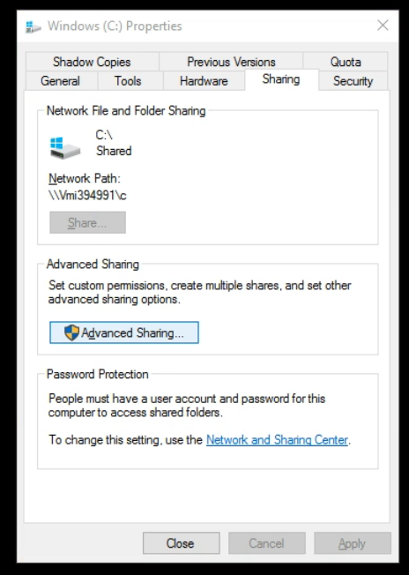

Click Advanced Sharing:  
  
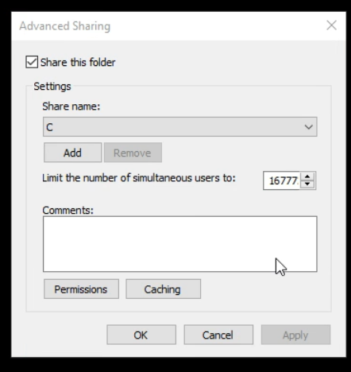  
  
Click Add and give it a name, such as "C", and check "Share this folder"  
  
Click Permissions:  
  
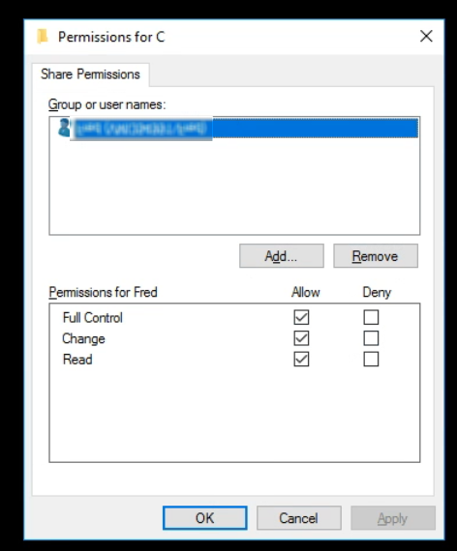  
  
  
Remove the "Everyone" group and  click Add and type in your login name.  
  
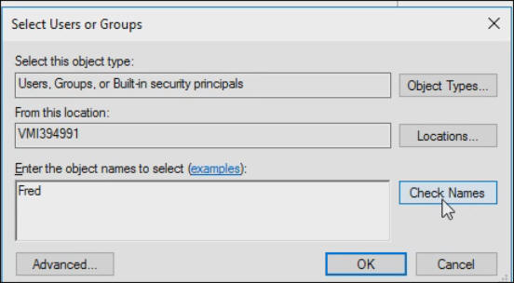  
  
Press OK  
  
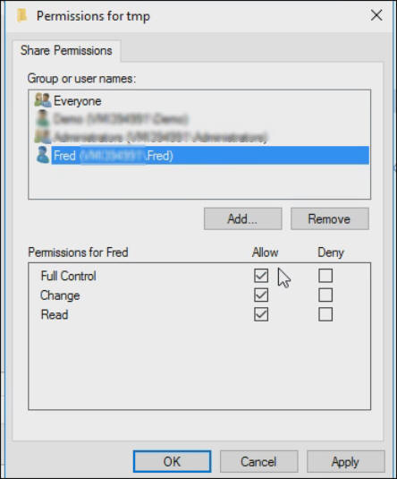  
  
Check "Full control" so all three permissions are lit up.  
  
Click OK

# Firewall Rules

You need to enable some ports in Windows Server.   Go to Control panel or search for Advanced Firewall.  
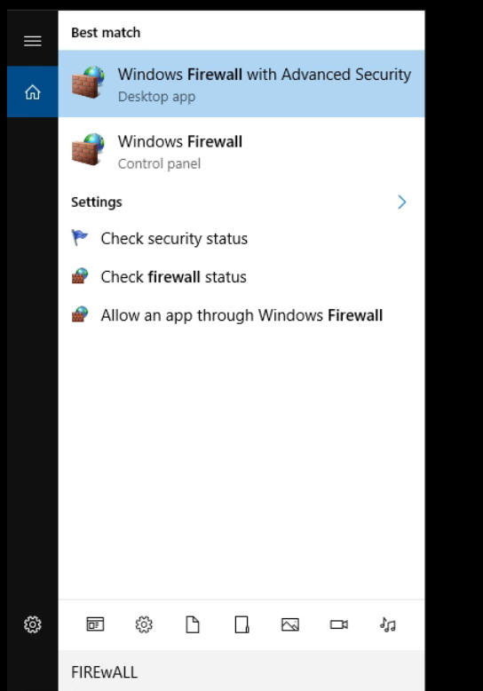  
  
In the firewall screen, click Inbound Rules  
  
  
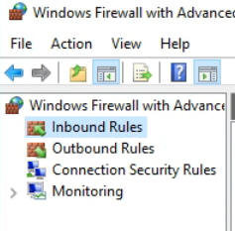

On the right side, click New Rule  
  
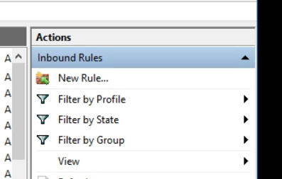  
  
Give it a name such as "File Sharing TCP"  
  
  
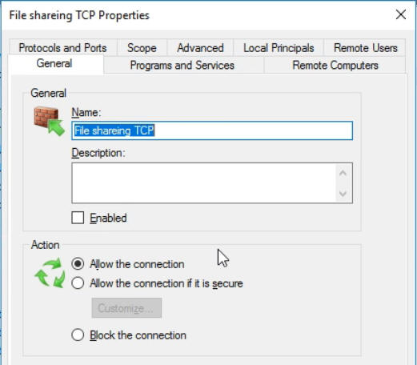  
  
In Protocols and Ports  Select TCP and add the following ports: 134-139, 445, 389, 88  
  
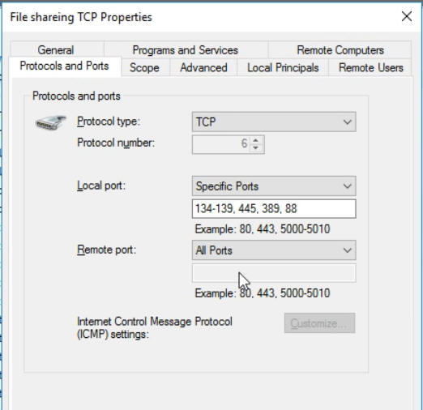  
  
  
Repeat the above steps for a name such as "File Sharing UDP"  
  
  
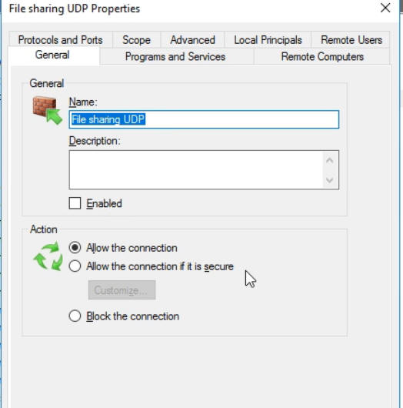  
  
Repeat the step "Protocols and Ports" Select UDP and add the following ports:  
  
134-139, 445, 389, 88  
  
  
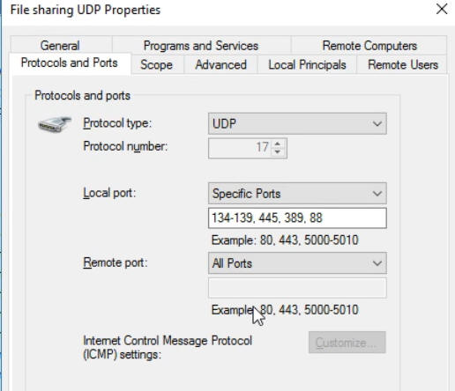  
  
Click Apply

# Sharing Files To And From Your Server

To connect, you can use the IP, DNS name, or Outworldz.net name.  This is the same name you connect to Contabo  in VNC or Remote Desktop,

Go to File Explorer in Windows at your Home PC. You can get there by pressing the Windows Logo key and the 'e' key at the same time.

Type two back slashes \\ in the address bar and then the  name of your server:

You should get a password prompt:

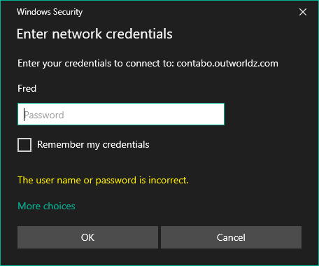

Enter your password and you should see the share name that you set up.

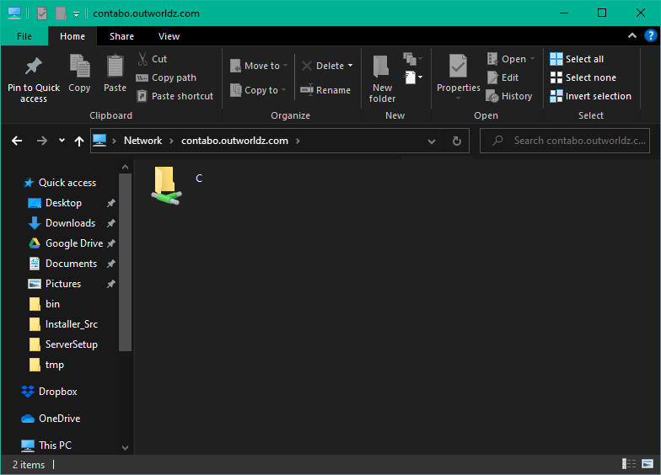

You can use this name and path as if it is local to your PC and drag and drop files to it. Or Copy and Paste.

You can also Map a drive letter to it.

Right click the folder and select "Map Network Drive"

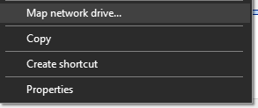

 Choose a drive letter and click Apply

Now you can simply go to the drive letter and access your server.

## Backups:

Now that your server is set up for file access, you can use programs such as  robocopy (free, built into windows), and paid backup programs such as SyncBack to mov e or copy your grid to your home PC on a regular basis.

Example: I created map drive as X: to a folder on the server and added a batch file named Backup.bat.

I then ran this from the server as X:/backup.bat and it copied my Servers X:\tmp folder to my home PC C:\tmp folder.

You can now use robocopy to backup your entire grid, or the Backup folder with one simple command "X:/Backup" by changing the folder names in the batch file.

PS X:\> .\Backup.bat  
  
X:\>robocopy X:\tmp c:\tmp /e  
  
-------------------------------------------------------------------------------  
ROBOCOPY :: Robust File Copy for Windows  
-------------------------------------------------------------------------------  
  
Started : Monday, October 19, 2020 11:38:27 PM  
Source : X:\tmp\  
Dest : c:\tmp\  
  
Files : *.*  
  
Options : *.* /S /E /DCOPY:DA /COPY:DAT /R:1000000 /W:30  
  
------------------------------------------------------------------------------  
  
0 X:\tmp\  
New Dir 0 X:\tmp\A\  
  
-----------------------------------------------------------------------------  
  
Total Copied Skipped Mismatch FAILED Extras  
Dirs : 2 1 1 0 0 1  
Files : 0 0 0 0 0 8  
Bytes : 0 0 0 0 0 27.63 m  
Times : 0:00:00 0:00:00 0:00:00 0:00:00  
Ended : Monday, October 19, 2020 11:38:28 PM  
PS X:\>

# Cache

Opensimulator has many caches of data to improve performance. You may optionally clear these caches. The system will refresh them on the next startup. This will slow your system down dramatically on the next boot as it must re-fetch all assets the next time it starts.

Opensim must be stopped to clear script and the Avatar Bake caches.

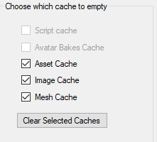

**Script cache:** Clearing the script cache is only necessary after an update to Opensim binaries. DreamGrid will not delete the “.STATE” files so your virtual pets will not die.

**Avatars bakes cache:** this folder holds the various baked skin layers.

**Asset cache:**  holds the assets (mesh, prims, textures) and is typically exceptionally large. It automatically flushes itself every 48 hours.

**Image cache:** holds the images and is typically exceptionally large.

**Mesh cache:** holds mesh pieces.

# Flotsam Cache Settings

OpenSimulator has an asset cache that stores the assets retrieved from an asset service. This reduces the load on a possibly remote asset service and improves OpenSimulator responsiveness.

**Viewer cache** is for modern viewers. If you use old viewers you may have issues. Turn this off for old viewers.

**Cache Enabled**: The cache should always be enabled.

**Cache Directory** man be moved to another disk. It is best practice to save all large folders such as this cache to another disk.

**Log level** is for debugging.

**Timeout in Hours** is how you set how much disk it uses. Lower numbers = less disk space. The larger the number, the better performance you will get. Typical numbers are 24 hours for small grids, a few hours for large grids.

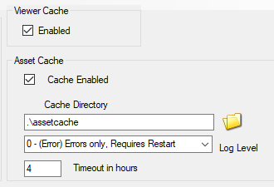

## Settings

Note: You must run the Flotsam asset cache if you are running the FSassets file system database.

The Flotsam asset cache stores assets on disk and in memory.

At the moment, the amount of memory or filesystem storage used by the cache can only be limited via manual actions (wiping all or part of cached assets from the filesystem), by console commands (e.g. "fcache clear") or by timeout settings (e.g. FileCacheTimeout = 1 to automatically remove cache files not accessed for 1 hours).

# Database Settings

Did MySQL crash? See section **Crashes**.

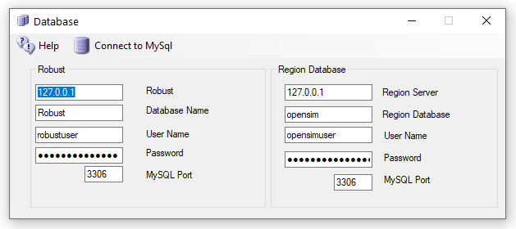

Do not change any of these settings without knowing what you are doing!

Any change here must match complicated hand-made changes in MySQL! See the bottom of this help section for more details.

There are two databases in DreamGrid: Robust is the login and inventory database. Each region also uses a separate Opensim database for storing what is in region.

Database root password is blank. This is safe as it only listens on localhost, which is your server.

## Robust Database:

**Robust Server:** should always be 127.0.0.1. This is the Server that runs Robust (itself). It can be the IP address of a different server running MySQL. Default: *127.0.0.1*

**Robust name**: The name of the Robust database. Default: *robust*

**User Name:** The login name 'robustuser'@localhost'. Default: *robustuser*

**Password:** The password for Robust. Default: *robustpassword*

**MySQL Port:** The TCP/IP port that both databases use. Default = 3306. You can set this to 3307, 3308 or 3309 to not interfere with the Other MySQL’s that may be running.

**FSAssets:** You can select the FSAssets button to set up a File System As Assets Database. This is recommended only for large grids, with hundreds of Gigabyte sized databases.

## Local Region Database:

**DB name**: The name of the region database. default: *opensim*

**User Name:** The login name 'opensimuser'@localhost'. default: *opensimuser*

**Password:** The password for opensim region database. default = *opensimpassword*

**MySQL Port:** The TCP/IP port that both databases use. Default = 3309 to not interfere with the normal MySQL Port of 3306

If you want to alter the username and password to either database, you must use the MySQL.exe program in a DOS box.

cd Outworldzfiles\mysql\bin  
mysql -u root  
use opensim;  
create user 'anewopensimuser'@'localhost' identified by 'opensimpassword';  
grant all on opensim.* to 'anewopensimuser'@'localhost';  
use robust;  
create user 'anewrobustuser'@'localhost' identified by 'robustpassword';  
grant all on robust.* to 'anewrobustuser'@'localhost';  
quit;

## Running MySQL as a Service

DreamGrid will detect any running MySQL using the same port. You can install MySQL as a Windows service. There is a batch file “InstallAsAService.bat” in MySQL\bin to set this up. MySQL will then start and stop safely with Windows. This batch file must be run once, as an Administrator. You type "CMD" in the search box, and then right click the Command Prompt and select "Run as Administrator".



Use that DOS box to run **InstallAsAService.bat**. Then type in 'Services.msc", and use it to start MySQL, or type in ‘net start MySQL’<enter>.

You can verify MySQL is running by typing 'mysql - u root<enter>'. If you get a MySQL prompt, it is running as a service. Then type quit; with the semicolon and enter.  
  
You should also set the service to restart so MySQL restarts on any crash. Windows knows about services and will send signals to MySQL to shut itself off gracefully. The only danger is that power fails and you corrupt the database. If you are serious about running a grid, then a UPS is necessary.

## MySQL Crashes:

Your MySQL database may be crashed. Here is a way to recover and start MYSQL manually.

Navigate to the **Outworldzfiles\mysql\bin** folder.

Then double-click "StartManually.bat”

Any error message it prints may be helpful. If the DOS window closes, a MySQL LOG file will be saved in OutworldzFiles\mysql\data as a *.err file. That may give you a clue as to what to do.

## My database still did not start!

Try running Outworldzfiles\mysql\bin\Repair_ISAM.bat.

Then double-click "StartManually.bat”. The DOS window that appears should ‘stick’ open.

Run Task manager by typing Ctrl-Shift-ESC.

Look for *mysqld.exe.* Wait for the CPU usage to go to 0 on mysqld.exe. This may take a long time as MySQL is rebuilding the database. It could take an hour or more, depending upon the size and your disk and CPU speed.

Double click CheckandRepair.bat to run diagnostics.

If errors appear, answer any questions with a ‘Y’. This will take a long time as MySQL is repairing the database.

Once the Check and Repair is finished, double-click Mysql\bin\StopMySQL.bat’

The DOS box that first appeared should now close. Your database has been recovered and it is safe to start DreamGrid.

If you still have issues, delete the file MySQL\Data\ib_logfile0 and ib_logfile1. Do not delete ibdata1! Then repeat the above sequence.

If I had really deep issues with a database and it was unrecoverable, I would try the last copied one, then the SQL, then an OAR, and the very last thing I would try is an OAR/IAR restore.    So far I have recovered at least a dozen databases for people.   One developed a bad bit which took about a week to ftp, to develop a fix for and a simple query to repair.

Also have fixed a crashed "primitems" table that has reoccurred on one grid. You log in to MySQL with the command ‘mysql -u root’ and type in:

use opensim;

repair table primitems;

quit;

Please do not give up if your database will not start! Contact me at [**fred@outworldz.com**](mailto:fred@outworldz.com) and I will see what I can do. I have not yet lost a database.

## Starting Over with a Blank Database

You can wipe ALL data out. If you do this, you must re-enter all accounts and recreate your system from OAR and IAR files. This WILL LOSE ALL DATA.

I recommend you make a backup of the MySQL\Data folder first.

I have not yet ‘lost’ a database, and I have seen dozens of them crash in oddball ways. Please contact me at [fred@outworldz.com](mailto:fred@outworldz.com) if you have questions or need more help in recovering a database. The largest was 70 Gigabytes which took four days just to get a copy sent to me. It was fixed in a few hours. The problem was to a single bad character in a UUID. So please do not delete it unless you really, really want to start over!

If you MUST wipe out the database and start over, delete the folder MySQL\data. Then extract the contents of the file Blank-Mysql-Data-folder.zip to make a new MySQL\Data folder.

This will make it start over at the very beginning. The database should start up now. You must go to Robust; type create user<enter>’ and re-enter your Avatar name and password. You can then re-enter your estate information in each DOS box for Each region.

You can restore the database if you have a .SQL backup. Or use OARs and IARs.

# Diva Web Control Panel

The Management Web page is at <http://127.0.0.1:8002> if the checkbox is enabled and Robust is running.

For other users, it will be [http://YourDomainName:8002](http://yourdomainname:8002), where YourDomainName is your Public, Internet-facing IP or DNS name.

The features of Wifi are:

* Account creation, optionally controlled by the Wifi Admin Account
* Configurable default avatars for new accounts
* Account updates by both users and administrator
* Account deletion by administrator
* Password recovery via email
* Simple user inventory management

You can change many of the parameters of Wifi in this panel:

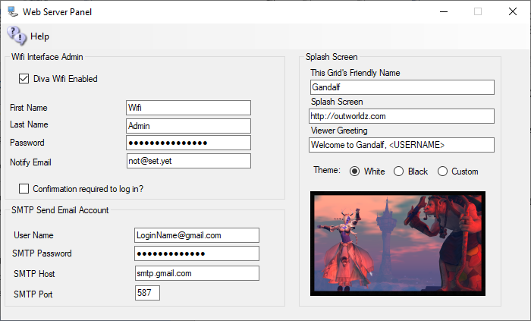

There are three sections that can be modified:

* Wifi Interface Admin: A super-user that administers the system. This can be you. It comes with Wifi Admin as a default login.
* Splash Screen: Things that affect the page that shows in the viewer window.
* SMTP Email: Settings to send email for things such as password changes and confirmation off emails.

The system automatically makes several accounts the first time. One of these is "Wifi Admin'. This user has special rights in the web panel. It can administer all other accounts, change passwords, enable and disable, or delete and approve them.

A random password is created at startup. You may change it. As the Hypergrid exposes this login page to the Internet, please choose a strong password.

You must already have a user with levels set to 100 or higher to change the name from Wifi Admin. You can add another user and set it to that elevated level too.



## Wifi Admin USER

There are three Opensim users made at startup. One is for the grid to use. GRID MANAGER is the main user If you mess with it your grid will die. It does things that require a User account to do, such as send a user an IM.

**Wifi Admin** is used to control users and run the Web page. It can rename, delete, stop, or allow a user on the grid by the web page. The robust console can do all this, but it is arcane and easier to use the web page.

Wifi Admin is created with a random password. Go to settings->Web Page and click the password field. It will show it to you. You can change this passwort by typing in a new name when Robust is running.

Go to Help-Web Page and it will open your grid Wifi Panel. It is also at <http://localhost:8002>.

Log in as Wifi Admin using that password. and you will see a Manage Accounts section.

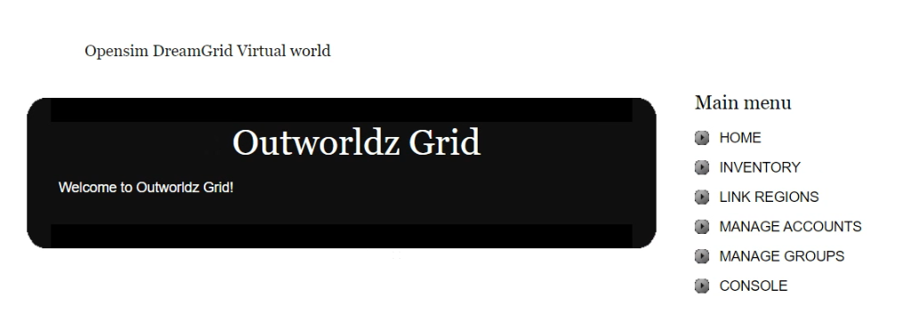

Go to it, press a space bar in search, and it will show you the three users.

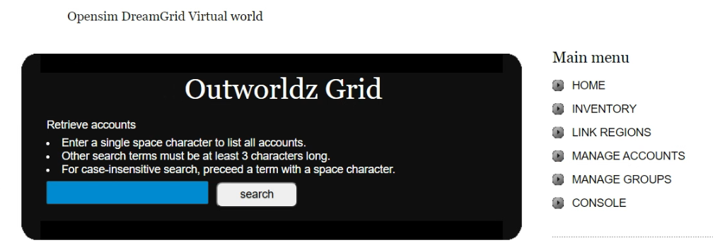

## User Levels

If you any users the level to -1, they cannot log in.

Level 0, they can log in.

Level 100 is a Wifi Admin.

Level 200 allows them to be a god if Allow User Gods switch is enabled in Setup->Settings->Permissions

## Confirmation Required to Log In:

Wifi Admin can create new accounts in two manners: uncontrolled and controlled. If you choose to have controlled account creation, every time someone creates an account, the Wifi Admin account will receive an email notifying of such an event (make sure you have the Wifi Admin’s email address properly set).

You should then login to Wifi as administrator and choose USER MANAGEMENT. You are presented with a list of all pending accounts, which you can then approve or ignore.

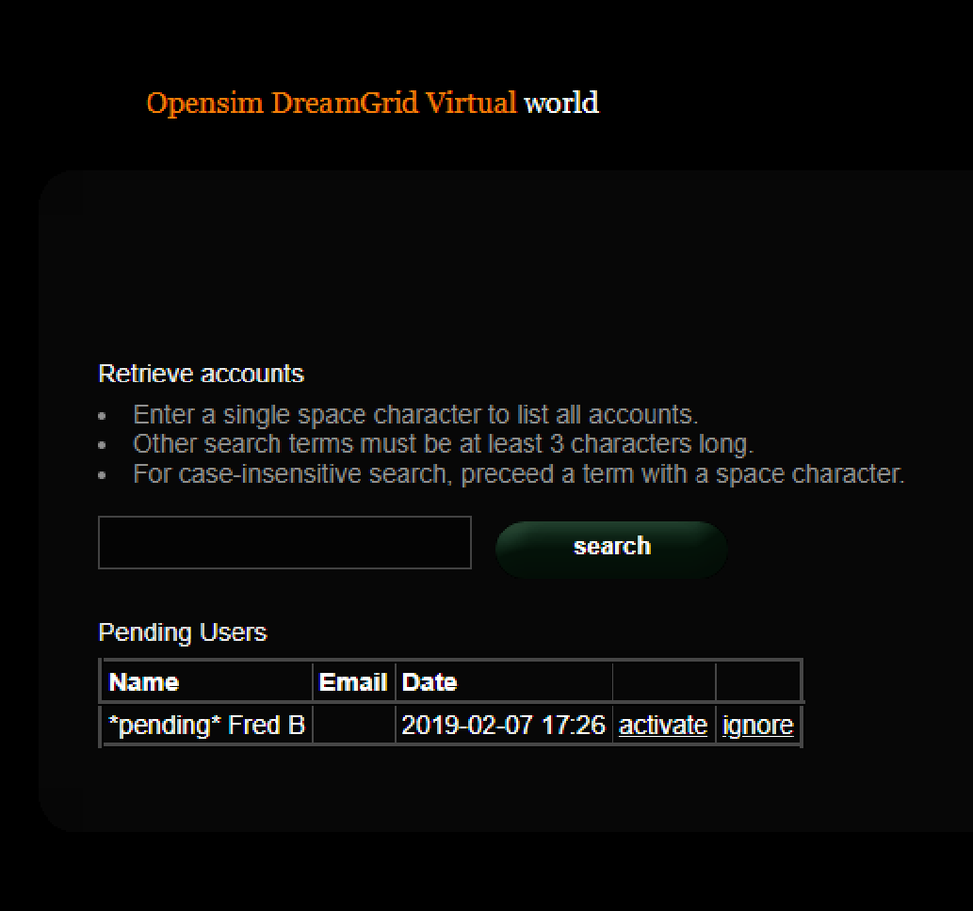

If you choose to have uncontrolled account creation, then anyone can create an account in your world without going through your approval.

## SMTP Email

You may optionally set up Simple Mail Transport Protocol to send email for events such as password changes.

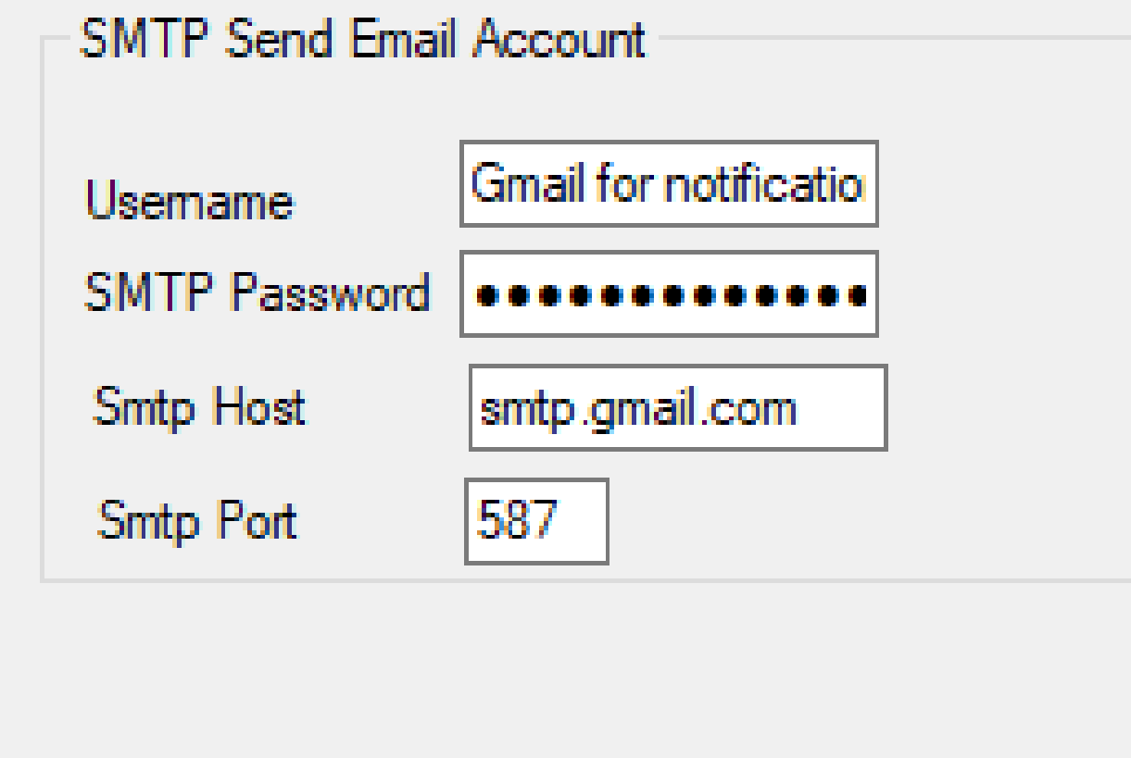

**If you use Gmail for SMTP, you will need to enable Less-Secure mail settings at Gmail in your account.**

**You can find information about this at** [**https://support.google.com/accounts/answer/6010255**](https://support.google.com/accounts/answer/6010255)

## Theme

There are three theme colors, Black on White, White on Black, and Custom. The default theme is Black, or the selected theme will be set by DreamGrid into the real WifiPages folder on startup.

Custom starts out as the White theme. You can modify this theme according to instructions down below.

Click the photo to change it for the theme.



## Viewer Splash Screen URL:

The Splash screen URL appears on the login screen as a web page. You can use any web page. If you change this URL, you must delete the grid setting in your viewer, and re-add it to get it updated.

**If you change this, you must delete and re-add the grid to the viewer.**

The Splash Screen URL is shown below.



Set this to http://(URL of your grid):8002 so they can see the Login Page. It can be any web page.

## Greeting

This message appears when a person logs in.



## Friendly Name

The friendly name appears on the login screen at the top. It is broadcast to viewers as the grid name in the grid Selector Pulldown. If you change this, you must delete and re-add the grid to the viewer.



## Default Avatars:

A “Wifi.ini” file lets you select one of three default appearances for a newly created avatar. In a new environment you must set those avatars up first.

1. Create the avatars with names “Female Avatar”, Male Avatar”, “Neutral Avatar”. and authorize them via the Wifi Admin.
2. Login as each avatar in turn. They will usually appear as a cloud initially and then after a short while rez to appear as “Ruth” wearing four basic body parts, new pants, and new shirt. These parts come directly from the Opensim Library and MUST NOT be worn in your final appearance for the default avatars. You can COPY these library parts into the avatar’s inventory if you wish, or create new body parts and clothing, but before you finish you should remove any items that show as “worn” in the Opensim Library as those will not rez on avatars based on these models.
3. Create new body parts and clothing and edit them and/or add any other mesh, clothing, attachments, or HUDs you wish to appear on the avatars.
4. You can extend (or change the avatars names or labels) for the default appearances and/or change the preselected default by altering Wifi.ini.

;;Syntax: AvatarAccount_<AvatarType> = "<FirstName> <LastName>"  
;;(replace spaces in <AvatarType> with underscore)  
AvatarAccount_Female="Female Avatar"   
AvatarAccount_Male="Male Avatar"   
AvatarAccount_Neutral="Neutral Avatar"   
;; Preselection for default avatar in new account registration   
AvatarPreselection="Neutral"

5. When you create a new avatar via the Wifi web interface based on these predefined avatars the items worn will appear in the newly created avatar’s inventory under Clothes -> Default Avatar <AvatarType>.

## Customizing your theme

You can change the theme with this switch to one of several sets of folders, White, Black, or Custom.

**White theme** consists of two folders:

* Outworldzfiles\Opensim\WifiPages-White
* Outworldzfiles\Opensim\bin\WifiPages-White

**Black theme** consists of two folders:

* Outworldzfiles\Opensim\WifiPages-Black
* Outworldzfiles\Opensim\bin\WifiPages-Black

If you want to make modifications, please use a custom theme. Otherwise, your changes to the -Black, -White or WifiPages folders will be over-written in an update.

First copy both the two Black, or the two White folders to the WifiPages-Custom folder next to them. Each set of files goes in these places:

* Opensim/WifiPages-Custom
* Opensim/bin/WifiPages-Custom

The updater will never overwrite these custom pages. If you make changes to the custom pages, they will be set into the Wifi page on startup.

Click the photo to change it for the theme.



## Changing the HTML

Diva Canto uses some advanced, Opensim-specific code in her Diva pages.

The site starts from Opensim\bin\WifiPages\index.html.

**#includes** There are several include directives that bring in the rest of the web site. Diva uses a series of <!--#include file=header.html --> statements to bring in files from the other folder set in Opensim\WifiPages. Includes in those files then bring in increasingly of the web pages from Opensim\Bin\Wifipages.

**#get** There are several statements that are replaced by server data:

**Users in World:** <!-- #get var=UsersInworld -->

**Regions:** <!-- #get var=RegionsTotal -->

**Total Users:** <!-- #get var=UsersTotal -->

**Active Users last** <!-- #get var=UsersActivePeriod --> **days**

**Active Users:** <!-- #get var=UsersActive -->

# Hypergrid and Domain Name Setup

Hypergrid requires a DNS name or a Public IP. You can register and use your own domain, or use your routers public IP, or use the Outworldz system’s’ free Dynamic DNS system (DYN DNS).

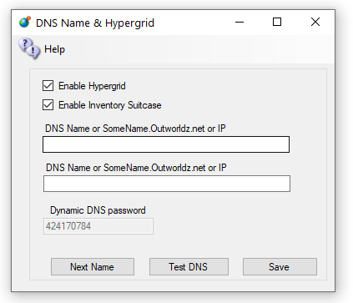

## DNS name

For a Free Dynamic DNS name, use the format "somename.outworldz.net" or “Somename.inworldz.net”. You can a;so just make up a name, so choose a name and add ".outworldz.net" or “.inworldz.net”. For domain names, the letters, numbers a-z, digits 0-9 and a dash (-) are the only allowed characters.

You may add an alternate name to be registered in the dynamic DNS system. This is typically used for the WWW function in Apache’s web server.

Do not add anything else other than a name, periods ‘.’ and either ‘inworldz.net’, or ‘.outworldz.net’.

IP addresses may be used.

If blank, the PC's LAN address will be used. Hypergrid will not be available, but other LAN PC's will be able to connect. This is ideal for schools and other types of private work grids.

## Running on the LAN only

When there is no network connection, such as when travelling, use localhost, or 127.0.0.1. These allow only the viewer on the server to connect.

## DynDNS Password

This is a random number that may be used to keep your DNS Name from being used by others. It is first come, first served. Your password must be copied from one installation to another to use the same DYN DNS name. If you need help with this, or wish to delete your DNS name, please email me at [fred@outworldz.net](mailto:fred@outworldz.net).

## Enable Hypergrid

If unchecked, the Hypergrid will not be available. The grid will be only a Private Grid, with access possible only by logging into the grid directly.

## Enable My Suitcase

If checked, Hypergrid travel uses a viewer suitcase. The purpose of the Suitcase is to prevent a foreign "rogue" grid from stealing your inventory while you are visiting. However, any items in your suitcase are exposed to other grids. you can only rez or give items in other grids that are already in your suitcase.

The My Suitcase folder is special: it is the folder tree that receives objects you collect while you are visiting other grids. But now it is even more special: it is the **only** folder tree that is accessible to you (and therefore to the rest of the Internet) while you are traveling. Period.

If you disable the suitcase by unchecking this box, as OsGrid does, you will be able to rez and give items while on other grids from anywhere in your inventory. Items you take or are given will still end up in your suitcase.

## Next Name

to use the free Outworldz Dynamic DNS, click "Next Name" to get a name. The Dreamgrid Dynamic DNS system will automatically register your PC's ever-changing IP address and keep your sim running.

## Test DNS

Will register the DNS name and check that it is resolvable. The result should be the Public IP address of your router.

## Troubleshooting Network:

1) Go back to running locally.  Set the DNS name or IP to 127.0.0.1 and press Save.

Start the grid up.

2) Now that the grid is running, use http://www.canyouseeme.org on port 8002 to verify your router has ports forwarded.  if not, work on the router/firewalls so you can see the Opensim Robust service on 8002.

3)   Try to get to that same IP address plus :8002 in a web browser from the server. My IP was 24.173.0.66, so I would try http://24.173.0.66:8002

If you get no web page, your router does not support loopback.

4)Add the Windows Device driver for loopback. Use the exact same IP address that http://www.canyouseeme.org reported.  This is what mine looks like

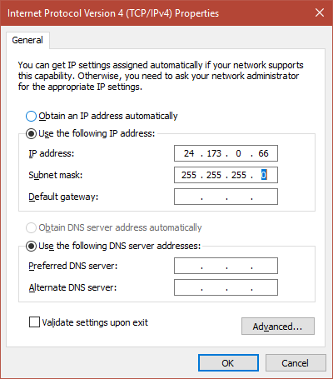

1. Click Start, then type cmd in the search box.  
2. In the command prompt, type hdwwiz.exe and press Enter.  
3. Click Next.  
4. Select Install the hardware that I manually select from a list (Advanced), then click Next.  
5. Select Network adapters, then click Next.  
6. Select Microsoft as the manufacturer, select Microsoft KM-TEST Loopback Adapter as the adapter for Windows10 , then click Next.  
7. Select Next to confirm the installation.  
9. Select Finish to complete the installation.  
  
To configure the newly created adapter:  
  
1. Click Start > Control Panel > Network Connections.  
2,. Select the newly created connection (named Local Area Connection #, where # is its order number).  
4. Right-click on the selected connection and choose Properties from the menu.  
4. Confirm that Microsoft Loopback Adapter or Microsoft Loopback Adapter # is displayed in the Connect Using: field.  
5. If it is not, return to step 2 and retry properties for another adapter.  
7. Select Internet Protocol IPV4 and click Properties to open Internet Protocol (TCP/IP) Properties.  
8. Select Use the following IP address. Fill in the IP address and Subnet mask fields.  
  
Example: 10.10.10.10, 255.255.255.0 <=====But use the IP address shown by http://www.canyouseeme.org  
  
9. Click OK to close the Internet Protocol (TCP/IP) Properties.  
10. Click OK to close the connection properties.  
11. Right click the Microsoft Driver and rename it to just "Loopback". DreamGrid will automatically update the driver if your Public IP changes.

12.   You should be able to reach your grid at the IP Address:8002 now.   If so, you can now go back to the HyperGrid Setting and choose a DNS name.

links:

<http://www.canyouseeme.org>

# Easy Free Database

The Easy Free Database is an LSL-scripted database to save and fetch persistent variables in Second Life and OpenSim scripts.

## URL

http://outworldz.appspot.com/store?service=<service uuid>&keyfield=<variable name>&datafield=<data to be stored>

**Example:** <http://outworldz.appspot.com/store?service=2b307c02-2133-4dba-bcc5-3d8f7db53eee&keyfield=AnimalName&datafield=bunny>

**service uuid:** unique identifier for your application. You can use a different one for each script or share the same identifier across several scripts in order to share data. To generate a random uuid: [http://outworldz.appspot.com/rand](https://outworldz.appspot.com/rand)

**keyfield:** variable name or other identifier for your data

**datafield:** data that you want to be stored.

## Response

This will return string OK as the body if successful.

You can get your data back by loading:

http://outworldz.appspot.com/load?service=<service uuid>&keyfield=<variable name>

Sample LSL script:

// src: <https://www.hypergridbusiness.com/2012/12/free-database-for-opensim-scripts/>  
// Change this to a UUID from [http://outworldz.appspot.com/rand](https://outworldz.appspot.com/rand)  
//

string serviceid = "b1e5e346-b831-47fa-9930-11223456778";  
default  
{  
 touch_start(integer counter)  
 {  
 string URL = "http://outworldz.appspot.com/load?service=" + serviceid + "&keyfield=colors";  
 key httpkey=llHTTPRequest(URL, [] ,"");  
 }

http_response(key id, integer status, list meta, string body)  
 {  
 list colors = llParseString2List(body,[","],[" "]);  
 llSetColor(<llList2Float(colors,0), llList2Float(colors,1), llList2Float(colors,2)>,ALL_SIDES);

}  
}

# FIREWALL

DreamGrid Automatically adds rules to the Windows firewall for Robust, Opensim, Icecast, and Apache. There is no need to adjust these rules.

If you accidently denied the firewall rule request, you will have to locate the NO symbol in the firewall and delete it.

You may want to block certain IP addresses from accessing your system. This manual shows how. **The Banlist Manual shows how to do it with DreamGrid.**

The Windows firewall is automatically opened for TCP and UDP for any ports that DreamGrid needs. It closes those ports if you reduce the number of regions and increases the open port count if you add regions. This also works on Icecast and Apache.

You can use the Windows firewall to block specific IP addresses and ranges of Ip addresses.

Open the windows firewall and click **Advanced Settings** on the upper left side.

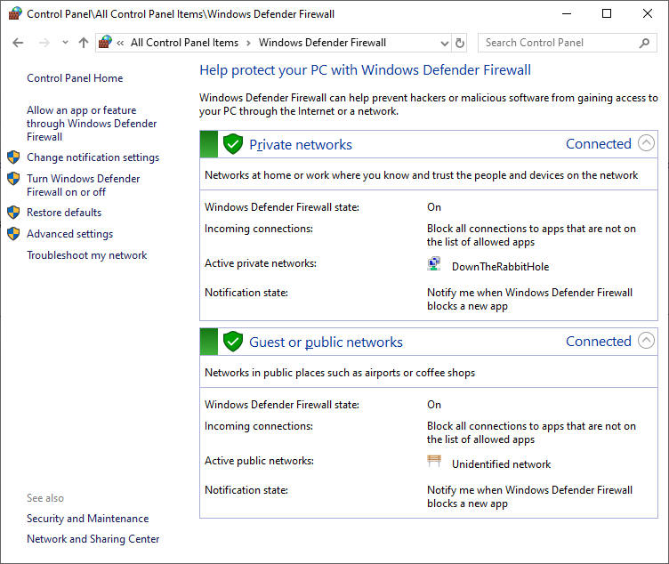

## Advanced settings screen:

[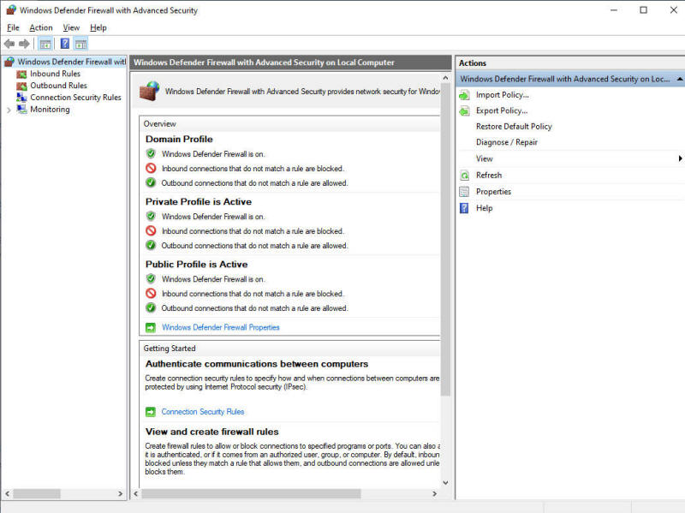](https://outworldz.com/opensim/posts/firewall/imgD.jpg)

Right click **Inbound Rules** and select **New Rule:**

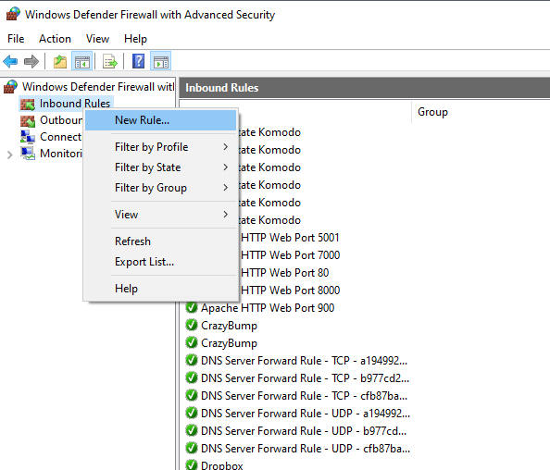

Select Custom Rule

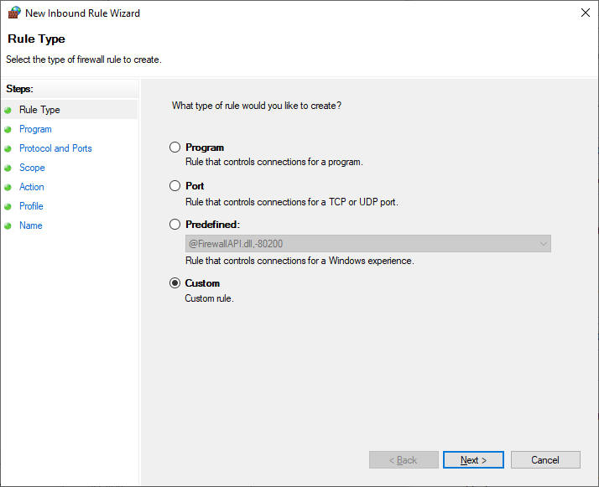

Select **All programs:**

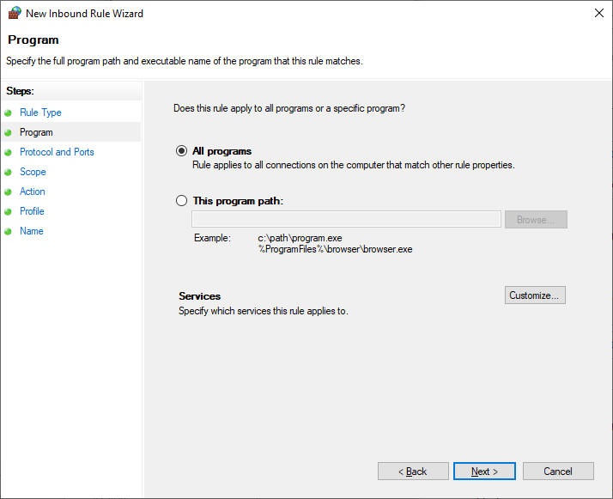

Enter the port for your grid login. Yours is likely to be **8002**. TCP is used to log in, so we will block it.

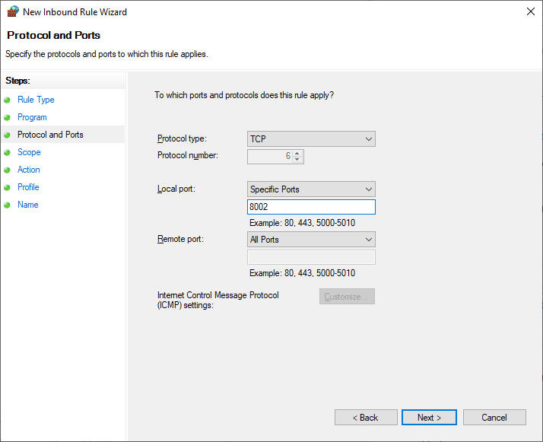

Select **Which Remote IP does this rule belong to** and click **These IP addresses**and click **Add**

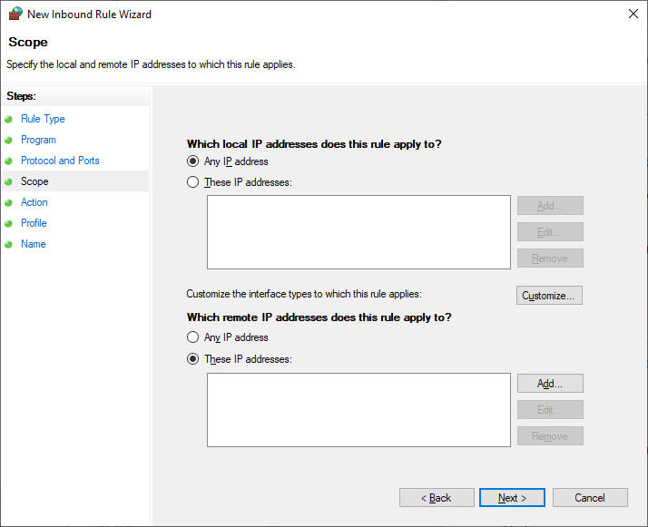

Enter the IP or range of IP's.

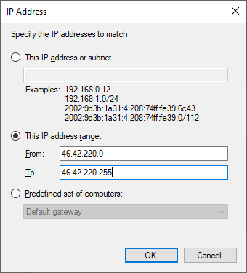

Click **OK**

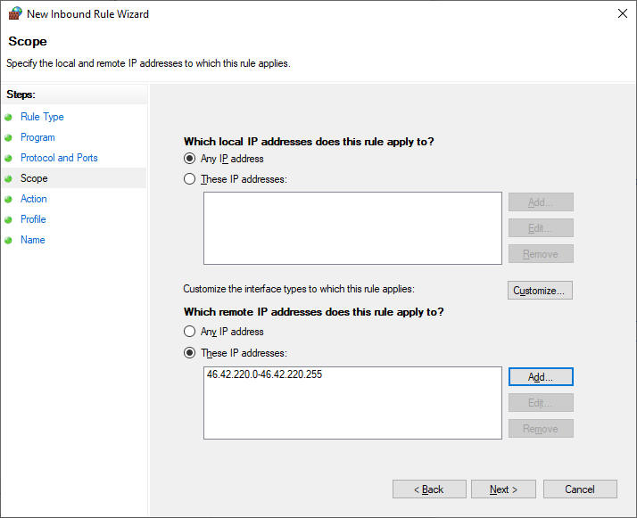

Click Next

Click "**Block this connection**"

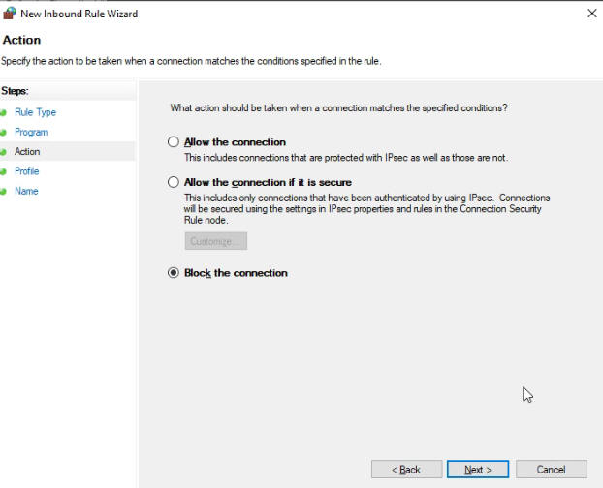

Which firewalls? Do all of them. These are for machines that may travel to public places such as a McDonalds. Your grid should be set for Private. In corporate environments, it would be Domain.

Is safe to just do them all.

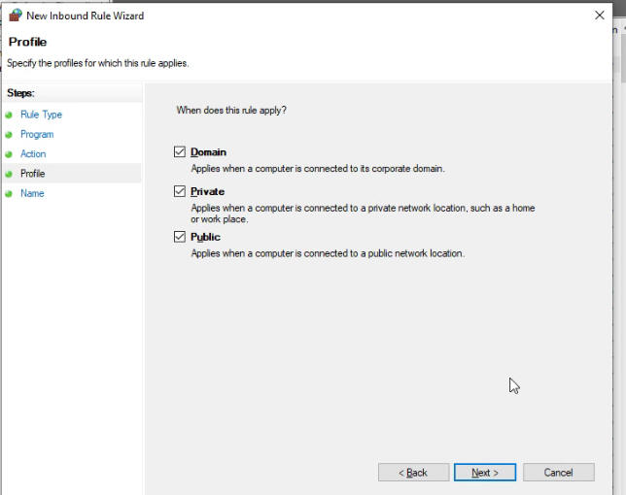

Enter a descriptive name.

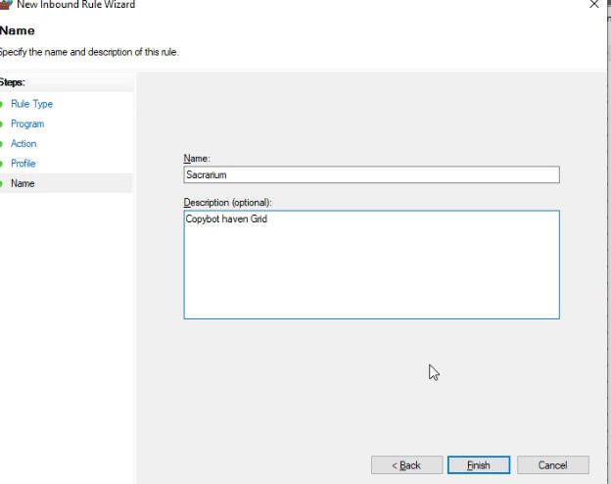

Click **Finish**.

# Flotsam Cache Settings

OpenSimulator has an asset cache that stores the assets retrieved from an asset service. This reduces the load on a asset service and improves OpenSimulator responsiveness.

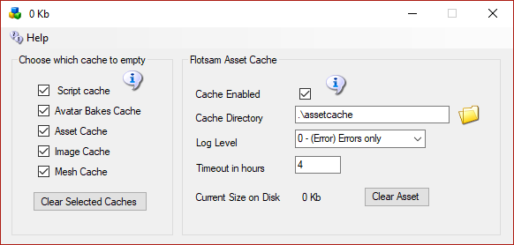

## Flotsam asset cache

The Flotsam asset cache, stores assets on disk and in memory.

At the moment, the amount of memory or filesystem storage used by the cache can only be limited via manual actions (wiping all or part of cached assets from the filesystem), by console commands (e.g. "fcache clear") or by timeout settings (e.g. FileCacheTimeout = 1 to automatically remove cache files not accessed for 1 hours).

## General principles

When OpenSimulator requires an asset (e.g., in response to a viewer request for a notecard), then it first asks the cache for this data. If the data is not found in the cache, then it asks the grid asset service (or a foreign asset service in the case of Hypergrid). If the asset is there, then it is both stored in the cache and returned to the user.

If an asset is uploaded to OpenSimulator (e.g., by the viewer uploading an animation), then the asset is at once both kept in cache (if there is room and the asset is not temporary) and sent to the asset service (if the asset is not temporary).

Therefore, at any point you can wipe any temporary data stored by the asset cache (e.g., on the filesystem), since the next request for that asset will simply query the asset service as the asset will not be found in cache.

# FSAssets Settings

FSAssets is enabled by default. This option will save the assets to the file system as opposed to the default service which stores assets as blobs in the database. This option also provides deduplication abilities. Each asset is hashed when it is received for storage. If the asset already exists, the asset service will link to the existing file rather than store two copies.

**IMPORTANT:** This is a major change in database structure. If you already have a MySQL database running with a lot of assets, this will help speed it up, but it will take more disk space. If you start out with this setting, it will use the least space. **Once you switch to FSAssets, you cannot go back to just MySQL without losing data entered since the switchover!**

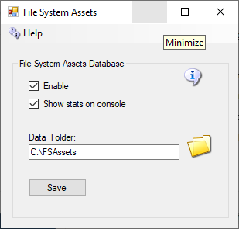

**Data Folder**

This is the folder in which the asset data will be saved. Default = ./fsassets/data

**SpoolDirectory Folder**

The spool directory is a folder used for temporary storage while the asset is hashed and compressed before it gets moved to the BaseDirectory. This must be on the same file system as the base directory. Default = ./fsassets/tmp

## Migration

FSAssets will use the MySQL database to collect the original data. This will not automatically convert all the old assets to the new service. To convert all assets from the default service there is a Robust console command provided:

import <conn> <table> [<start> <count>]

The import command expects a database connection string and the name of the legacy asset table to be passed as parameters. The following example shows how to start the import process for a MySQL database. Change the connection details to match your database schema, username and password, or use the DreamGrid default shown here, and copy and paste this into your Robust console:

import "Data Source=localhost;Port=3306;Database=robust;User ID=robustuser;Password=robustpassword;Old Guids=true;Command Timeout=300;" assets

Depending on the size of your existing assets table, the import process will take some time to complete. The optional parameters start and count allow you to specify the position and number of rows to convert.

A default, blank database will look like this:

R.O.B.U.S.T.# import "Data Source=localhost;Port=3306;Database=robust;User ID=robustuser;Password=robustpassword;Old Guids=true;Command Timeout=300;" assets

Reading data  
0 assets imported so far  
100 assets imported so far  
200 assets imported so far  
Import done, 274 assets imported  
R.O.B.U.S.T.#

# Grid Type

Grid Type lets you choose from either a Grid Server with Robust, or from 3 Region Server choices to connect to another grid.

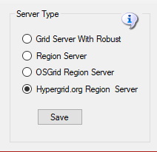

## Grid Server with Robust

**Grid Server with Robust** is a complete DreamGrid, with your own inventory, logins, and name. This is the default. When you start your grid, a Robust Box will open to control all your users’ inventory.

One server must have a running copy of Robust. More PC's can connect to the Robust server to add more regions.

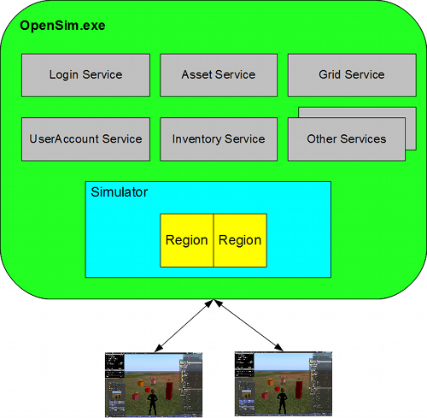

<http://opensimulator.org/wiki/Configuration>

## Region Server

**Region Server** is an add-on to an existing DreamGrid. You can connect additional regions on one or more PC's to an existing Grid Server. You must have access to port 8003 on the Robust server to do this.

A region Server can connect to another Dreamgrid, provided it can reach the Dream Grid’s Port 8003. You connect to the Dreamgrid server by changing the DNS name on the Region Server to the name of the grid. For example, my grid is normally named ‘<www.outworldz.com:9000>’. So I change the DNS to [www.outworldz.com](http://www.outworldz.com), and change the HTTP port to 9000 and the robust port to what the grid runs on (which happens to be 9003).

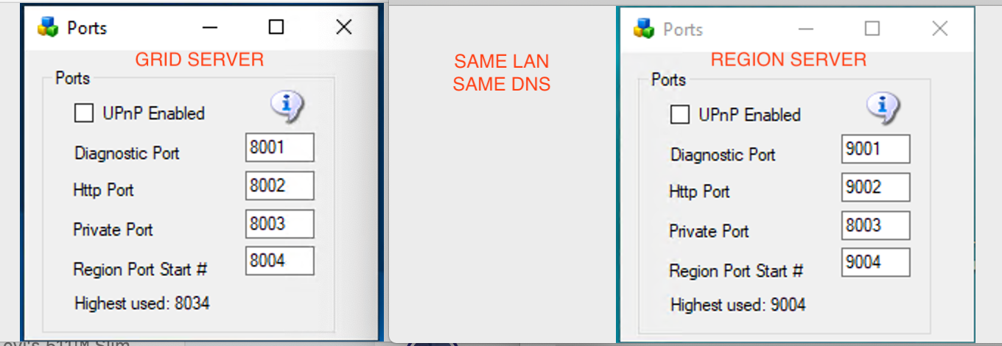

pic courtesy of Michael Bradley

The firewall must also be opened between the two machines. This is not normally an issue on a LAN. But if the region Server(s) are on the Internet, you should not allow access to the port 8003 from everyone. Set up a firewall rule to allow only the Region Servers to access your servers port 8003.

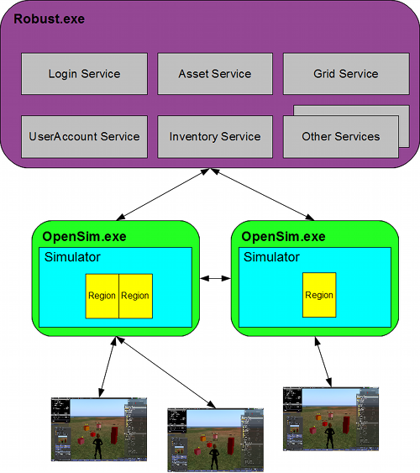

<http://opensimulator.org/wiki/Configuration>

## OSGrid Server

**OsGrid Server** This choice is much like running a Region server. OsGrid Servers connect to OsGrid.org. OsGrid is already configured to accept your connections. There are some simple rules you must follow to connect to OsGrid

You will need to choose an empty spot on OsGrid's map for each region.

Your viewer login must be set to hg.osgrid.org.



<http://opensimulator.org/wiki/Configuration> CC-BY-SA 2.5

## Hypergrid.org Server

**Hypergrid.org Server** This choice is also much like running a Region server. These servers connect to hypergrid.org, commonly called **"Metropolis Grid"**. Metropolis is already configured to accept your connections. There are some simple rules you must follow to connect to Metro in the section below.



<http://opensimulator.org/wiki/Configuration> CC-BY-SA 2.5

## Metropolis Server

Metro has a monthly charge to connect your region(s) to their grid, there is also a one-time one Euro charge to register/verify your avatar/account which you need to do to connect a region and login.  
  
See [https://hypergrid.org/metropolis/wiki/en/index.php?title=SIM](https://hypergrid.org/metropolis/wiki/en/index.php?title=SIM&fbclid=IwAR0EfU2ajm8jxRk6TdZLnIxtINao5_ngDwppnAiwqpCe1y54Fg1MY1nyqLc)  
  
When connecting a self-hosted region, the grid services will be charged a fee of 1.50 euros per month. This contribution is automatically collected monthly from the owner of the respective region.  
  
Any avatar registered in METROPOLIS can move freely within the grid and, if interested, visit most regions freely. Furthermore, he can also collect and use freebies.   
  
Only two functions require verification of the user:  
  
- if a self-hosted region should be connected  
- if the user wants to build on sandboxes or on the DUNE regions.  
  
Since copyright-relevant objects can also be loaded into the grid for the aforementioned functions, we are obliged to verify the respective user for legal reasons.  
  
**How can I verify?**  
  
To verify an avatar, a one-off symbolic Euro (1 Euro) will be paid to the Metropolis grid via PayPal. Upon payment, PayPal transmits an ID number of the payer. This ID tag (and only these) is stored in the METRO database. No RL names or other RL details are requested and / or stored.  
  
Subsequently, the name of the avatar name indicates the user for whom the verification is to be performed. IMPORTANT: After payment has been made via PayPal, you must return to the METRO page via the link on the PayPal confirmation page.  
  
For the verification a PayPal account is required, which can be created for free on paypal.de . The account is available within a few minutes."

<https://hypergrid.org/metropolis/wiki/en/index.php?title=SIM>

# Shoutcast And Icecast Server

Outworldz DreamGrid contains a free Icecast and Shoutcast server. You can use this to broadcast voice and music to any radio, web page, Opensim, Second Life, or your own grid.

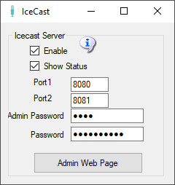

**Enable**: Starts an Icecast Server when Start is clicked.

**Show Status**: Displays in the window the server’s status

**Port1 & Port 2**: Default is 8080 and 8081. Both ports must be Port Forwarded in your router from the Internet so users can hear the music.

**Admin Password**: Enter a strong password for control of your Shoutcast server. This Password protects a web page, so choose a good one.

**Password**: This password is used to stream music to your server. You give it and the stream mount point out to applications and musicians who can stream music using your server.

**Admin Web Page**: Click this button when Icecast is running to get to the control panel web page.

## Troubleshooting:

The latest "default" for ports for NEW installs is 8100 and 8101.

Check in Setup->Icecast which port is set.  Check that Icecast is enabled.  There is an Icecast DOS box that appears when it is running.  You can restart it by clicking the Icon or Menu bar at top of DreamGrid.

Check that you can reach the Icecast server at http://127.0.0.1:8080.   If not, check Icecast error.log and access.log.

This is normal error.log:

[2019-08-20  11:13:33] INFO main/main. C Icecast 2.4.3 server started  
[2019-08-20  11:13:33] INFO yp/yp.c YP update thread started  
[2019-08-20  11:13:33] INFO connection/connection.c No SSL capability on any configured ports

Check the port with http://CanyouSeeme.org to see that it is open.  If not, make sure both ports are port forward for TCP and UDP.

Add an exclusion for both ports to your firewall.  Keep trying this until you get it to answer to http://127.0.0.1:8100. At that point Winamp should connect.

## How to Broadcast Music:

To streaming your own radio, you need a program to play music and send it to your stream.

I use Winamp. You can also use Mixxx, or any third-party streamer. Instructions for both follow.

## WINAMP

You can use many different music or microphone players to stream music to your system. These instructions are for the popular Winamp player.

First, [download](https://www.outworldz.com/Outworldz_installer/Grid/winamp5666_full_en-us_redux.exe) and install Winamp.

Then [download](https://www.outworldz.com/Outworldz_installer/Grid/shoutcast-dsp-2-3-5-windows.exe) and install the Shoutcast DSP

Run Winamp.  You should see a screen like this:

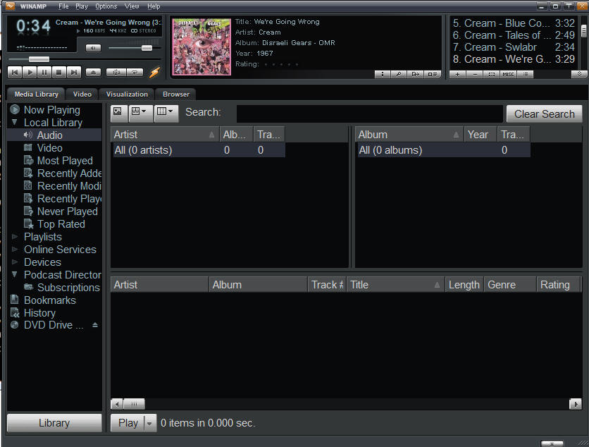

Navigate to the Options -> Preferences screen

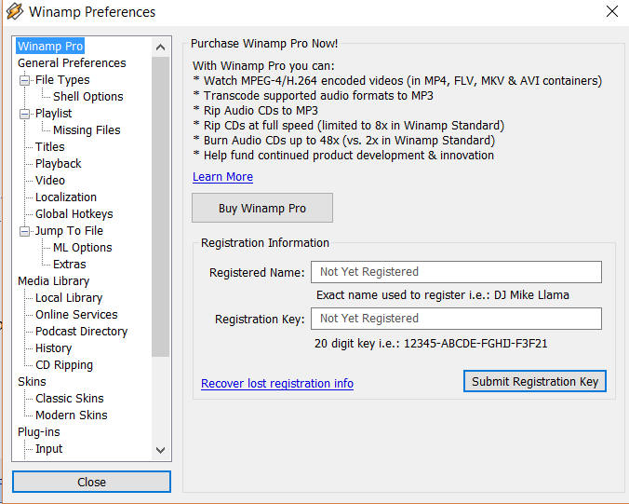

Scroll to the DSP/Effect section on the left side:

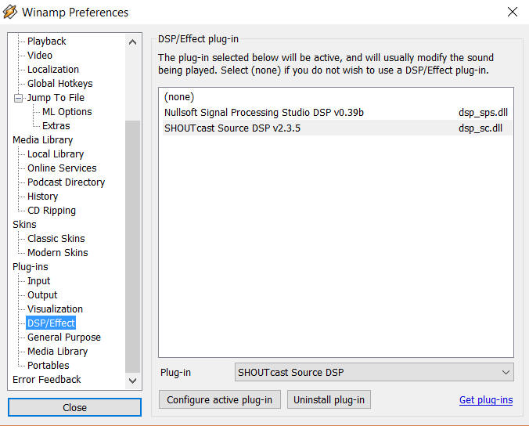

Double click the Shoutcast DSP on the right side to get the DSP setup screen.

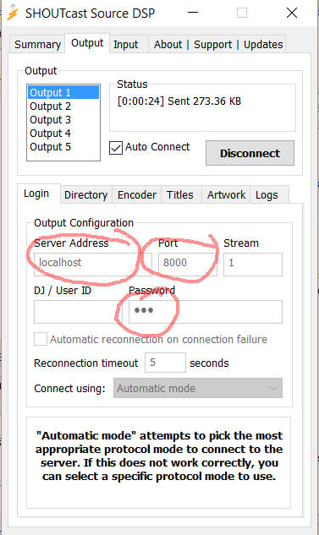

**Server Address**: Enter 'localhost' for the Server Address.  If you wish to run Winamp on a different machine, use the Server LAN address.

**Password:** Choose the same password as you used in the Dream grid’s password field (not the Admin password).

**Port:**Also enter the same port you used in the DreamGrid setup screen.  The default is 8000.   If you want others to hear this stream from outside your network, remember to either forward the port or enable the UPNP setting and restart your server.

You can configure more of the screens, but they are not required.

Click **[Auto Connect]** and make certain you see it connect to your Shoutcast server.

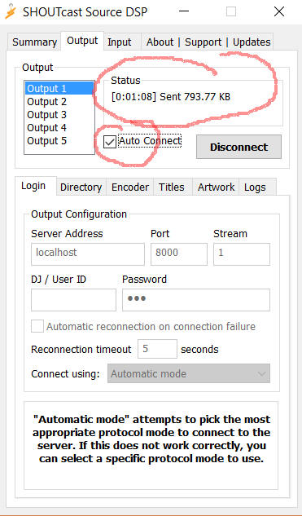

## Shoutcast Control Panel

Click the Shoutcast [Control, View and Listen] Button to view your Shoutcast web page.  

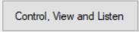  
  
It should open a web page that looks like this when there is no stream playing.  
  
  
  
  
Go find some music in Winamp and press "Play".  
  
The screen should now change to show it is up.

## Setting up the in-world radio

You can use any radio script to set your radio onto the land. A straightforward way is to navigate to the About Land tab and enter the URL into the Sound Tab. For more information see <http://wiki.phoenixviewer.com/land_audio_tab>  
  
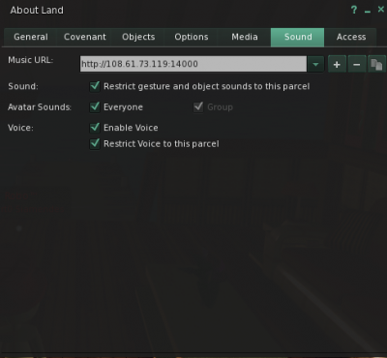  
  
Now enable the media to play in your viewers Sound & Media tab.  
  
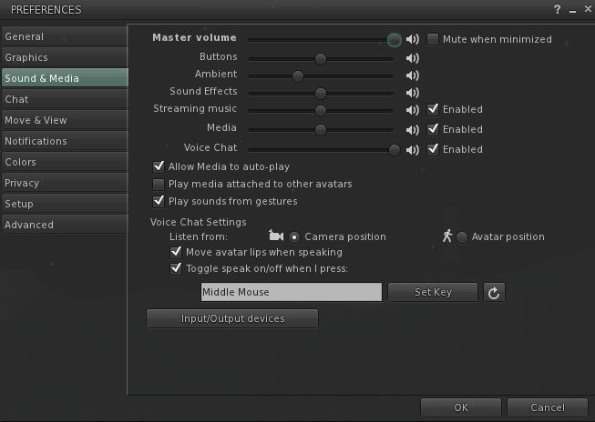  
  
For more details, please see <http://wiki.phoenixviewer.com/land_audio_tab>

## MIXXX

Download and install [Mixxx](https://www.mixxx.org/) from https://www.mixxx.org/. This is what the screen looks like.

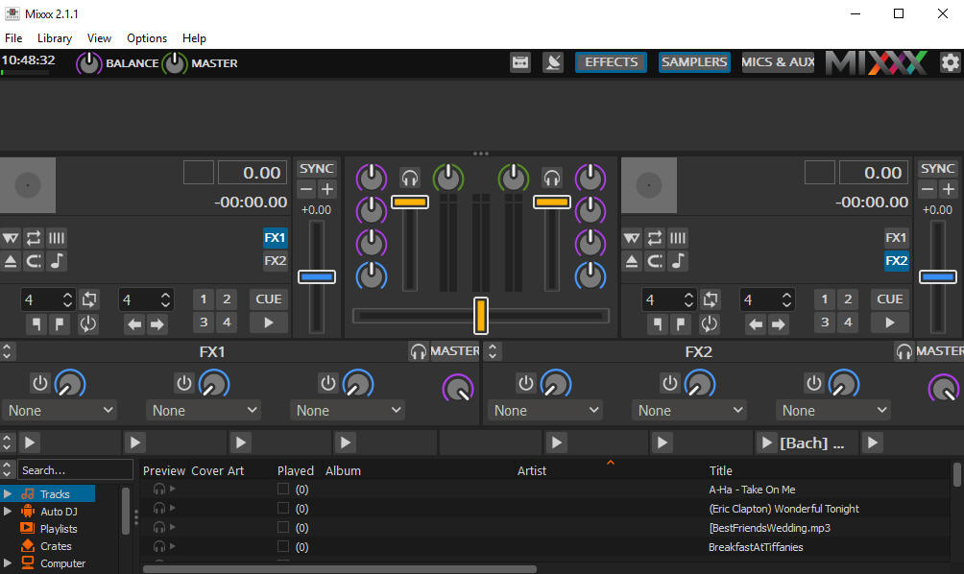

## Special instructions for MP3 files:

To enable MP3 streaming on Windows, you must follow these instructions:

First, download the lame library from http://www.rarewares.org. The download page includes 32-bit and 64-bit versions. Make sure the version you download matches the version of Mixxx that you use, not the version of Windows. If you are on 64-bit Windows but are using 32bit Mixxx, you need the 32bit (“x86”) version of the library. Unpack the downloaded ZIP archive.

Copy libmp3lame.dll to the location you have installed Mixxx, probably C:\Program Files\Mixxx\.

## Running Mixxx

Go to Mixxx's Preferences Screen, then select the "Live Broadcasting" tab on the left. These are the settings I used:

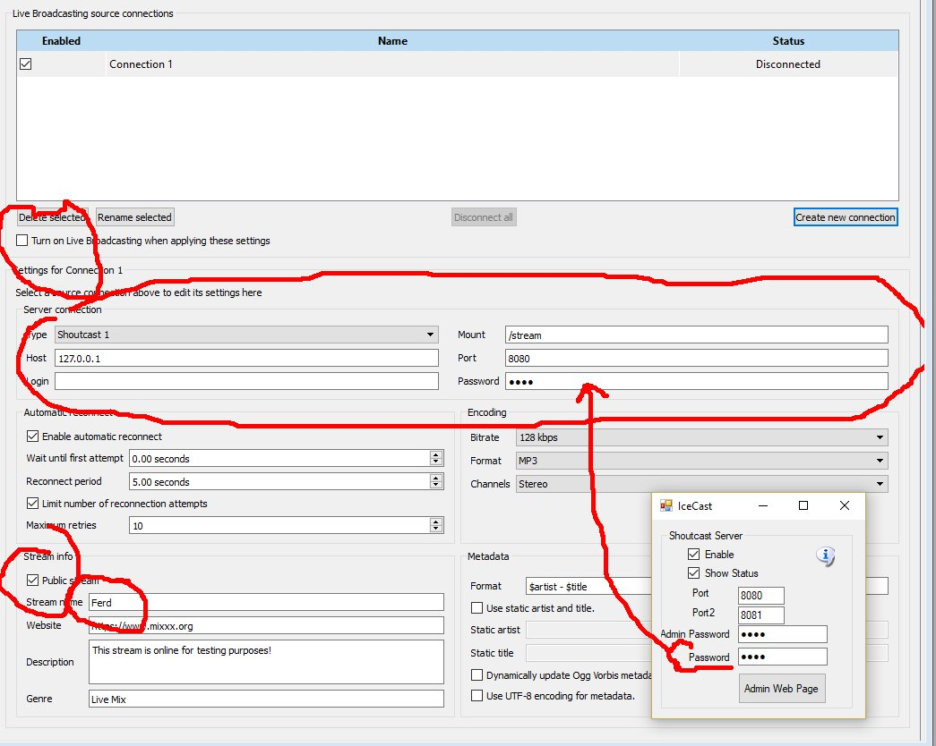

* Check **Turn On Live Broadcasting**
* Set type to **Shoutcast1**
* The standard mount point everyone uses is **/stream**
* Host is **127.0.0.1**
* Port is **8080** from the Dreamworld setup.
* Login is **blank**
* Password is the same password in your Dreamworld setup.
* Check **Public** if you want your stream to be on the Mixxx website. Give it a name.
* Click **Okay** and the screen will gray out and should show no errors.

## Mixx Setup

On the top of the Mixxx main screen is an **Options** menu. Click **Enable Live Broadcasting**. I have it shown in the photo. Load a track and click play. For me, that was hard to find! It is circled in the picture and shows a pause button.

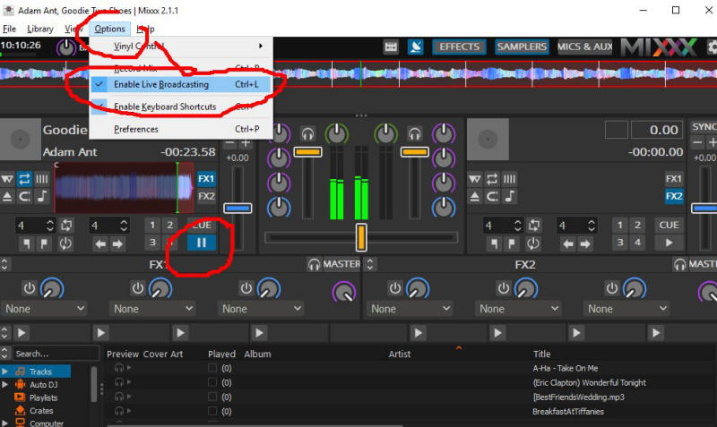

Use a web browser and navigate to http://127.0.0.1:8080/stream and click the play button. You can also click the **Admin Web Page** button. You should hear the music, delayed by maybe 15 seconds. This is normal buffering. Click Stop in Mixxx and the music will play for a bit longer due to the buffering.

The Public URL or Domain Name for your world is entered into your sim instead of 127.0.0.1, so for my simulator, the music URL becomes **http://www.outworldz.com:8080/stream**. This URL must include the 'mount point' of /stream you entered earlier.

Navigate to http://127.0.0.1:8080. You should see the standard web page for Icecast. Yours truly, can log in using your administrator password, see the status, and see the mount point.

## Troubleshooting:

If it cannot connect, make sure Icecast is running in a separate DOS box.

You do not have to run the grid to stream music. It is only used to set up the files and start Icecast. For example, you can run a radio station or use it for Second Life. There is a batch file in /Icecast called 'icecast.bat' that will run the server.

## Port Forwards:

Add port 8080 and 8081 to your routers Port Forward.  You should also check they are not blocked by your firewall or anti-virus. This is my setup:

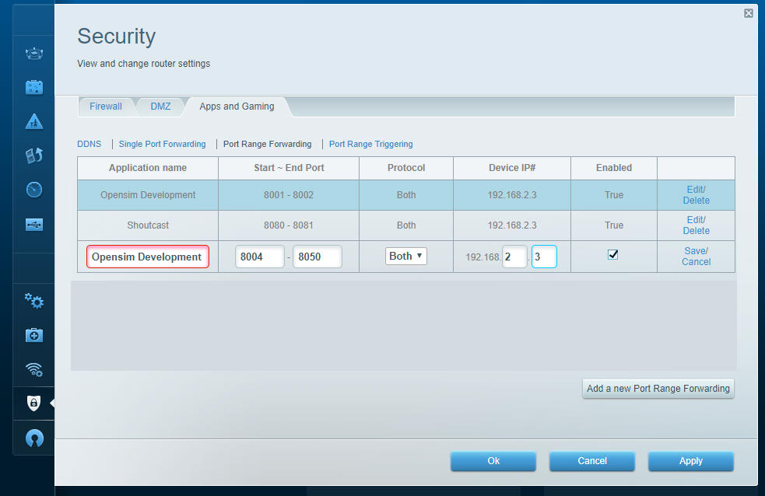

The Shoutcast setting shown above is used when you are running the Icecast/Shoutcast server.

# JOOMLA/JOPENSIM UPDATE

IMPORTANT: this version required changes in DreamGrid, Joomla and in jOpensim. This also the reason why this version will not update as usual with the Joomla updater. Clicking on update in Joomla without following these instructions will result in a broken jOpensim installation. If you also have jOpenSim PayPal in use, you will need to update this component as well.

## How to Update:

First, update your Joomla installation to version 3.9.23. This can be done by logging into the Administrator panel and clicking the notice. Or click on Components->Joomla Update. **Do not update past Version 3.9.23 to V 4!**

In DreamGrid, go to Setup->Settings-> and then to Joomla/jOpensim.

Press the [Update] button to update to the latest jOpensim. This will take you to this screen:  
  


Click the big green “Or Browse for file” and navigate to the Outworldzfiles\jOpensimfiles\ folder. Select “pkg_jopensim.0.3.2.0.zip” and click Ok. This will update you to jOpensim V3.0.2.0.

# Joomla and jOpensim

1. Make sure Apache is enabled. See the Help file for Apache on how to enable it. You must install the C++ Runtimes.
2. Leave the Apache Content Manager set at “Diva” to prevent redirects. When you finish with Joomla, you can enable JOpensim. This redirects all traffic to your web server to Joomla/jOpensim.

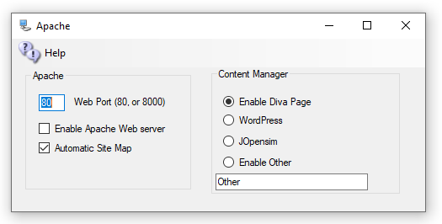



Both the MySQL and Apache icons should be Green.

1. Click Setup->Joomla/JOpensim and click the Install Button.   
   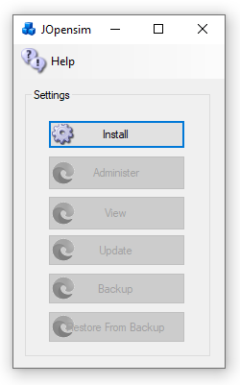

It will install the files:

1. You should see the Joomla Setup Page. Fill in the Site Name, a short Description, and pick a Super User Account name and password. Joomla is exposed to the public Internet, so be sure that you use a long and secure password that you have never used before. Write it down as you will need it often!



1. Press Next
2. Fill in the Host name as **127.0.0.1**
3. Database name as **Joomla**
4. Username should be **robustuser**
5. Password should be **robustpassword**.



1. Press Next   
     
   Verify that there are no errors



1. Press Install  
     
   
2. Click 

## Restore data

1. In your web browser go to <http://127.0.0.1/JOpensim/kickstart.php>, or in Setup->Settings->Joomla/jOpensim, click the [Restore] button.
2. Press <esc> key to close the warning screen.
3. Select the latest backup jOpensimBackupV{X}.jpa in the pulldown.

**CAUTION: There is NO PASSWORD. If your browser adds one, please blank it out or the setup will fail.**  


1. Click Start. It will show it is extracting.   
   
2. Click Run the Installer  
   
3. Press Next at Upper Right  
     
   

Fill in the values:

* Database Host is **127.0.0.1**
* User name is **robustuser**
* Password is **robustpassword**
* Database name is **Joomla**

Leave the table prefix alone, as the name is assigned randomly for security.  
  


1. Click Next at the top right  
     
   
2. Fill in the upper part and leave the ‘Live Site URL’ blank.  
   
3. Fill in the bottom part with your Desired Super User Password. You need to remember this! The login id will be Admin with this password, not the prior one you used!  
     
   
4. Press Next at Upper right
5. Close this window to return to Kickstart. Click the **Clean Up** button to start using your restored site.



Joomla will require some edits to match your preferences.   
  
Click the Administer button to log in as “Admin” with your Super User password.

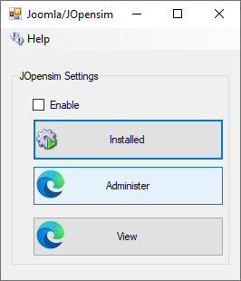



## Backups:

You can back up Joomla and JOpensim with Akeeba backup, which I built into your distribution.

Click Components->Akeeba Backup and select “Full Backup”.



To restore a backup, Click [Restore] in the Dreamrgid jOpensim menu to extract kickstart-core-7.0.2.zip and load the URL as shown in section “Restore the Data”, above.

## Update:

Press the Update button to update to the latest jOpenSim. This will take you to this screen:  
  


Click “Or Browse for file” and navigate to the Outworldzfiles\jOpensim_Files\ and select pkg_jopensim.0.3.2.0.zip. This will update you to Version 0.3.2.0.

## jOpensim Money

***This is currently NOT available***

1. Enable jOpenSimMoney in your jOpenSim configuration, in "Settings".
2. You need to define one OpenSim account as banker in "user". To do so, mark the checkbox beside the desired user and click on "Edit user". In "Login Level" you now should be able to select "Banker" and select Save. This account will be disabled for regular login and only responsible for handling transactions with the grid (e.g. upload fees, group creation, etc...) and in demo mode it will reset all user balances (give or take the difference to the reset value) at login and when crossing any region border.
3. Now go to "Money System" in admin. It now shows a small form, where you can select the banker and set some other values important for your money system. For the first time, even if your banker is already selected, IT IS IMPORTANT to save this banker account, otherwise the module will disable.
4. The money module have 3 possible stages:

* Demo-Mode: If no or the demo license key is provided, in this mode everything works fine, but the user balance will be reset at every login and when crossing a region border to a predefined value (by default 5000).
* Default Mode: this should be the regular mode. No popups, no reset, everything (hopefully) working fine
* Disabled: if an invalid or expired license key was provided, the module will disable currency completely (e.g. due to a typo in the ini or just missed to extend license). Like this, no demo mode will screw up an already existing transaction history.

After demo mode, you might want to clean 2 tables manually in your Joomla database to reset all balances and transactions for the "real" mode: #_opensim_moneybalances #_opensim_moneytransactions You can do this e.g. by executing a query like: "TRUNCATE TABLE #_opensim_moneybalances;" and "TRUNCATE TABLE #_opensim_moneytransactions;" (of course replace #_ with the correct prefix of your joomla database)

## References:

Jopensim Wiki <http://wiki.jopensim.com/>

JOpensim Bugs <https://mantis.jopensim.com/>

# Landscaping

The Landscape modules lets you add terrains and plants to any region.

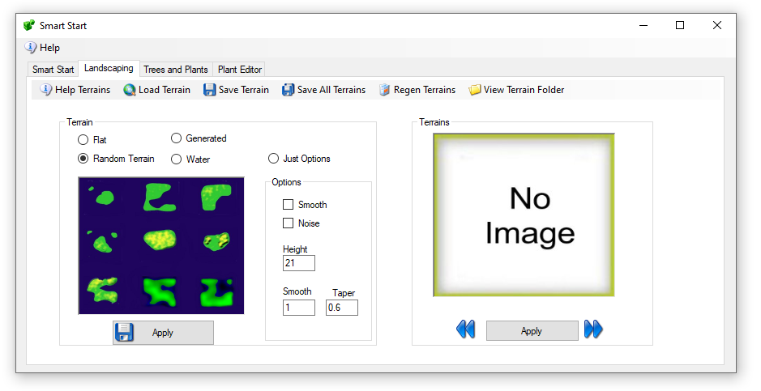

The left side has 4 types of auto or premade terrains. The right side lets you browse and apply to any region any saved Terrain.

## Menu:

* Load Terrain – You can choose any of the many pre-defined terrain files or browse to another location. The system supports PNG, RAW, R32, and TER (Terragen) formats
* Save Terrain – The system will save the selected region file in the above 4 formats along with a JPG image.
* Save All Terrains – The system will save the selected region file in the above 4 formats along with a JPG image in all running regions as well as all Idled Smart Start Regions.
* View Terrain Folder - open file explorer to the Opensim\bin\Terrain\ folder

## Terrain Section

The left side has a set of functions for what effect to apply to the land.

Options: These modify the chosen effect"

**Just Options** – ignore the terrain land, just apply the options.

**Smooth**: smooths the land. The smoothing operation is somewhat different than the others, as it does not deal with elevation values, but rather with strength values (in the range of 0.01 to 0.99). The algorithm is simplistic in averaging the values around a point, and is implemented as follows:

The "strength" parameter specifies how much of the result is from the original value ("strength" * map[x,y]).

The "taper" parameter specifies how much of the remainder is from the first ring surrounding the point (1.0 - "strength") * "taper". There are 8 elements in the first ring.

The remaining contribution is made from the second ring surrounding the point. There are 16 elements in the second ring. e.g. *terrain modify smooth 0.5 -taper=0.6*

* the original element will contribute 0.5 * map[x0,y0]
* each element 1m from the point will contribute ((1-0.5)*0.6)/8 * map[x1,y1]
* each element 2m from the point will contribute ((1-0.5)*0.4)/16 * map[x2,y2]

**Noise -** The smooth value represents a delta amount (at centre of range)

**Taper** - represents a delta amount (at edges of range)

## Land Types

**Flat** – Land is always flat. The Option “Noise” will make the land bumpy. This makes nice underwater if the Option for Height is set below water level of 20 meters.

**Random Terrain -** uses one of the saved terrains. Options can apply

Water – The same as flat land with Height set to 0

Generated – a series of steps are applied:

* Options are set for Min Level between 22 and 40 meters
* Taper between 0 and 135 meters high
* Upon setting Apply the system will have:
* One in 6 chance fill of land at Height meters with the random taper
* One in 6 chance for low lying land at 12 meters with lots of noise
* One in 6 chance for center to be squared from 20 to 40 meters with the random taper
* One in 6 chance for water level with a variable raised bump with noise
* One in 6 chance for water level with a variable raised bump

# Load IAR

An IAR is an Inventory Archive - all inventory, or an object, image, mesh, or a folder. You click the Menu to load a Free IAR from the Outworldz, and a list of free IARs appears:

The name, file size, and the credits/license for the IAR appears when you hover your mouse over the photo.

You can search for an IAR.

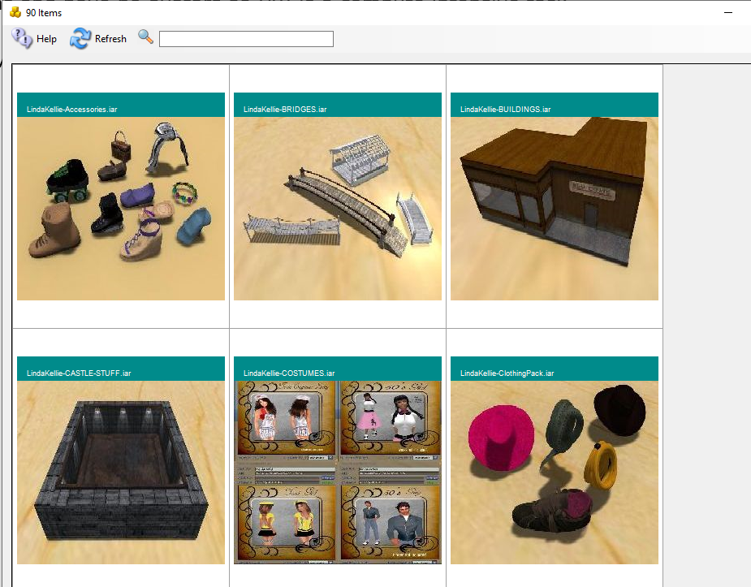

After clicking a desired Item, The system will show an avatar First and Last Name box.

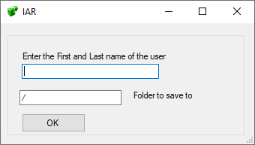

The default is "/", but you can load your IAR to the Inventory with "/Objects", or to a specific folder, such as /Textures.

The inventory will load in one of the Dos boxes.

You may need to re-login in order to see your new inventory item.

## Links:

<http://opensimulator.org/wiki/Inventory_Archives>

# Load OAR

An OAR is an Object Archive - a complete region with content, terrain, and scripts. You click the Menu to load a Free OAR from the Outworldz, and a list of free OARs appears:



The name, file size, and the credits/license for the OAR appears when you hover your mouse over the photo.

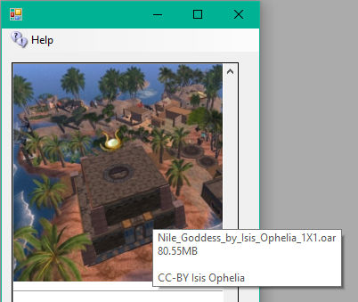

Clicking any photo brings up a region chooser box:

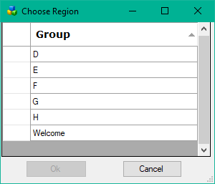

Select the Region you wish to load and click OK. you can also double-click the region.

Click a Blue section to choose which section of this Var Region to put this OAR in.

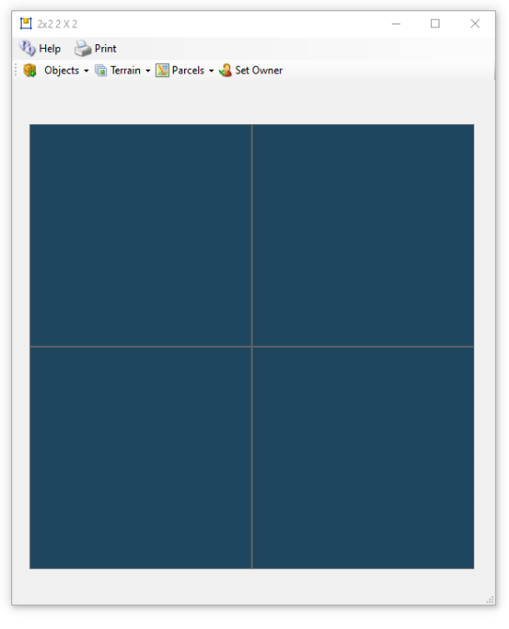

This is a 1X1 region

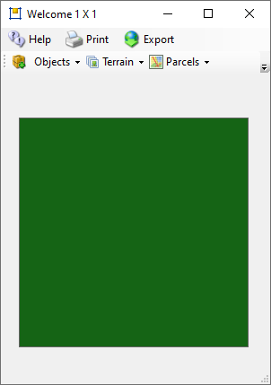

## Options:

### -merge



Merge the contents of the reading OAR with the existing contents in the region, or clear the entire region and load it.

### --displacement



Specify a displacement that is added to all data as it is added to the destination region. The displacement MUST be specified as "<x,y,z>". So, for instance, to load an OAR from a 256x256 region into the middle of a larger 512x512 region, the parameter would be --displacement "<128,128,0>". Note that you can specify a "Z" displacement which will move the objects up or down. Thus --displacement "<0,0,1000>" will put all the OAR's objects up high for a sky box.

The displacement is also applied to the terrain if it is included. The 'z' component is added to the terrain's heights.

### --force-terrain



Force terrain loading on --merge. Normally, --merge does not overwrite the existing region's terrain.

### --force-parcels



Force parcel loading on --merge. Normally, --merge does not overwrite the existing region's parcel data.

### --default-user "<first-name> <last-name>"

Instead of setting object ownership to the estate owner, assign it to the named user. This only applies to objects that have UUIDs that do not match any user account in the receiving grid's installation. There is currently no option that will force a change of owner for all loaded objects no matter whether they match a user in the receiving installation. One workaround to achieve this would be to save the OAR with the --publish "save oar" option to strip owner information and then reload it.

## Links:

<http://opensimulator.org/wiki/Load_Oar_0.9.0%2B>

# Logging

There are multiple levels of logging in Opensim:

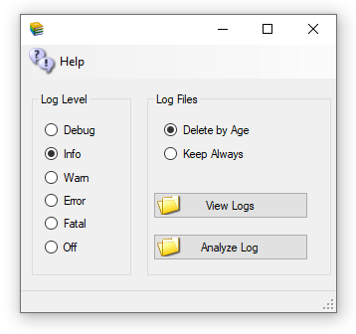

"DEBUG" - Developer level notices are sent to the log, plus the levels below.

"INFO" - Useful information, plus the levels below.

"WARN" - Warnings are logged, plus the levels below.

"ERROR" - Errors are logged, plus the levels below.

"FATAL" - Only Fatal errors are logged.

"OFF" - nothing is sent to the log files.

"Logs" are the Robust.Log located in Opensim\bin, and the Opensim logs located in Opensim\Bin\Regions in each DOS Box folder.

The Log File Age settings apply to most of the logs, including Apache. The Age is set in the AutoBackup settings.

Loopback

Since you are reading this, it is probably because you already know loopback is not working and clicked the Help menu to get here. You can skip down below and go right to "How To Test for Loopback ".

Loopback from your router is necessary in Opensimulator if you are going to be running on the Hypergrid. The usual symptom of a broken loopback is being unable to log in to the server after switching to a Public IP or a Dynamic DNS name. If your router does not support loopback, which is common, you can install a simple fix so it can run a viewer. The loopback adapter lets a viewer on the server reach itself, as the loopback via the router is not functioning.

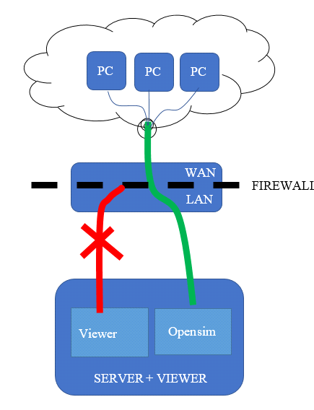

Without working Loopback you cannot get to your own PC using the address of outside of the router.

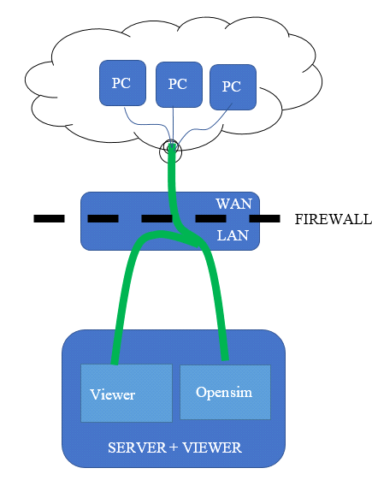

How to test for loopback

You can manually test for loopback by starting Opensimulator, then use a web browser to navigate to <http://canyouseeme.org>. Enter port 8002 and click Check Port. This must work. if not, fix the port forwarding issues and come back and try this test again. You may need to Open Ports in the firewall or disable it on the PC temporarily.

Do not install a loopback adapter until the above test passes! There is one more test to do to see if you really need to add an adapter.

Your ports are known to be working now, so go get the Public IP of your system from <http://canyouseeme.org>. Use a web browser to navigate to <http://(Public> IP):8002. Use your Public IP where it says (Public IP).

You should get a login page. **If you get this page, loopback is working.** **You do not need to install an adapter** If you do not get this page, loopback is not working in your router.

Installing the Loopback Adapter

1. Click Start, then type cmd in the search box.

2. When cmd.exe appears, right-click it and choose Run as administrator.

3. In the command prompt, type hdwwiz.exe and press Enter.

251658240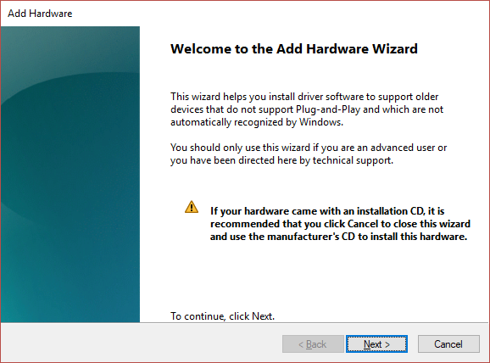

4. Click Next.

5. Select **Install the hardware that I manually select from a list (Advanced),** then click Next.

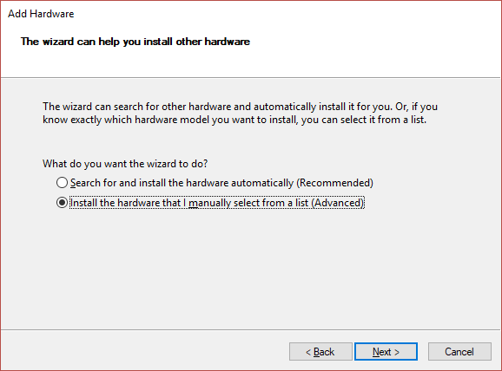

6. Select Network adapters then click Next.

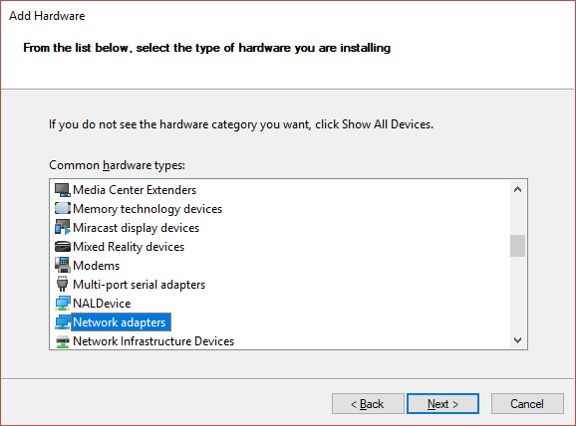

7. Select **Microsoft** as the manufacturer, select **Microsoft KM-TEST Loopback Adapter** as the adapter for Windows 10, then click Next.

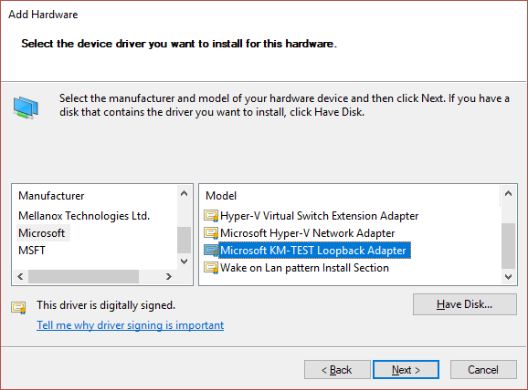

8. Select Next to confirm the installation.

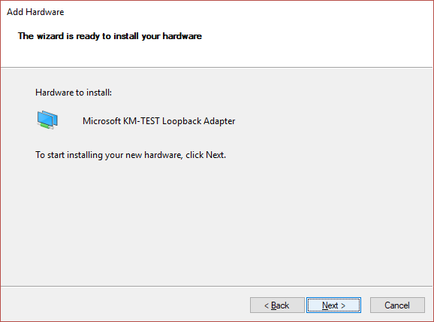

9. Select Finish to complete the installation.

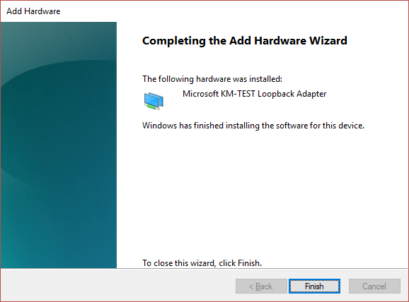

10. Go to your Network Adapters in Control panel and rename the Microsoft Loopback Adapter to just "Loopback".

11. Exit the DreamGrid entirely if it was running, and then start it again. A black DOS box will appear as DreamGrid automatically configures your Loopback adapter.

# LSL Scripting

There are several extra features in DreamGrid to help Opensim LSL work better.

The Library has been extended in DreamGrid to hold 261 example LSL Scripts. These are located in plain text in Opensim\bin\assets\ScriptAsset as well as in the Viewers Library at the bottom of your inventory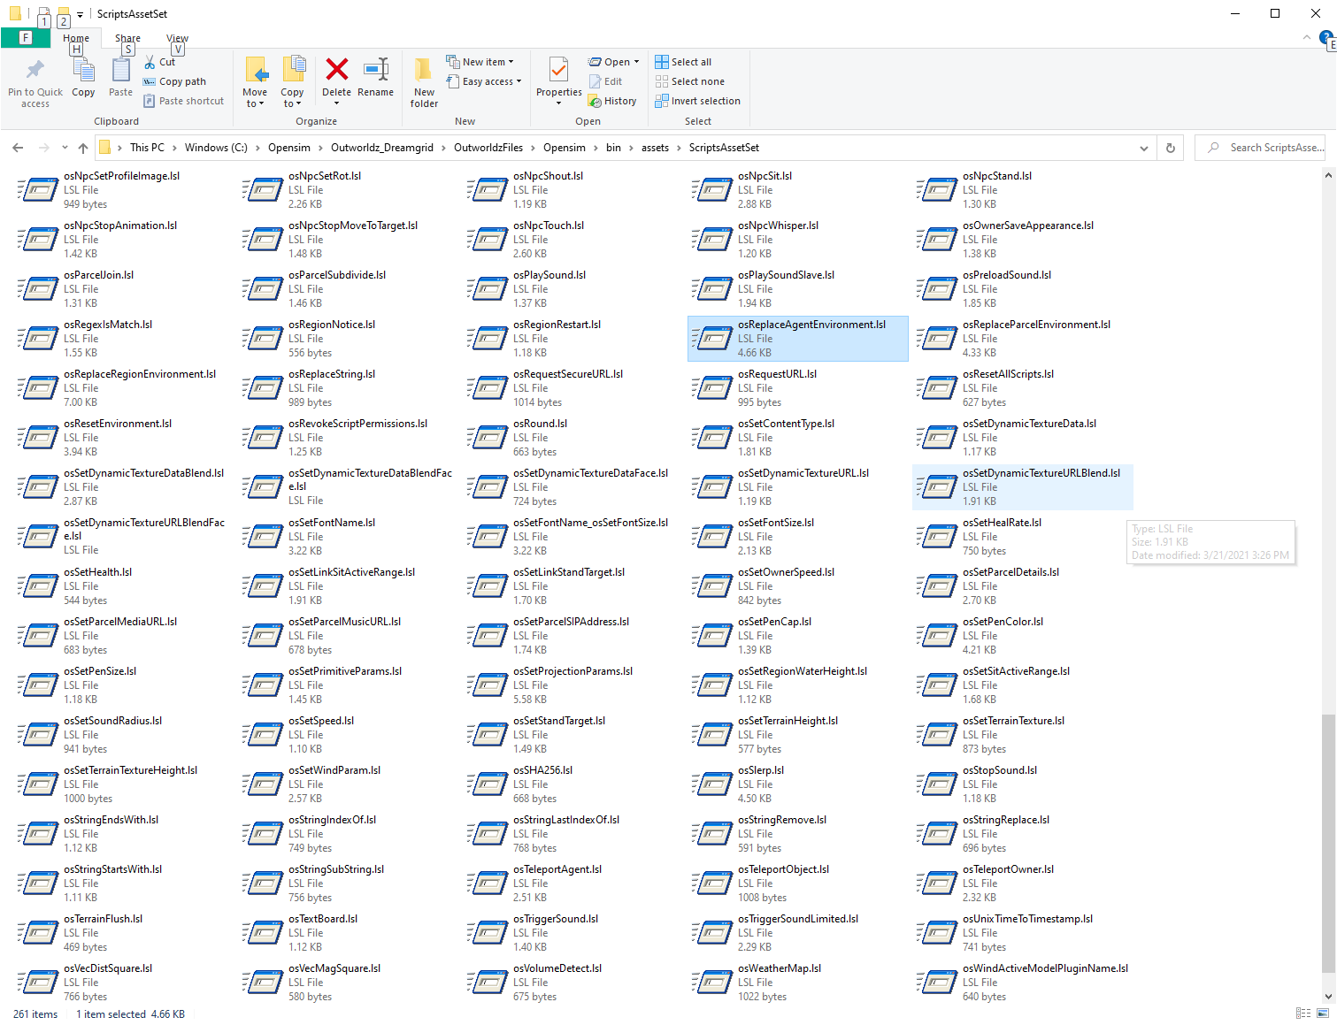

**EasyDatabase** is a way to store name=Value parameters from any script, region, or grid to any other script. See the manual for EasyDatabase.rtf

**Online Regions** can be fetched from <http://YourGrid::8002/Teleports.htm>. This is used by the Region signs you will find in Content->Load Local IARs.

**Item Giver with Notice Script** uses LSL to save the current date, a Name, and a Region to a CSV file. This makes it easy to see what and who got what item by touching a LSL giver script.

You need the password from the file Outworldzfiles\Opensim\bin\ AddinExample.ini.

To test this, fill in some sample data in <http://YourGrid::8004/diva/AddinExample.htm> This is data associated with the very first region. You must use the port for the region you are in to write, and it must be a POST action.



After clicking submit, you should see a confirmation the data was stored.

The data will be in Outworldzfiles\Opensim\bin\Name.csv

Sample Script:

//  
// Give with notice via HTTP  
//  
// Fill in your server and port, if necessary, port 80 is a default. It will connect to this with the parameter: ?name=(Prim Name)

string SERVER = "http://outworldz.com";

// * This function cases the script to sleep for 3.0 seconds.  
// * If inventory is missing from the prim's inventory then an error is shouted on DEBUG_CHANNEL.  
// * Avatar must be, or have recently been, within the same Region as sending object.  
// * Does not create a folder when avatar is a prim UUID.  
// o The prim must be in the same region.

//Examples  
// When a user clicks this object, this script will give a folder containing everything in the objects inventory  
// This can serve as a unpacker script for boxed objects

default {

http_request(key id, string method, string body) {  
 llOwnerSay("Someone just got " + llGetObjectName());  
 }

touch_start(integer total_number) {

llHTTPRequest(SERVER + "?Name=" + llGetObjectName(),[], "");

list inventory;  
 string name;  
 integer num = llGetInventoryNumber(INVENTORY_ALL);  
 integer i;

for (i = 0; i < num; ++i) {  
 name = llGetInventoryName(INVENTORY_ALL, i);  
 if(llGetInventoryPermMask(name, MASK_NEXT) & PERM_COPY)  
 inventory += name;  
 else  
 llSay(0, "Don't have permissions to give you \""+name+"\".");  
 }

//we don't want to give them this script  
 i = llListFindList(inventory, [llGetScriptName()]);  
 inventory = llDeleteSubList(inventory, i, i);

if (llGetListLength(inventory) < 1) {  
 llSay(0, "No items to offer.");

} else {  
 // give folder to agent, use name of object as name of folder we are giving  
 llGiveInventoryList(llDetectedKey(0), llGetObjectName(), inventory);  
 llHTTPRequest(SERVER,[],llGetObjectName());  
 }  
 }  
}

# Maps

Opensim has many different maps settings. DreamGrid has multiple easy-to-use combinations. Opensimulator has several Map tile makers which vary in quality, and speed. It can take an exceedingly long time to boot when using the Better and Best maps. These maps which use the Warp3D engine must load all prims, mesh, and textures, so it takes a long time to generate new maps. Also, any bad textures may cause harmless errors from corrupted assets to appear on your console.

I recommend you run all maps at Best setting once, then set Maps to None. You can remake maps when enough changes have been made.

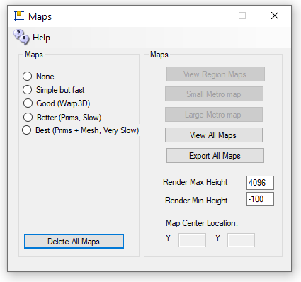

* **None**: No maps will be made. This is a good setting as the regions will boot very quickly. Any existing maps are not deleted.
* **Simple but Fast**: MapImageModule is used with just Land showing
* **Good**: Uses Warp3D module with just Land showing
* **Better**: Uses Warp3D module with Land, Prims, and land Textures showing

**Best**: Uses Warp3D module with Land, Prims, Mesh, Sculpts, and all Textures including prims showing.

**Delete All Maps:** If you delete a region the map will remain. Click this to clear out all maps. You will need to regenerate all maps again by choosing a setting and restarting all regions.

**View Map Web page:** Enabled if your system is running. Opens a web browser to <http://localhost:8002/wifi/map.htm>.

Small **Metro Map and Large Metro Maps:**  Available only if your Apache/PHP is enabled in Settings Web Pages. These maps are generated by PHP and Apache web server.

View **All Maps displays all maps. You** can save or print them. Clicking a map causes it to exit.

Render Max Height can be changed to not show skyboxes.

Render **Min Height can be changed to not** show water or ground structure.

## Manual regeneration

Normally you would generate map tiles at startup. You can also manually force map tile regeneration with the console command 'generate map<enter>'.

A) Go to Setup Settings->Maps and erase them all with "Delete All Maps"

B) Now choose "Best (prims + Mesh Very Slow)"

C) Close this window which saves the new Global setting.

D) Press Start.

E) Once all the regions have booted to the DOS boxes, set map back to "None".  They can still be making maps. They just need to all be starting up and then you can change the Global Settings.

The next time you boot, the regions will load very quickly as the maps will not be remade. Maps only need to be cleared when you delete a region or move them around.

Each region has an override setting.   If set, the override will choose a different setting for maps.

**Example: I leave the global maps off** all the time.   But I may be working heavily on a region and changing it around, and want that to appear after every reboot.  I go to the Regions List and click the Region and set the override to the desired setting, and reboot the region.

# Migration From Dreamworld To Dreamgrid

Migrating from a Standalone Dreamworld to a Gridded Dreamgrid requires you to take special steps.

Start your original Dreamworld. Dump the database by clicking the Content-> Backup Database menu. This makes a backup in the AutoBackup folder in the Standalone Dreamworld.

Created a new DreamGrid, but before you start, set the robust name to opensim and the robust userid to opensimuser and the robust password to opensimpassword. These are the same as in the lower section for the Regions database. Also fill in the various Setting menus for the name and ports to match the original Standalone Dreamworld.

Then click [Start]. This boots Mysql on the new grid. It will start Robust and a new Welcome region (even if it has the same name, it has a random UUID so will be different). Then shut the grid down gracefully by clicking [Stop]. This left the DreamGrid menu enabled and MySQL running.

Navigate to the DreamGrid’s Content->Restore Database menu and browse to the original Dreamworld's AutoBackup folder. Click the .sql file you just made. This will load the OpenSim.sql file into the new grid.

# Region Files

You will need to move your region.ini file. You cannot just copy them over in a file explorer unless you make a special pattern of folders.

Open the Region Panel with Ctr-R, or go to Setting->Region. Delete the existing Welcome region.  
  
Now click Import and browse to the Opensim\bin\regionb folder in the OLD dreamworld and import them one at a time.

There will be anywhere from one to many Region.INI files in your old system. There is no need to load from OAR files.

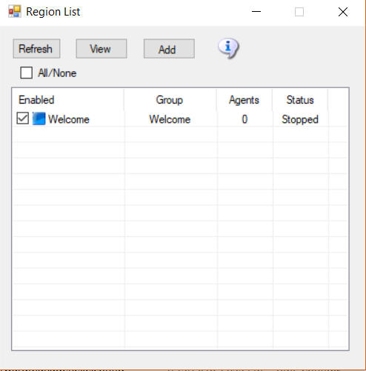

Use the windows explorer and navigate to the original Dreamworld location on your disk.    Look in Outworldsfiles\Opensim\bin\Regions.   If you are running 0.9.0, look in Outworldsfiles\Opensim-0.9\bin\Regions.   Left click each region, one at a time, and drag and drop it onto the Regions panel.

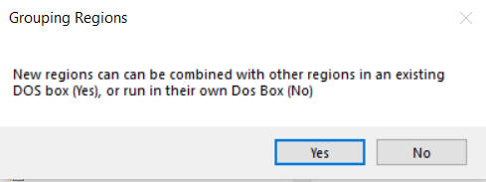

Yes: If you answer Yes, a Chooser dialog will appear. You must chose which region you want to combine your new region with. This places both regions into a single DOS box.

No: If you answer No, you will get a different DOS box when this region starts.

You should limit the number of DOS boxes by combining your regions into logical groups.   A typical system will run 4 to 8 such groups.  You can run more, but you will pay a penalty in RAM use for each box.

Starting Up

Now click [Start] to boot the new grid. You can log in with the Standalone grids user names at this point. Your inventory should be there. The regions will appear.

# Modules

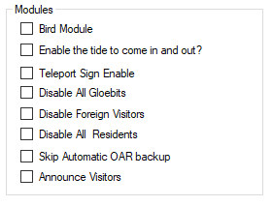

**Bird module** makes flocks of birds possible. See the help manual on Birds. This must be enabled for birds to appear in a region.

**Enable Tides** makes the water level rise and fall in this region. See the help manual on Tides. This must be enabled for tide to appear in a region.

**Teleport Sign Enable** lets you use a standardized Outworldz Teleport Sign to direct visitors in your world. This sign is located in the Content-Inventory IAR Load and Save ->Local IAR menu. There are multiple variations of the sign.

* **Outworldz Teleport System V2.5.iar** is a standardized sign for all uses.
* **Outworldz Teleport System V3.9.iar** is for testing of the Smart Start system and is subject to change.

**Disable all Gloebits** should stop the Gloebits system on this region.

**Disable Foreign Visitors** will prevent hypergrid visitors from entering your region.

**Disable Residents** will prevent all resident from entering your region. Only Estate managers or owners can get in.

**Skip Automatic OAR backup** will prevent the automatic OAR system from backing up this region.

**Announce visitors** will chat any arrivals or departures.

# Moving a DreamGrid

There are no dependencies outside of the DreamGrid folder to copy to a new location.

## Method 1

Stop the original grid and go to Setup->Setting->Caches. Select and clear all the caches. These do not need to be copied and are huge. Opensim will recreate them as needed. The states of scripts will be maintained as the .STATE files are not deleted.

Now copy the entire folder from one machine to the other or from one folder to another.

## Method 2

Another method is to unzip a new copy of DreamGrid on the destination machine. Then copy the file Outworldzfiles\Settings.ini, Outworldzfiles\mysql\data, Outworldzfiles\opensim\bin\fsassets and Outworldzfiles\opensim\bin\regions to the second machine or folder.

If you are running the Apache web server (for jOpensim Or Maps), install the service packs in Setting->Apache, which is also in the folder MSFT_Runtimes.    
  
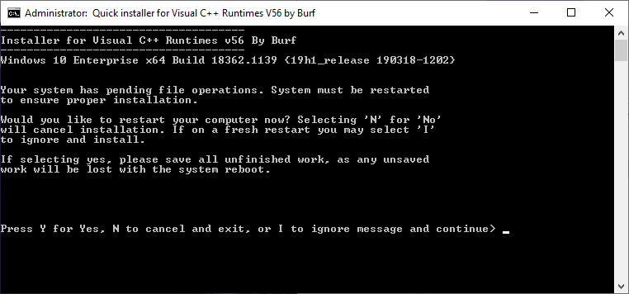

It may ask to reboot. There is no need to reboot. If it asks, type 'i' to ignore, then 'y' to install.

**Router:** You will need to port forward to the new IP if you are on the hypergrid.    
  
**Anti Virus:** If setting up a new computer, you will want to check that any 3rd party anti-virus is not blocking ports. Also add an exclusion to the Opensim\bin folder to the Real-time component of any virus scanner as this area gets heavy use of Script DLLS, and it will cause issues with scripts starting up or being created.   Opensim does not create viruses, and all my code is digitally encrypted and signed by Microsoft Authenticode and will not run if even a single bit changes.

## Method 3

All these ways to copy the files depends upon copying up to a million or more files. In particular, Msql’s ibdata file and the Outworldzfiles\opensim\bin\fsassets folder are extremely large.

## Running DreamGrid On A Server

One of the difficulties in moving to a server such as Contabo.com is moving the files to it.

The big problem is mysql\data\ibdata - which is literally your grid and must be moved. There are many ways to do this: Google drive, dropbox, ftp, but most of those require $$ or are slow. One way is to use Windows SMB file sharing.

The remote server can appear as a local disk, such as X: or Z: with SMB file shares so you can copy and paste files. This makes it trivially easy to make backups and move OARs and backups off Contabo and store them at your home.

## Log Into Your Server

Log in with remote desktop or VNC  as an Administrator.   You need a strong password for your account!   Don't skimp on this step, as your server is exposed to the internet in an intimate way, and it will be probed constantly for weaknesses.  
  
Now choose a folder.  The safest way to share is by making a shared folder, such as your AUTOBACKUP folder.  If someone guesses your password, then all they get are backups. And you can share the entire drive, too.  
  
Right click a folder or C: and select Properties.



Click Advanced Sharing:

  
  
Click Add and give it a name, such as "C", and check "Share this folder"  
  
Click Permissions:  
  
  
  
  
Remove the "Everyone" group and  click Add and type in your login name.  
  
  
Press OK  
  
  
  
Check "Full control" so all three permissions are lit up.  
  
Click OK

## Firewall Rules

You need to enable some ports in Windows Server.   Go to Control panel or search for Advanced Firewall.  
  
  
  
In the firewall screen, click Inbound Rules  
  
  


On the right side, click New Rule  
  
  
  
Give it a name such as "File Sharing TCP"  
  


In Protocols and Ports  Select TCP and add the following ports:

134-139, 445, 389, 88  
  
  
  
**Repeat the above steps for a name such as "File Sharing UDP"**  
Repeat the step "Protocols and Ports" Select **UDP**and add the following ports:  
  
134-139, 445, 389, 88  
  
Click Apply

## Sharing Files To And From Your Server

To connect, you can use the IP, DNS name, or Outworldz.net name.  This is the same name you connect to Contabo  in VNC or Remote Desktop,

Go to File Explorer in Windows at your Home PC. You can get there by pressing the Windows Logo key and the 'e' key at the same time.

Type two back slashes \\ in the address bar and then the  name of your server:

You should get a password prompt:



Enter your password and you should see the share name that you set up.



You can use this name and path as if it is local to your PC and drag and drop files to it. Or Copy and Paste.

You can also Map a drive letter to it.

Right click the folder and select "Map Network Drive"



 Choose a drive letter and click Apply

Now you can simply go to the drive letter and access your server.**Backups:**

Now that your server is set up for file access, you can use programs such as  robocopy (free, built into windows), and paid backup programs such as SyncBack to move or copy your grid to your home PC on a regular basis.

Example: I created map drive as X: to a folder on the server and added a batch file named Backup.bat.

I then ran this from the server as X:/backup.bat and it copied my Servers X:\tmp folder to my home PC C:\tmp folder.

You can now use robocopy to backup your entire grid, or the Backup folder with one simple command "X:/Backup" by changing the folder names in the batch file.

PS X:\> .\Backup.bat  
  
X:\>robocopy X:\tmp c:\tmp /e  
  
-------------------------------------------------------------------------------  
ROBOCOPY :: Robust File Copy for Windows  
-------------------------------------------------------------------------------  
  
Started : Monday, October 19, 2020 11:38:27 PM  
Source : X:\tmp\  
Dest : c:\tmp\  
  
Files : *.*  
  
Options : *.* /S /E /DCOPY:DA /COPY:DAT /R:1000000 /W:30  
  
------------------------------------------------------------------------------  
0 X:\tmp\  
New Dir 0 X:\tmp\A\  
------------------------------------------------------------------------------  
  
Total Copied Skipped Mismatch FAILED Extras  
Dirs : 2 1 1 0 0 1  
Files : 0 0 0 0 0 8  
Bytes : 0 0 0 0 0 27.63 m  
Times : 0:00:00 0:00:00 0:00:00 0:00:00  
Ended : Monday, October 19, 2020 11:38:28 PM

# Plant Editor

The Plant Setting lets you easily save, restore and add Trees and Plants to regions. It is used with Smart Start “Automatic Sim Surround” to create regions with water or various landforms as you drive, fly or boat across Opensim.

## Trees and Plants

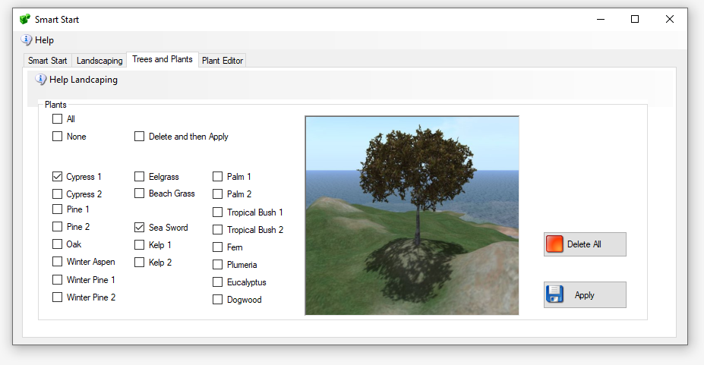

**Apply**: Plants the tree or plant that is selected. It will be placed on any chosen region when you click Apply.

Delete All. Deletes any AI-planted tree on this region.

## Plant Editor

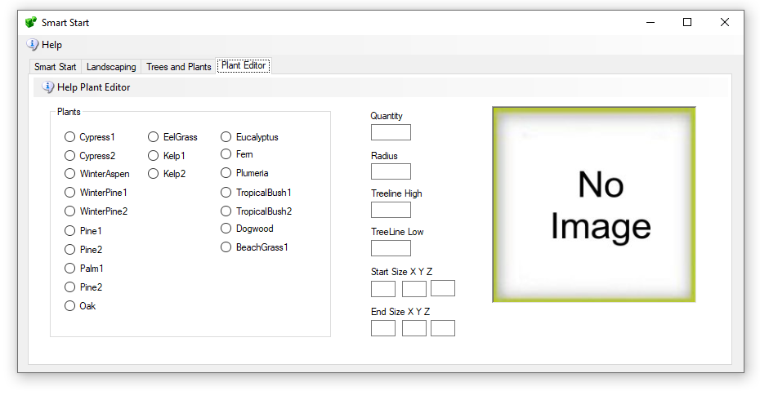

The Plant editor can modify any of the plants.

First, Choose a plant. They are categorized by a range of heights they will be placed within.

The larger trees are planted higher than grasses. The Eelgrass and Kelp will only be planted underwater.

**Quantity** - A random number of plants, from 0 to N plants, will be created.

**Radius** - The plants start in the middle and are sprayed onto the land in a circle. A radius of ~ 300 seems to fill most of a Standard 256 X 256.

**Tree Line High** – is the highest place a tree is planted.

**Tree Line Low** – is the lowest place a tree will be planted. Water is at 20 usually, so a 20 would be right to the edge of a beach.

Start Size X, Y, Z – The size of the tree at the start of the growth cycle.

Stop Size X, Y, Z – The size of the tree at the end of the growth cycle.

# Port Settings and UPnP

Multiple TCP ad UDP Ports are used in Opensim. The defaults are shown below.

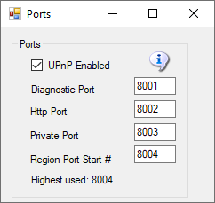

The defaults are 8001 (Diagnostic), 8002 (Public) , 8003 (Private) and 8004 (Starting Region). If you have manually added more regions, their region ports also need to be open. Each region that is used takes up one port. They start at 8004 and count up by one.

## Port Forwards:

See the section on **Troubleshooting Ports** on how to manually set the ports.

**UPnP Enabled:** The Outworldz program uses Universal Plug and Play (UPnP) to automatically allow data to come from the Internet to your computer. This is called "Port Forwarding". UPnP capability may be disabled in your router, or it may not support it.

You may need to stop the SSDP Service to prevent this service from intercepting these messages.

If UPnP is enabled and your router supports it, Dreamgrid will automatically open the correct ports. This can be slow and time-consuming, so you may prefer to disable UPnP and set your ports manually

Do you have Plug and Play (UPnP) issues? The Dreamgrid help menu has a useful tool to look at uPnP in your router:

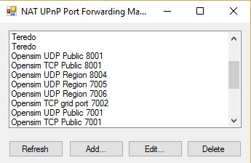  
 UPnp (Universal Plug and Play) Tool for Windows

You can add, delete, and modify the settings without a password, assuming you have UPnP enabled. This tool is available in Dreamworld and Dreamgrid in the Help menu.

## Troubleshooting Ports

A list of routers and instructions is at  http://www.portforward.com which can help you identify your router type.

Step 1) Get your PC LAN IP address by going to a DOS prompt and typing 'ipconfig'.



In the above photo, my IP was 192.168.1.3.   Yours is likely to be in the range 192.160.*.*, but it could also be a 10.0.*.* number. For my Linksys, it looks like this:



## IceCast/Shoutcast Ports

Ports 8080 and 8081 must be added when you are running the Icecast/Shoutcast server.

**Which ports?** You need to Port-Forward 8001, 8002, and 8004-8010 (or higher, I usually open up to 8050) to have room for expansion. You can also add 8080 and 8081 for Shoutcast/Icecast.  Do not do 8003 for security reasons. These can usually be done in ranges, like 8001-8002 and 8004-8010. The latter ones are for regions - you need one port per region, so this would let you have 7 regions. Add more if you want - nothing wrong with opening up to 8020 or 8030 or so.  In the above photo, I have opened ports 8004 through 8005.

They need to be open for both TCP and UDP. Your router will have a button or a pulldown to select UDP, TCP, or both.  If you do not have a Both or All option, you have to add them twice, once for UDP and once for TCP.

**How do I know this worked?** You can tell if it worked by starting Opensimulator, and then use a web browser to go to [http://www.canyouseeme.org](http://www.canyouseeme.org/), and enter 8002 while Opensimulator is running. Then click the Test Button at CanYouSeeMe. If that works, the ports are fine. If this does not work, try disabling your PC firewall. If this works, you must add exclusions to the firewall and then turn the firewall back on.

See **Firewall Issues** for help with the PC firewall.

Keep working with the router, firewall, antivirus exclusions and IP address until this test passes.

## Loopback:

The second part that must work is loopback - either your router supports it, or not. You can immediately tell if your loopback works after running the above CanYouSeeMe.org tests. You use your web browser to navigate to <http://(YOUR> PUBLIC IP):8002. Mine was <http://24.173.0.66:8002>. Of course, your IP address will be different than shown here, so use whatever CanYouSeeme.org shows you. If the system is working, you get a web page.

If not, you must add a loopback adapter. Go to <https://www.outworldz.com/Outworldz_installer/Loopback.htm> and follow the instructions.

Then go to Hypergrid/DNS Name page and enter your desired Hypergrid name

**Firewall Issues:**

Windows will prompt you to allow Opensim to open ports when it first runs. If you say no, you will not be able to log in. I also set all the ports to be open in firewalls when you first click start.

If you are using an Anti-virus with a firewall, such as Zone Alarm, AVG Internet Suite, or anything else, running Start.exe may trigger the 3rd party firewall popup warnings. Opensim.exe needs to be allowed internet access, and Start.exe must be allowed to make changes to the firewall. If not, it will not work, and you will have to take manual action to fix it.

This code is safe and is digitally signed by me, Fred Beckhusen of Outworldz.com, and is open source and available for inspection at  <https://www.github.com/Outworldz>.

You may have to manually add firewall rules to allow incoming traffic on the ports.

1. On the client operating system, go to Start>Run and type firewall.cpl. The Windows Firewall window opens.  
2. Click on the “Advanced Settings” link on the left pane. The Windows Firewall with Advanced security window opens.  
3. Click on the “Inbound Rules” option.  
4. On the left pane, click on “New rule”.  
5. Under “Rule Type” select the option “Port” and click next.  
6. Select “TCP” and “specific local ports” options.  
7. Key in the port number, the port is 8001-8010 (or higher for more regions)  
8. Click Next.  
9. Select the option “Allow the connection”.  
10. Click Next, do not change any option here and click Next again.  
11. Specify a name for this rule.  
12. Click Finish.  
14. Repeat the above but using UDP from step 6

**More information about Opensim Ports**

Here is more detail about ports and the way the interact with the outside world such as [www.canyouseeme.org](http://www.canyouiseeme.org/) and to my diagnostics tests.

Put simply, only port 8001 and 8002 can report back to those tools as to being open and can do so only when Opensim is running.

**Port 8001:**

8001 is a TCP/HTTP port that is open for help->Network diagnostics. It is unique to Dreamworld and not to Opensim. It is used for a "port forward" test, just like Canyouseeme.org does, and for a loopback test. It collects data on sim's going up and down to change the icons and collects Partner information if two people click the partner prim.

**Port 8002:**

Opensim has a web server that web browsers understand, using the same protocol (TCP/HTTP) that tools like www.canyouseeme.org support. Put simply, Opensim is the only thing that listens to port 8002 and answers to http:// GET and POST requests on 8002. Port 8002 is like port 80, the default port for web pages. You can actually set Dreamworld's 8002 port to 80, and it will still work. You can then drop the need to type :8002 at the end of your hyperlink. <http://hg.Osgrid.org> does this. There would be no need to type the :80, as literally http:// means "add a :80 to the end of it".

8002 works with web based ‘GET’ probe tools. If you do switch it to 80, then you forfeit using an additional web server on your home machine as only one program can listen to a port.

If Opensim is not running and your ports are open, it is as if you tried to connect to www.google.com's web server, but their web server is down. Nothing will happen, though your packets can get through the Google firewall because it is still open to traffic and is steering it to a dead server. You will get no answer. Similarly, if Opensim is not running, there is no web server to answer the request.

**Port 8003:**

This port is used by Opensim to listen to region traffic. Regions chat to the server database for login, presence, and other services use it to talk to the region so people can teleport from one region to another. In Dream World, regions must be on the same machine. In DreamGrid, just like OsGrid or any other remotely attachable grid, the regions can run on any machine anywhere in the world.

If you opened port 8003 to anyone on the web, you expose the internal database protocol to the web. Anyone with the right knowledge could attach a region to your sim. If you run a DreamGrid and host regions outside your LAN, it is recommended you use firewall rules to only allow access from known IP addresses running approved regions.

**Port 8004 and upwards:**

The region ports (8004-upward) run both TCP and UDP.   UDP is used for the viewer. UDP cuts the load on the server dramatically as there is no need to automatically always ACK every packet. As one example, no one cares if an audio stream gets briefly interrupted as you cannot hear it anyway, and it is too late to use it if it comes later in a retry. It just gets discarded.

For multiple regions in a single DOS box, all regions listen for TCP traffic on the last port used in that DOS box. As one example, if one region is in a DOS box by itself, and it is the first region, then it listens on both TCP and UDP on 8004.

If you had two regions in one DOS box, and they start at 8004, then the regions listen to UDP on 8004 and 8005, and both regions listen to 8005 for TCP traffic. You can check that the region is reachable on the Hypergrid only by using port 8005. 8004 will not respond, as it only listens to 8004 on UDP.

As a result, you can test regions with tools like Canyouseeme.org or a web browser

Links:

Port Testing: [http://www.canyouseeme.org](http://www.canyouseeme.org/)

# Publicity

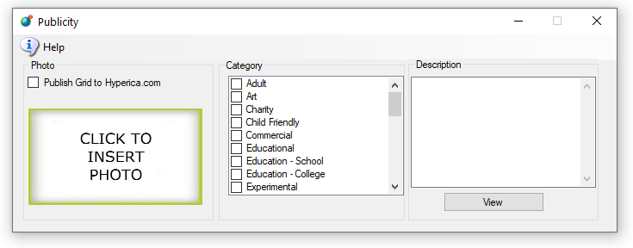

Publish Grid sends shows your grid in the list at [Hyperica.com](http://hyperica.com/):

Categories are used to put you grid into the Destination Guide.

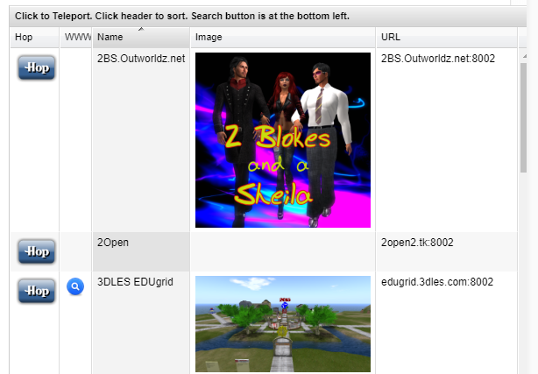

**Photos:** Click the box to load a PNG image and it will appear in your listing.

# Region Panel

This panel has setting that are is specific to this one region. As an example, if you want maps to made Best quality for just one region, you can set it here. It will override the global maps setting for this region.

# Region Basics

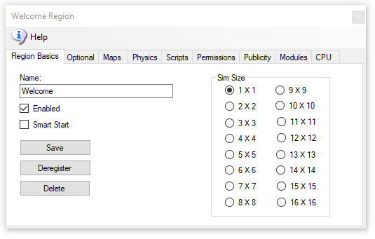

Give your region a name and click [Save].

Make sure it is Enabled. Smart Start is discussed in the Manual “Smart Start”.

Sims can be any size from 1X1 (256 X 256 Meters) to 16X16, with 64 regions. Larger regions take more RAM and cut the frame rate down considerably.

If you click [Delete], the region INI file will still be there, but the file name will change to .bak from .ini and will be ignored. This should automatically Deregister the region.  
  
[Deregister] will remove the region from the Robust reservation list but not remove the region. A region that shuts off is deregistered automatically. But a crashed region cannot deregister itself.   
  
The result is that you cannot place another region with a different UUID in the same registered place. Deregistering the region lets you move another region to the original position.  
  
Smart Start Regions remain registered when powered down so that they appear on the map and appear as available. If your region still will not start due to it overlapping, type this into the Robust console:

deregister region id <UUID Goes Here>

Regions are stored by DreamGrid in OutworldzFiles\opensim\bin\Regions in folders by each DOS box name. The DOS box folder has a Region folder in it that holds the Region.ini file. See Rules for INI files at the bottom of this Help file for more details.

# Options

This has optional items that are part of standard Opensim you may choose to change.

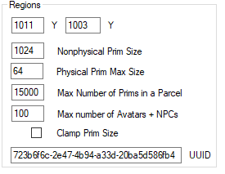

The Options page has the (x, y) Global location of the region on the grid. You can set regions next to each other by changing the X and Y coordinates and restarting the region. The X and Y is the lower left point on the global map.

If you get messages saying that regions overlap, change the coordinates to some substantial number and retry the region boot.

**UUID**: You can only change the UUID of the grid is stopped. Never change the UUID unless you want to start with a blank region again. Altering the UUID will force the system to create a new, blank region the next time the grid starts, and you will be forced to move your region to another spot if it is not deregistered. This is a read-only field when the grid is running. You can only change this by stopping the grid.

**MaxAgents**: The maximum number of agents that can be in the in the region at any given time. The default is 100.

**MaxPrims**: The maximum number of prims that the region will be listed as supporting. However, this limit is not currently enforced by OpenSimulator. Due to LL protocol constraints, the maximum limit that can be shown is 45000.

**PhysicalPrimMax**: The maximum dimensions of a physical prim. This is a single number which applies to X, Y and Z co-ordinates. This will affect resizing of existing prims. Default is 10.

**NonphysicalPrimMax**: The maximum dimensions for a non-physical prim. This is a single number which applies to X, Y and Z co-ordinates. This will affect resizing of existing prims. Default is 256.

**ClampPrimSize**: If true then if a viewer attempts to create a prim which has any dimension larger than the NonphysicalPrimMax, then that dimension is reduced to NonphysicalPrimMax. Default is false.

# Map Overrides

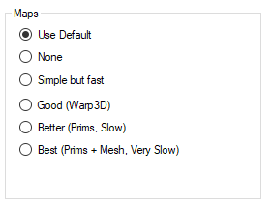

The Map Overrides change this one region’s map making.

* **None**: No maps will be made. This is a good setting as the regions will boot very quickly. Any existing maps are kept.
* **Simple but Fast**: MapImageModule is used with just Land showing
* **Good**: Uses Warp3D module with just Land showing
* **Better**: Uses Warp3D module with Land, Prims, and land Textures showing
* **Best**: Uses Warp3D module with Land, Prims, Mesh, Sculpts, and all Textures including prims showing.

# Physics Overrides

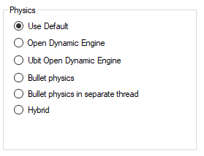

ODE is a very old physics engine with many limitations. It does support Ninja Physics.

* UBODE is closer to Second Life in vehicle performance.
* Both BulletSim and UBODE support varregions.
* BulletSim provides the best performance and most functionality.
* Bullet in a separate thread prevents physics crashes from crashing the region. It is the default physics engine.
* ODE Ninja physics are documented in another manual

# Script Overrides

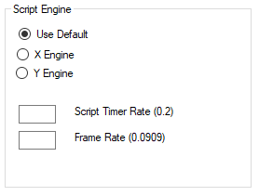

**XEngine** is and older and very stable Opensimulator script engine.

**YEngine** is a new engine that has better support for the llSleep() command. YEngine offers some features that improve performance and prevent timeouts. The problem with using llSleep function in Opensim scripts is that it may cause a script to freeze, requiring a reset. This is due to the way XEngine deals with running multiple scripts at once.

The parse in Yengine is also like Second Life as it uses the same order when evaluating a series of expressions. XEngine parsed the order in the opposite direction from Second Life.

**Script Timer Rate** is normally no faster than 1/5th of a second. It should rarely, if ever be faster than this. There are many less laggy ways to code a LSL system!

**Frame rate** is how fast physics and other ‘steps’ are run. It is normally set to 1/11ths of a second, which is 1/5th of Second Life’s rate. Some systems can benefit by running this slower or faster.

# Permission Overrides

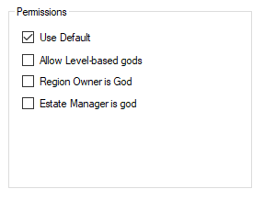

**Allow Gods:** God mode is available to selected people if enabled.   These levels can be set for individual users in the Web control panel.

Level = 0 is a normal user

·Level = 50 (or a level you set) is used to indicate a privileged user (e.g. who can set up new Hypergrid linked regions)

·Level = 100 is a Wifi admin account user

.Level >= 200 can become a God

**Estate Owner is God:** If enabled, the region owner may go into God mode.

**Estate Manager is God:** If enabled, any region estate manager may go into God mode.

# Publicity Overrides

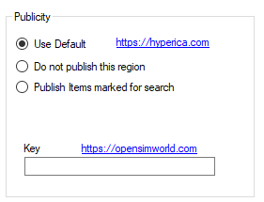

Publicity override can be used to publish or unpublish one region at a time to Hyperica.com.

**Use Default** uses the Settings->Publicity.

**Do Not Publish** will not send data to Hyperica.

**Publish Items marked for search** will send your grid location, description and any items you have martked for Show In Search in world.

**OpensimWorld Key:** You can enter your OpensimWorld key here for this region. Then you do not need to scriptred box.

# Modules



**Bird module** makes flocks of birds possible. See the help manual on Birds. This must be enabled for birds to appear in a region.

**Enable Tides** makes the water level rise and fall in this region. See the help manual on Tides. This must be enabled for tide to appear in a region.

**Teleport Sign Enable** lets you use a standardized Outworldz Teleport Sign to direct visitors in your world. This sign is located in the Content-Inventory IAR Load and Save ->Local IAR menu. There are multiple variations of the sign.

* **Outworldz Teleport System V2.5.iar** is a standardized sign for all uses.
* **Outworldz Teleport System V3.9.iar** is for testing of the Smart Start system and is subject to change.

**Disable all Gloebits** should stop the Gloebits system on this region.

**Disable Foreign Visitors** will prevent hypergrid visitors from entering your region.

**Disable Residents** will prevent all resident from entering your region. Only Estate managers or owners can get in.

**Skip Automatic OAR backup** will prevent the automatic OAR system from backing up this region.

**Announce visitors** will chat any arrivals or departures.

# CPU

The CPU tab lets you choose one or more cores for the region to run on. You can also set priority for the region.

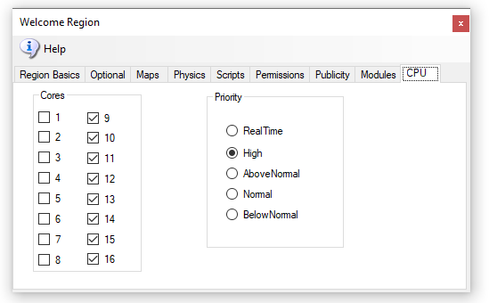

You can choose to set the process priority to Normal, High, Above Normal, Below Normal, or RealTime. Based on the time elapsed or other boosts, the base priority level can change when a process needs to be put ahead of others for access to the processor.

The processor affinity is the set of processors it has a relationship to. In other words, those cores it can be scheduled to run on.

A process thread can migrate from processor to processor, with each migration reloading the processor cache. Specifying a processor for a thread can improve performance under heavy system loads by reducing the number of times the processor cache is reloaded. The system schedules threads on their preferred processors whenever possible.

## **“Real Time,” vs High, or using “low”**

A scenery/low script region has no need for any optimization. It is already low lag, and load load. You need to think about these system-wide, and what the regions are doing under load.

You could just dedicate all such regions to Core 1 and set priority normal. If one person was in one of those regions, it would seem 'normal to them even if all other cores were hard at work. Opensim loves cores, so this may not be ideal, but it does protect that region from the other CPU cores.

Limit: Scripts or physics may need to be limited. A limit may be needed on large Satyr Farms. They make a great number of changes to prims which can swamp a server with MySQL writes. I can show you a half dozen regions on two different grids that write to SSD's as fast as possible - 7 to 15 MB a second! I upgraded one to more cores and it just wrote even faster. So these sims really need to be much lower in priority for CPU. It's horrible - a Contabo machine costing $50 a month is barely capable of running one region because of Satyr Farm!

Unlimited**:** The opposite example would be a racing simulation, where you want more responsiveness. Set that region to a higher priority. Look at ﻿[@Cuteulala Artis](https://mewe.com/group/5bc12bdc322b35103f0965d3/members/profile/5d463db2ea9ee17fa4d50a61)﻿ wonderful organ simulation in your free OARs list near the bottom. This wonderful creation requires a faster script timer in region settings to play properly. It could potentially benefit from a higher priority above 'Normal' on a heavily loaded server.

* Dedicated Cores is something else. To increase performance even more, you can dedicate one or more cores or more to a DOS box. Default is all cores are served to all DOS boxes. A dedicated core is more efficient as the system does not share the cores with other tasks and the hardware scheduler can make smarter decisions about this one DOS box.
* Dedicated Cores are a marketable product. SL sells a **dedicated core with** one256 X 256 region in it for $229 a month. We are not SL, obviously , but if someone wanted to sell a dedicated core for more than the usual fee, they can now.
* Src: <https://secondlife.com/land/private-pricing>. It has a higher value than sharing a machine with all others.
* Assume you are running a high CPU load on an 8-CPU Intel machine with hyperthreads so 16 cores are available. (AMD is not hyperthreadable). Assume also that the GUI in DreamGrid is lagging, or Windows is not being very responsive. You can set all your regions to use, lets say 14, of those 16 cores so two cores would be left for Windows and DreamGrid GUI, Robust, and Mysql, and other tasks without being bothered by Satyr Farm. ( I currently do not have code to dedicate a core to Robust and Mysql, but I will add that soon)
* Rules for INI files
* DreamGrid has several simple rules for *.INI files that differ slightly from stock Opensim.
* No Duplicates:  Do not leave a Region.ini in one folder and the same Region.ini in another.  All files such as Region.bak are ignored.
* The only thing you need to put in the SOME DOS BOX NAME\Region\ is one or more Region.INI files.
* All other files, such as Opensim.ini  are automatically re-created when you start the region.
* The INI file name must match the [Region Name] inside it. This example region [Welcome] must be saved as “Welcome.ini”.
* Only one [Region Name] is allowed in an INI file.
* Use multiples of 256 such as 256X256, 512X512, and so on.
* Each region size can be anything from 256 X 256 to 1024 X 1024, or higher. Huge region sizes such as 4096 X 4096 can be used for flying or car racing. If you go over 8192 X 8192, you can expect it to be slow and laggy as the land size gets exceptionally large as it grows exponentially.
* You can replace 4 single regions with a single 2X2 region and there will be no lag when crossing the (nonexistent) border. Vehicles can move smoothly anywhere. Also, NPCs can move about freely. Look in any region settings panel and you will see a "size" box. Check the 2X2 box, save it, and restart the region. It will grow North and East and will be 4 times larger, overall. You will also need to move it in X and/or Y or delete the other regions as regions cannot overlap. You can shrink them, too, but objects that fall off the right and top edge will be lost.

Example of how regions are organized is found in the file system:

Opensim\bin\Regions\SOME DOS BOX NAME\Region\Fred.ini  
Opensim\bin\Regions\**SOME DOS BOX NAME**\Region\**Rak**.ini

These two regions **Fred and Rak will be** in **a** single Dos box named **"SOME DOS BOX** NAME".

If you rename the folder "**SOME DOS BOX NAME**" to "**Internet**", they will be in a DOS box named "**Internet**". If you create a new folder named "**HEY**", like this:

Opensim\bin\Regions\**HEY**\

Andthen MOVE Region\Rak.ini into it:

Opensim**\bin\Regions\HEY\**Region\Rak**.ini**

You will end up with a **DOS box named** "Hey" withthe Region named "Rak" in it.  
The other Dosbox will have just Fred in it:

Opensimulator\bin**\**Regions\SOME DOS BOX **NAME**\Region\**Fred**.ini

Region List

Open the Region Panel with Ctrl-R or go to Setting-Region.

There may be many Region.INI files in your system. These show up in this panel. The default is an island called "Welcome".

## Buttons

### Refresh Button

Click Refresh to rescan the system status and update this panel.

### Details Button

This screen shows the regions plus all the details on each region.

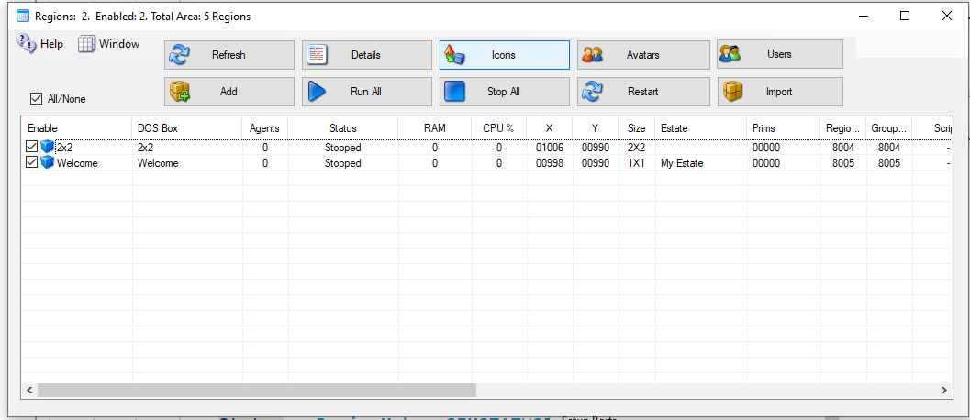

The Detail view can be sorted by Name, Group, Agents or Status by clicking the column name.

### Icons Button

This screen shows the Icon on each region. Clicking a Region opens the Region Editor.

### Avatars Button

This screen shows the Hypergrid and Local Visitors to your regions. If you have a viewer on the server, you can click the person and it will generate a Teleport link to that person.

### Users Button

This screen has a list of all registered users on your system.

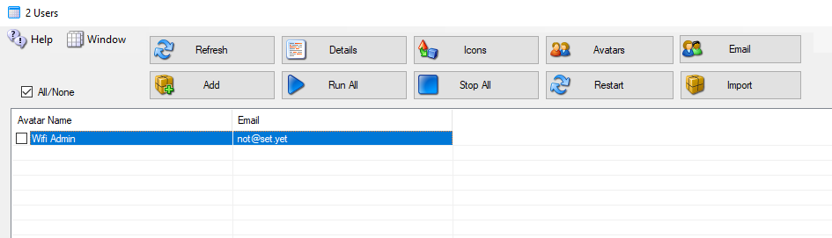

You can Checkmark each user to send an email to them. The Email button appears to top right

### Add Button

Click the Add button to make a new region. You only need to give it a name and save it.

### Run All Button

Runs all Checked regions.

### Stop All Button

Stops all regions.

### Restart Button

Restarts all checked regions.

### Import Button

This button lets you find region.ini files from other system, such as the standalone Dream World or backups, and import the file into DreamGrid in a new or existing DOS box.

## File Folder Arrangement

DreamGrid uses a slightly different folder setting than stock Opensim. You cannot just copy them over in a file explorer unless you make a special pattern of folders, with an extra set of folders inside it.

The format is:

Opensim\bin\Regions\DOS Box Name\Region\RegionName.ini

DreamGrid has several simple rules for *.INI files that differ slightly from stock Opensim.

* The INI file name must match the [Region Name] inside it. This example region [Region Name] must be saved as “Region Name.ini”.
* Only one [Region Name] is allowed in an INI file.
* All contents of a Region file are made by Dreamgrid and will be overwritten. See the Region Control Panel to change the settings.

## Clicking a Region

A new panel appears if you click a region:

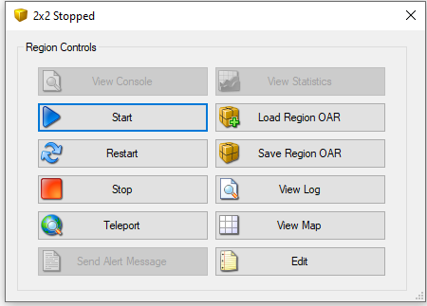

### View Console Button

Shows the DOS Box console window.

### Start Button

Starts this one region.

### Restart Button

Restarts this one region.

### Stop Button

Stop this one region.

### Teleport Button

Generates a Teleport to the region in the viewer.

### Send Alert Message Button

Send a region wide message to all users in the region

### Load Region OAR Button

Loads an OAR into the region

### Save Region OAR button

Saves an Oar from the region

### View Log Button

Views the Opensim.log file

### View Map Button

Shows the region Map.

### Edit Button

Edits the region.

## Region Stats

The region stats are a web-based data collector. First, choose a region:

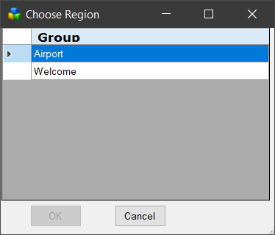

The first screen shows general statistics:

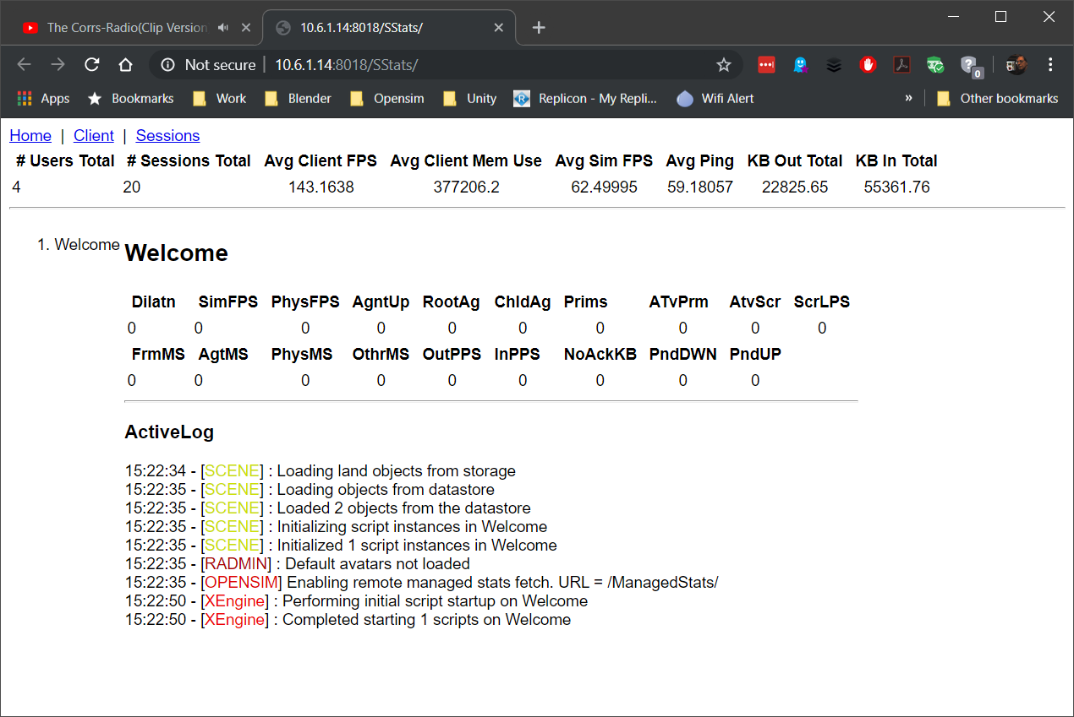

The client screen shows the types of viewers that have visited

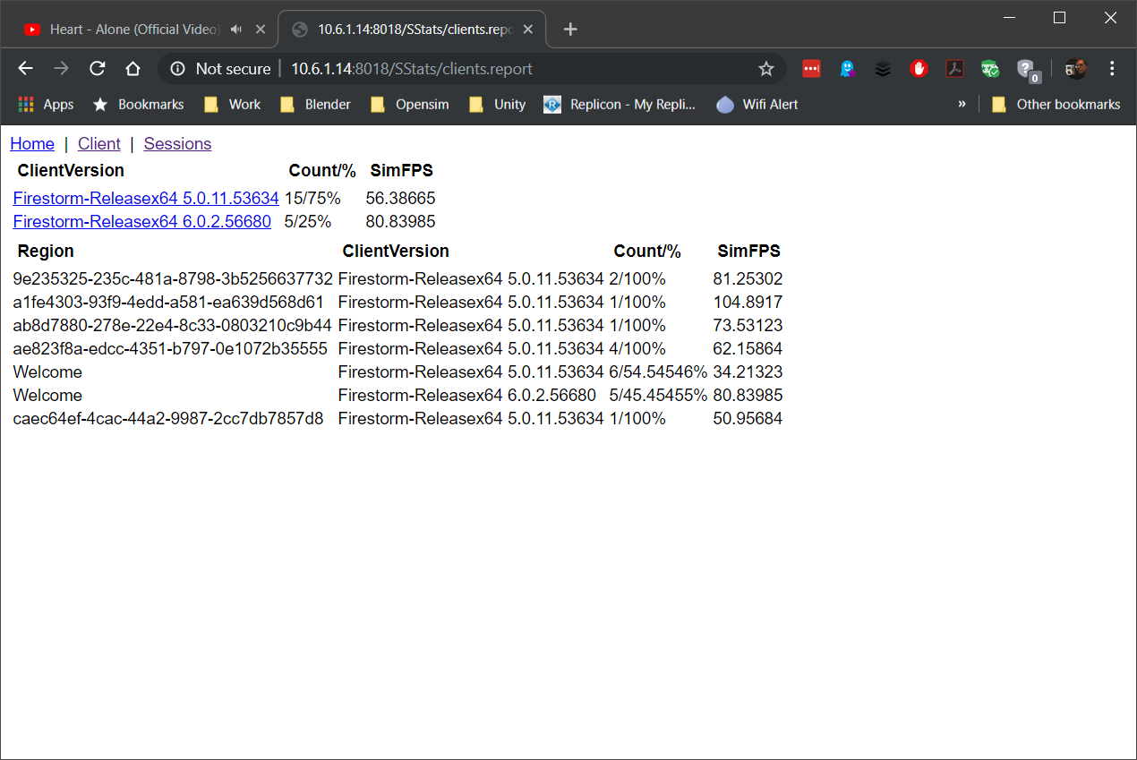

The Sessions screen shows the visitor list

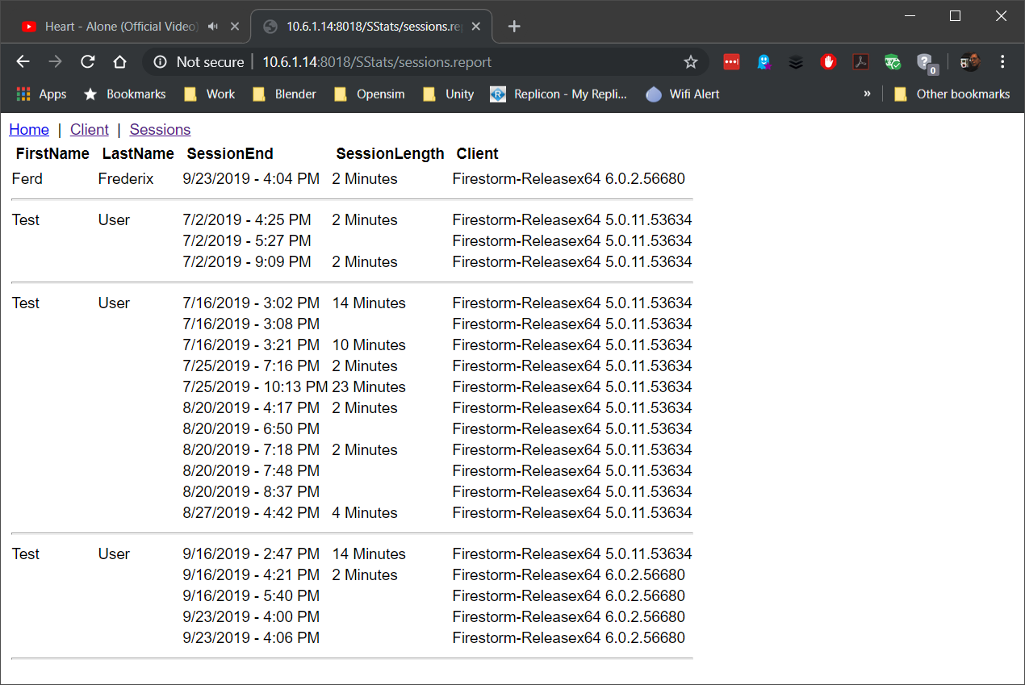

# Regions

**Default region for visitors:** This is your “Welcome” region.Hypergrid visitors and people who log in for the first time get sent to this region. The region must be online.

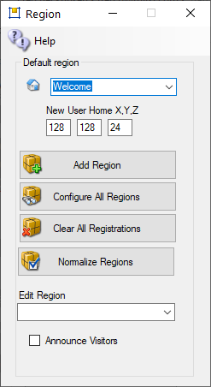

**New User Home X, Y, Z:** Users that create accounts on the web page will land at this spot on your Welcome region. Their home is set here. Default: 128,128,24

**Add a Region:** will bring up a dialog form for adding a new region.

**Configure All Regions:** will open all regions for editing.

**Clear All Registrations:** You may get an error when you add a region where another region once existed or overlapped. A crashed region will leave behind this registration, and you cannot place another region there. Pressing this will deregister all regions so all regions can be moved. This button deletes all regions from the “present and accounted for’, region table in Robust.

This requires that the grid not be running. See below for more details on Region Error.

**Normalize Regions:** The web maps require that the lowerleft corner be started at 1000,1000. This will move all regions so that the chosen region is at 1000,1000. All regions maintain their relative positions.

**Edit Region:** will bring up a dialog form to edit the selected region.

Announce Visitors: This is a global enable so regions can announce arrivals of visitors. The region must also have an override for “Announce Visitors” in the Modules section of the Region settings.

**Region Error:** if you add a region where another already exists, you may get this error.

2021-03-27 09:53:51,132 ERROR [GRID CONNECTOR]: Registration failed: Region overlaps another region when contacting http://192.168.2.139:8003/grid  
2021-03-27 09:53:51,137 ERROR [STARTUP]: Registration of region with grid failed, aborting startup due to Region overlaps another region    at OpenSim.Region.Framework.Scenes.Scene.RegisterRegionWithGrid() in C:\Opensim\Outworldz_Dreamgrid\OutworldzFiles\Opensim\OpenSim\Region\Framework\Scenes\Scene.cs:line 2384  
   at OpenSim.OpenSimBase.CreateRegion(RegionInfo regionInfo, Boolean portadd_flag, Boolean do_post_init, IScene& mscene) in C:\Opensim\Outworldz_Dreamgrid\OutworldzFiles\Opensim\OpenSim\Region\Application\OpenSimBase.cs:line 499

Robust says:

09:59:23 - [GRID SERVICE]: Register region conflict in scope 00000000-0000-0000-0000-000000000000. Region overlaps another region

One solution is to deregister it by hand.  Go to robust and type this:

show regions < enter>

you get a list of all regions.

R.O.B.U.S.T.# show regions  
Name                  ID                                    Position     Size         Flags  
Region 1016, 1007     0e871ad3-41ec-4eb5-8aad-96d9b5561803  1016,1007    256x256      RegionOnline  
Region 1017, 1010     0f75a6ba-bbc0-4489-846d-a3aaa286c3ae  1017,1010    256x256      RegionOnline  
Region 1017, 1008     1b47af46-9364-4cde-909c-a3173d98291f  1017,1008    256x256      RegionOnline  
Region 1015, 1007     2302b841-11d3-4c2c-9ebb-0fce4c26beea  1015,1007    256x256      RegionOnline  
Region 1013, 1009     4e69b298-c084-466f-b450-f34fbffa2238  1013,1009    256x256      RegionOnline  
Region 1015, 1009     74f9d745-fa42-450b-96e5-0770eae37928  1015,1009    256x256      RegionOnline  
**Region 1016, 1009     a357ccd6-43d6-45ff-8563-35f09345908e  1016,1009    256x256      RegionOnline**Region 1017, 1007     c8775e97-ae1d-4164-8db8-ec205e46a148  1017,1007    256x256      RegionOnline  
Welcome               c91ceea4-77f5-40f6-afad-36f822097a4d  1016,1008    256x256      DefaultRegion, RegionOnline, DefaultHGRegion  
Region 1015, 1008     dce9b253-789f-497a-b040-7df958262c69  1015,1008    256x256      RegionOnline  
Region 1017, 1009     e819b0f7-86d7-4391-9064-67f6cb8708cd  1017,1009    256x256      RegionOnline  
Region 1016, 1017     eab4f2bb-c92f-42fe-be92-30b29ba5a61b  1016,1017    256x256      RegionOnline  
  
Find the region at the same coordinates as the one you are trying to boot.  The one that is conflicting on my test server is this one at 10156,1009

Region 1016, 1009     a357ccd6-43d6-45ff-8563-35f09345908e  1016,1009    256x256      RegionOnline

 This UUID is different than the one there previously. So it will not let the new region steal it.

Copy the UUID from, above: **a357ccd6-43d6-45ff-8563-35f09345908e**

Type in this:

**deregister region id <PASTE UUID HERE>**

R.O.B.U.S.T.# deregister region id a357ccd6-43d6-45ff-8563-35f09345908e  
Deregistered Region 1016, 1009 a357ccd6-43d6-45ff-8563-35f09345908e  
R.O.B.U.S.T.#

# Restart and Startup Settings

Opensim uses up increased RAM as people arrive and leave. Periodic restarting of regions is necessary to clear memory. You can set up a restart timer here.

Dreamgrid will not restart a region if avatars are present. It will restart the region only after all avatars leave.

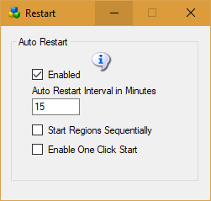

**Enable:** If enabled, the auto restart interval will be set to 1440 minutes, which is one day. If disabled, the regions will try to run forever.

**Auto restart Interval:** The number of minutes a region runs before it restarts.

* 0 = Off
* 720 is 1/2 day. 1440 is one day. 2880 is 2 days.
* If Autobackup is enabled, this interval will be extended beyond the Autobackup Interval by 30 minutes to allow Autobackup to complete.

**Start Regions Sequentially:** Unchecked= start a new region every few seconds. This can overwhelm the database, memory and/or CPU on some systems. Checking this box will start each region sequentially it will wait for it to boot completely before starting the next. It will extend the waiting period up to 3 minutes. per region.

**Enable One Click Start**: If set, running Start.exe will automatically start Opensim without needing to click the second [Start] button.

# Save IAR

OpenSimulator Inventory Archives (IARs) are a means by which inventory folders and items can be saved offline to a single file (an IAR). This file can then be loaded into a different OpenSimulator installation.  
  
Like Opensim Archives, IARs save all the necessary asset data to fully restore the items including textures, sounds, scripts, and objects contained in the inventory of other objects.

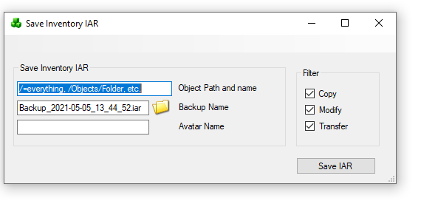

The command to save an IAR on the region console is

save iar [-h|--home=<url>] [-v|--verbose] [--noassets] [--perm=<permissions>] <user-name> <path> [<filename>]

where <user-name> is the name of the user to save inventory.

<path> is the path to an inventory item or folder. If the path is for a folder, that folder and all its contents (both descendant folders and items) are saved. If the path is for an item, then only that item is saved.

Components of the path are separated by a forward slash ("/"). If you need to specify a path with spaces, you can surround the whole thing with double quotation marks (e.g. "Folder A/Folder B")

You can specify that the contents of a folder should be saved rather than the folder itself using the * wildcard. For instance, "a/b/*" will save the contents of folder b but not folder b itself.

If a name or folder contains a forward slash ("/") then it can be escaped with the backslash (i.e. "\/") to stop it being seen as a path separator. Back slashes themselves need to be escaped with another backslash (i.e. "\\").

One further issue here is that it is not possible to distinguish between identically named folders or items on the path - the workaround is to rename your items/folders if you need to specify them in the path :)

filename> is an optional filename for the IAR. If none is supplied, then the filename user-inventory.iar is used in the current directory. I recommend that IARs have the .iar extension.

## Switches

If the --noassets option is specified, then the archive will be saved without assets. This can be handy if you are backing up the asset database separately and do not want the expense of including all the assets in each archive.

--home=<url> is the URL of this world's profile service. It is not required that the profile service is operational; the information will be saved, and it will be displayed wherever the archive will be loaded. NOTE: the older --profile option (the previous name of this switch) produced IARs that are not compatible with OpenSimulator 0.7.0.2 and earlier; do not use this option if you want to produce a compatible IAR.

--verbose prints out verbose saving messages

When the C/MX switches are set, the --perm option is specified, and items with insufficient permissions will not be saved to the IAR. This can be useful for grids that allow their customers to export their inventory to IARs, because it ensures that exporting to IAR cannot be used to bypass content permissions.

<permissions> specifies which permissions are required. It is a string that contains one or more of these characters:

"C" = Copy  
"T" = Transfer  
"M" = Modify

## **Examples**

Here is an example. Suppose you have an inventory structure like this

My Inventory  
 |  
 +-- FolderA  
 |   
 +-- FolderB  
 | |  
 | +-- ItemX  
 |  
 +-- ItemY

If you type:

save iar John Doe FolderA PASSWORD my-items.iar

then FolderA and everything in FolderA (FolderB, ItemX and ItemY) will be saved into an IAR called my-items.iar. On the other hand, if you type

save iar John Doe FolderA/FolderB/ItemX PASSWORD my-items.iar

then only ItemX will be saved.

If there is a space in the path to the item, for example if John Doe's folder was named "Folder A" instead of "FolderA", then quotes around the path are necessary on the command line:

save iar John Doe "Folder A/FolderB/ItemX" PASSWORD my-items.iar

## Saving an entire user's inventory

With save iar you can save your entire inventory as well as the contents of particular folders or individual items.

For instance, typing

save iar John Doe / password

# Script Settings

Default Engine for scripts is XEngine.

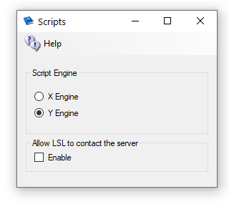

YEngine is a new engine that has better support for the llSleep() command. YEngine offers some features that improve performance and prevent timeouts.

The problem with using llSleep function in Opensim scripts is that it may cause a script to freeze, requiring a reset. This is due to the way XEngine deals with running multiple scripts at once.

The parse in Yengine is also like Second Life as it uses the same order when evaluating a series of expressions. XEngine parsed the order in the opposite direction from Second Life.

## Allow LSL to contact the server:

By default, OpenSimulator does not allow scripts to make HTTP calls to addresses on the simulator's LAN. This stop LSL from scanning your ports inside your firewall. If you need to allow scripts to make some LAN calls, enable this checkbox. We recommend that you do not enable this unless you are very sure about what you are doing. When disabled, it will allow access to no ports on the server. You can see more in Opensim.proto - search for OutboundDisallowForUserScripts.

Default: Unchecked

# Robust and Server Type

This menu item “Server Type” lets you choose from either a Grid Server with Robust, or from different Region Server choices to connect to another grid.

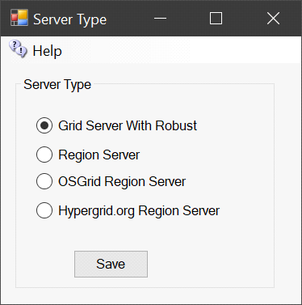

## Grid Server with Robust

A grid server is modeled after the World Wide Web, with independent domains. Content is spread across small, independent and on large domains, independently, yet interlinks. Robust is the service that lets HyperGrid users enter each world. A Grid Server can also support regions locally. A grid server can host as many Region servers as its memory and CPU capacity allows.

## Region Server

A Region server uses a separate DreamGrid Robust Grid Server for all assets and login services. Only regions and their content is stored locally. The grid server may be located on the same LAN, or on another WAN. A Region Server always uses the same Domain Name and port as the Hosting server.

In cases where the Grid server is on a different WAN IP address, you must also enter the Region Servers IP address or domain name in the Region Ports setting:

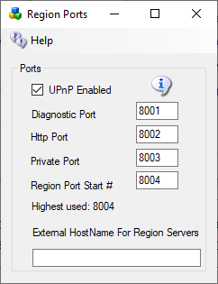

The Diagnostic port default is 8001.

The HTTP port MUST be the same as the Robust Server Port. Default 8002.

Private Port MUST be the same as the Robust Private Port. Default is 8003. This port is normally clocked at the Robust server. You need to port forward that Port 8003 and make sure that the Windows firewall only allow the region server in by its IP Address.

Region Port Start # Default is 8004.

Highest Used shows how many ports MUST be open and forwarded. DreamGrid can do this with UPNP in the router and it does it automatically in the Windows Firewall.

External Hostname: If on the same LAN as the Host Robust machine, this can be left alone, as port forwards do the work. If on a Different WAN, the IP address of DNS name of the Region Server MUST be enetered here.

## OsGrid Region Server

The **OsGrid** region server is a preconfigured region server already set up to connect to **OsGrid**.

## Hypergrid.org Region Server

The **Hypergrid.org** region server is a preconfigured region server already set up to connect to **Hypergrid.org**.

# Smart Start

Smart Start regions shut down when no one is in them.   A Smart Start region appears as a dual blue arrow ’recycle’ icon in the Regions panel:

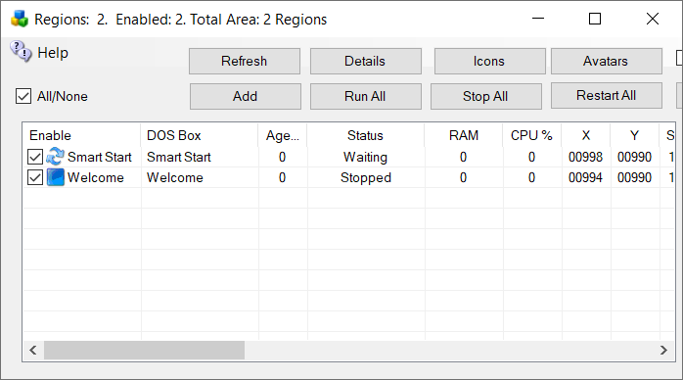

Smart start detects teleports.  When someone teleports into the system, or logs in, the system decides if their destination is already bootet.  If so, the teleport happens normally. But If the region is not ready, the system sends the avatar to a waiting area while the region is booted. When the original destination region is ready for logins, the avatar is teleported to the original destination.

## Enable Smart Start

Smart Start is disabled by default. You must first enable it in Setup->Settings->Smart Start:

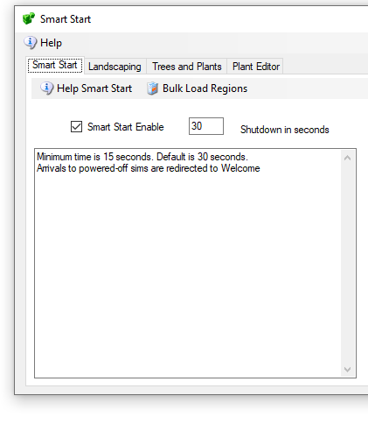

Enable Smart Start

The system can be set to power down the region when no one is in it. This length of time is from 15 seconds upward.

## Choose a Parking Region

If a region is offline and a teleport is initiated, the region will be booted. This may take more time than the viewer allows. The avatar is teleported to a waiting region, aka, a “Parking Region”. You can choose any region, such as your Welcome region, which is the Default.

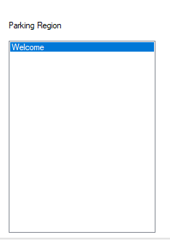

## Region Setup

You must enable Smart Start in the regions you want to remain powered down when no one needs them.

This can be enabled or disabled for any region.  Edit any region and set the Smart Start Checkbox to True. This goes into effect immediately.

If the region is running and no avatar  in it, it will shut down within the time period you set.

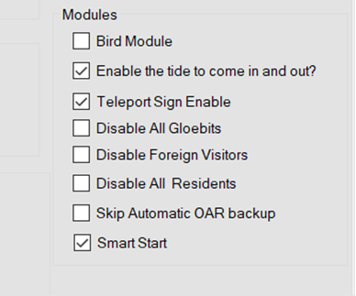

Enable Smart Start

## Automatic Fill

Automatic Fill is an optional Feature for Smart Start. If enabled, anyone moving into a region will trigger an automatic fill of surrounding regions with the Landscaping and Trees/Plants modules.

In those screens you can choose water regions, as just one example. If set to water, your avatar can walk, fly, or boat across the entire expanse of your grid. Its literally an Endless sea.

You should select an avatar that will own the Estate named “SimSurround”, which is the owner of these Regions.

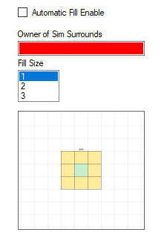

# Streaming MP3 files in Opensim

 MP3 files can be used to make region and parcel-wide background sounds.

The files are located in Outworldzfiles\Apache\htdocs\Audio.  You can add your own audio files there.

This selection of background sounds is CC-0 so can be used anywhere with no license restrictions.

You can play one sound at a time per parcel using your DreamGrid Apache web server. Apache must be enabled and running for this to work.  You can divide up your land into small parcels and play different audio sounds in each parcel

* Caves
* Oceans
* Forests
* Snow
* Rivers and Streams
* Waterfalls

How does it work?  It plays on a sim-wide on a special image.

These are the steps to play MP3 files continually on your region or parcel.

1.  In your viewer, go to the About Land Menu:

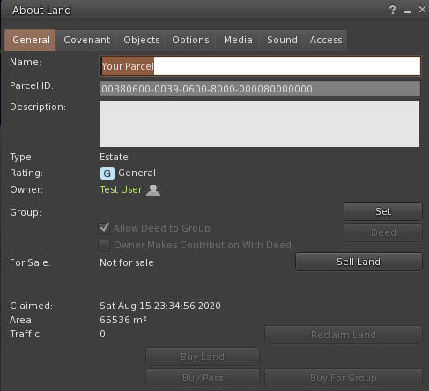

2. Change to the Media Tab:  
  
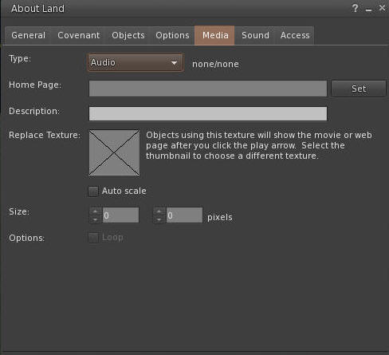  
  
3. Click the Set button and enter the URL of the desired sound.  You can click the link, and copy and paste the path.  
  
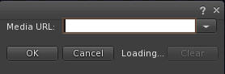  
  
4. You need a unique texture not used before. Something like a PNG file can be used. Upload it to your viewer.  
  
  
  
  
Drag and drop the Audio.png file into the X window so it appears like this.  You need to use the web URL for your grid, typically [http://something.outworldz.net:80/Audio](http://something.outworldz.net/Audio), where ‘something’ is your chosen URL. You can get this link in the Help menu in the fist selection. Then change the port to whatever port you use for Apache, in Settings->Apache.  
  
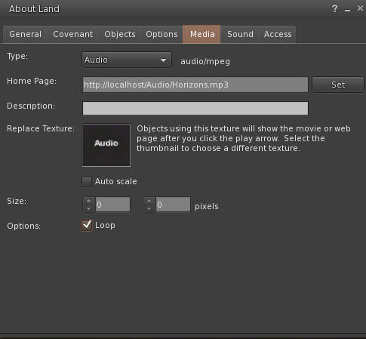  
  
Make a prim or find a hidden face on a prim. Click "Select Face". Choose one face only!  Drag and drop the image onto one fac.  
e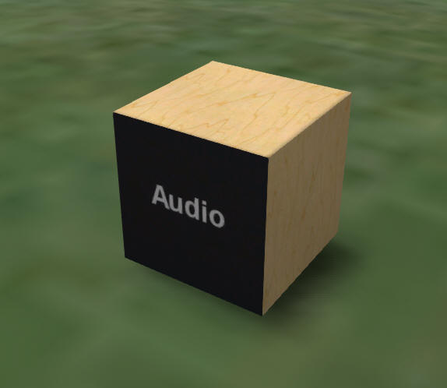  
Now click the movie camera at the top right of your viewer:  
  
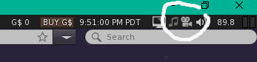

# Streaming MOVIE files in Opensim

Apple’s MOV files can be used to make region and parcel-wide video players. The Video you see here is located in Outworldzfiles\Apache\htdocs\Video.  You can add your own Video files there.

You can play one video at a time per parcel using your DreamGrid Apache web server. Apache must be enabled and running for this to work.  You can divide up your land into small parcels and play different audio sounds in each parcel.

Help Screens

Movies

About Your Region

 How does it work? .MOV files can be streamed n a special image.

These are the steps to play Video files continually on your region or parcel.

1.  In your viewer, go to the About Land Menu:

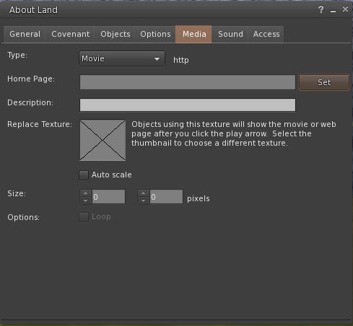

2. Change to the Media Tab:  
  
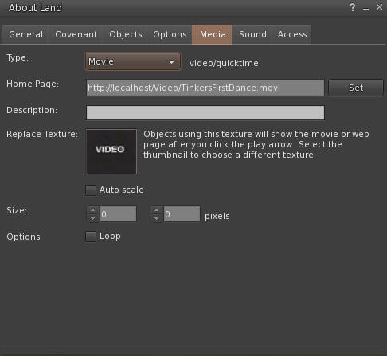  
  
3. Change to the Movie Pulldown  
  
  
  
3. Click the Set button and enter the URL of the desired video.  You can click the link to the sample, and then copy and paste the path or just use http://localhost:80/Video/Tinkers First Dance.mp4

  
  
4. You need a unique texture not used before. This PNG file can be used. Right click and save it, and then upload it to your viewer.  
  
  
  
  
Drag and drop the Audio.png file into the X window so it appears like this.  You need to use the web URL for your grid, typically [http://something.outworldz.net:80/](http://something.outworldz.net/Audio)Video/TinkersFirstDance.mov, where 'something' is your chosen URL. You can get this link in the Help menu in the first menu selection. Then change the port to whatever port you use for Apache, in Settings->Apache.  
  
  
Make a prim or find a hidden face on a prim. Click "Select Face". Then choose one face only!  Drag and drop the image onto one face only.  
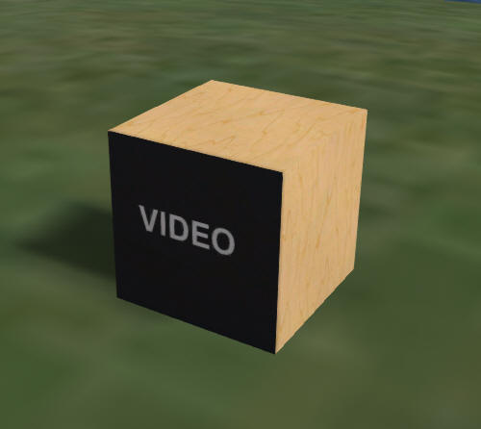  
  
Now click the movie camera at the top right of your viewer:  
  
  
  
And your video should play.  
  


# Terrain

The Terrain let The Landscape modules lets you add terrains and plants to any region.



The left side has 4 types of auto or premade terrains. The right side lets you browse and apply to any region any saved Terrain.

## Menu:

* Load Terrain – You can choose any of the many pre-defined terrain files or browse to another location. The system supports PNG, RAW, R32, and TER (Terragen) formats
* Save Terrain – The system will save the selected region file in the above 4 formats along with a JPG image.
* Save All Terrains – The system will save the selected region file in the above 4 formats along with a JPG image in all running regions as well as all Idled Smart Start Regions.
* View Terrain Folder - open file explorer to the Opensim\bin\Terrain\ folder

## Terrain Section

The left side has a set of functions for what effect to apply to the land.

Options: These modify the chosen effect

**Just Options** – ignore the terrain land, just apply the options.

**Smooth**: smooths the land. The smoothing operation is somewhat different than the others, as it does not deal with elevation values, but rather with strength values (in the range of 0.01 to 0.99). The algorithm is simplistic in averaging the values around a point, and is implemented as follows:

The "strength" parameter specifies how much of the result is from the original value ("strength" * map[x,y]).

The "taper" parameter specifies how much of the remainder is from the first ring surrounding the point (1.0 - "strength") * "taper". There are 8 elements in the first ring.

The remaining contribution is made from the second ring surrounding the point. There are 16 elements in the second ring.

e.g.

*terrain modify smooth 0.5 -taper=0.6*

* the original element will contribute 0.5 * map[x0,y0]
* each element 1m from the point will contribute ((1-0.5)*0.6)/8 * map[x1,y1]
* each element 2m from the point will contribute ((1-0.5)*0.4)/16 * map[x2,y2]

**Noise -** The smooth value represents a delta amount (at centre of range)

**Taper** - represents a delta amount (at edges of range)

## Land Types

**Flat** – Land is always flat. The Option “Noise” will make the land bumpy. This makes nice underwater if the Option for Height is set below water level of 20 meters.

**Random Terrain -** uses one of the saved terrains. Options can apply

Water – The same as flat land with Height set to 0

Generated – a series of steps are applied:

* Options are set for Min Level between 22 and 40 meters
* Taper between 0 and 135 meters high
* Upon setting Apply the system will have:
* One in 6 chance fill of land at Height meters with the random taper
* One in 6 chance for low lying land at 12 meters with lots of noise
* One in 6 chance for center to be squared from 20 to 40 meters with the random taper
* One in 6 chance for water level with a variable raised bump with noise
* One in 6 chance for water level with a variable raised bump

# Tides Module

The tide module makes water go up and down. It has a buoy with a script to make boats and objects float with the changing water level. It must be used on a single sim surrounded by water.

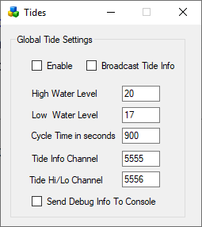

**Enable**: If set, Tides are enabled globally. Individual region Tide setting must be enabled to make the water go up and down in each region.

**Broadcast Tide Info**: This must be checked to send tide level info to the provided buoy. It uses channel 5555.

**High Water Level**: default 20 meters

**Low Water Level**: default 17 meters

**Cycle time in seconds**. default 900 seconds = 15 minutes

**Tide Info Channel**: As the tides rise and fall, a tide level command is broadcast on this channel. This must be set to 5555 for the provided script to work.

**Tide High Low Channel**: An announcement will be made on this channel when the tide is at a high or low level.

**Send Debug Info to console:** will send chat to the regions console for debugging.

Buoy:

A floating buoy is provided in the Load Local IAR menu.

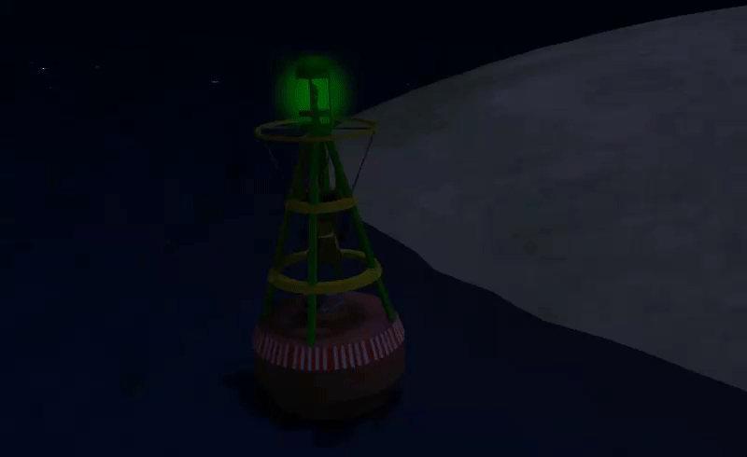

**Tide script:**

To make items float on water just place this script into their root prim.

integer listen_handle;  
vector myPos;  
float tideLevel = 20.0;

default {  
 on_rez(integer start_param)  
 {  
 llResetScript();  
 }

state_entry()  
 {  
 listen_handle = llListen(5556, "TIDE", NULL_KEY, "");  
 }

listen( integer channel, string name, key id, string message )  
 {  
 tideLevel=(float)message;  
 myPos = llGetPos();  
 llSetPos(<myPos.x, myPos.y, tideLevel + 0.05>);  
 }   
}

To make items float on water just place this script into their root prim.

More complex stuff can be done using the full info channel, which has data about where in the tide cycle we are. Rez a cube prim and place this script inside:

integer listen_handle;  
default  
{  
 state_entry()  
 {  
 listen_handle = llListen(5555, "TIDE", NULL_KEY, "");  
 }

listen( integer channel, string name, key id, string message )  
 {  
 llWhisper(0,channel + " " + name + " " + id + "\n" + message);  
 }  
}

The cube will whisper info about the current tide position every time the tide is updated.

Links:

Tides is by Jak Daniels from <https://github.com/JakDaniels/OpenSimTide>

# Terms of Service

The TOS form lets you change the HTML for your TOS. A SAMPLE TOS is included here.

Feel free to delete it or change it as you see fit.

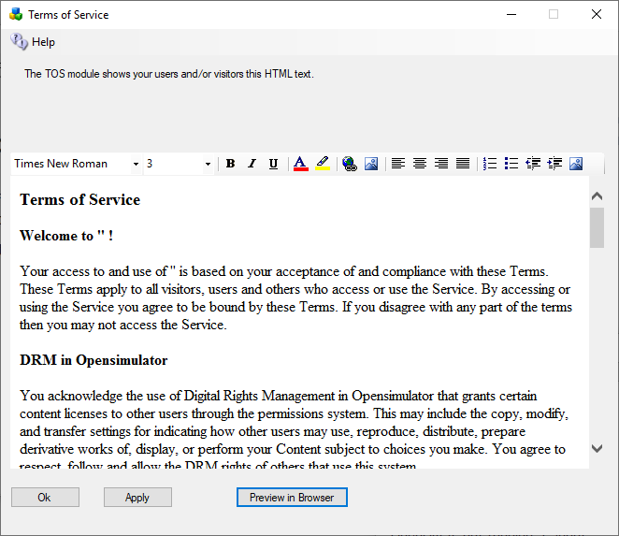

**#includes** There are several include directives that bring in the rest of the web site. Diva uses a series of <!--#include file=header.html --> statements to bring in files from the other folder set in Opensim\WifiPages. Includes in those files then bring in increasingly of the web pages from Opensim\Bin\Wifipages.

**#get** There are several statements that are replaced by server data:

**Users in World:** <!-- #get var=UsersInworld -->

**Regions:** <!-- #get var=RegionsTotal -->

**Total Users:** <!-- #get var=UsersTotal -->

**Active Users last** <!-- #get var=UsersActivePeriod --> **days**

**Active Users:** <!-- #get var=UsersActive -->

# Troubleshooting

You can just run Help-Network Diagnostics and see what it says. Or troubleshoot it manually, step-by-step. The diagnostics essentially do what is described below, but sometimes you just need to know more. This is a list of things to try.

Diagnostics are run once upon installation. You can run them again (Help->Diagnostics).

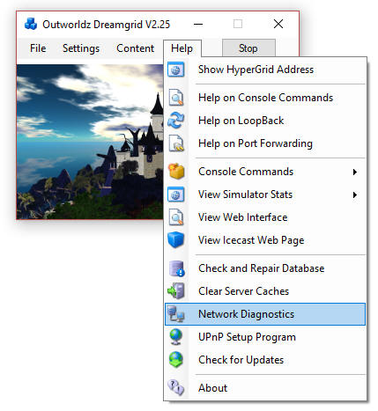

## Try This First:

Reset your router by cycling the router power. This is often the ONLY WAY to clear out old UPNP entries.

UPnP settings are usually removed when the program is started to keep your system safe. DreamGrid uses Universal Plug and Play (uPnP) and several diagnostics to configure compatible routers automatically. uPnP may be disabled or fail. If your router does not support uPnP, you must manually open ports in your router and Port Forward them to your PC.

## Try This Next

Go to Settings -> Expert mode, click the DNS button at top left, and enter '127.0.0.1'. Then restart the grid and use <http://127.0.0.1:8002> as the grid in the viewers "Add Grid" menu.

You should also be able to see the Systems admin web page with a viewer by clicking the above link.

Open up your viewer. Now add the grid <http://127.0.0.1:8002> to the viewer. You should now be able to log in on the Server from the Server.

You should see the Welcome region spit out a lot of text as you log in. If this fails, it is not your network, router, or loopback as you are on localhost, aka. 127.0.0.1.

## Password Reset

You probably forgot the password. You can reset your password with the command 'reset user password' in the Robust screen.

## Troubleshooting the Network.

Any IP from outside must be able to connect to ports 8001 to 8002, and from 8004 upwards. A test at http://canyouseeme.org should work on port 8002 when Robust is running.

If not, you need to Port Forward. See the manual on Port Forwards.   
  
If it does not work it is highly likely to be an antivirus firewall. Windows Defender firewall may be blocking ports.

**Anti Virus**

Progams such as MalwareBytes, Norton, Avast, and others are designed to block Ports. Try disabling them entirely to get Canyouseeme.org to work on port 8002. You have a firewall in your router so should be perfectly safe. Once you get the system running, enables your AV one at a time. If it quits, adde exclusions to the ports you used:

8001 – Used by PC for icons, signs and status  
8002 - Robust HTTP port “The Grid”. This is where avatars connect  
8003 – Should not be port forwarded. Must be open to the Server.  
8004 – from 8004 upwards one port per region.

**AV Eclusions**

You need to add exclusions to Real Time Scanners for Opensim\bin\. Opensim creates millions of files and thousands of DLL’s. Let it do so peacefully.

## Step-By-Step

Try these in order:

1.  http://127.0.0.1:8002 <- gives a web page.  Verifies that robust is running on the machines Network Card loopback adapter.  
  
    If not, start Robust.

**Go to the next step only when this test passes.**

2. Find your LAN IP with the dos command 'ipconfig'.

Use a web browser to go to your LAN IP, such as http://192.168.0.10:8002

You should get a web Page.  If not, check your IP with the dos command 'ipconfig'.  It will be listed as an IPV4 address. While there make sure there are no other gateways enabled.  This is usually 192.168.0.1.

**Go to the next step only when this test passes.**

 3. Use a cellphone or some other PC connected to your LAN for this next one.

Navigate using a web browser on that OTHER device to <http://192.168.0.10:8002>.

You should see the web page.   
  
If this fails, it is likely to be an antivirus program blocking a port such as the Windows Defender firewall. Turn them ALL off.  Look for Malwarebytes or other installations that can block the port.  I have troubleshot one machine that had three anti-viruses. You can turn them back on once you get it working, one at a time, and see when Opensim quits. Then add the necessary exclusions to that anti-virus program.

**Go to the next step only when this test passes.**

4. All the above tests are LAN-based.  So now try the router:  
  
    <http://canyouseeme.org> on port 8002  
  
This test must pass.   If it does not the problem is you skilled the Canyouseeme.org test which is failing, or another firewall is blocking you.  Usually this is when people realize they have their router plugged into another router that needs to port forward, too. Or that they are running 3 different Antiviruses.  
  
Go read the manual on Port Forwards.

Look up your router manual. Go to http://portforward.com and look it up.  
  
If this still fails, it is still likely to be your anti-virus. The grid was running back in Step 4.

It can also be the Windows Defender windows firewall. Turn them both off.  Look again for Avast and Malwarebytes or other installations that can block the LAN port.   You have already proven it is not DreamGrid, so there is no point in re-installing the grid or restarting it.  
  
**Do not go to the next step until the above is working**.  There is no point until the above works.    
  
Go to the next step only when this test passes.  
  
5.  Go to the network settings and click the properties of the Microsoft Driver for the Loopback Adapter.   You should have renamed it 'Loopback".  If you did, DreamGrid will update this IP when it changes.  In the IPV4 settings, it should show the same address Canyouseeme.org shows as the address.  The gateway is 255.255.255.0   No other settings are needed.   Close those settings, and right click the adapter and enable it.   
  
6.  Navigate to http://(The Ip address reported by CanyouSeeme.org):8002   
  
You should see the web page. If not, recheck the Loopback settings.   
  
**Go to the next step only when this test passes.**  
  
7. Right click the Loopback Network Adapter and disable it, if you have installed it. Navigate to http://(The Ip address reported by CanyouSeeme.org):8002.   It may or may not work.  If not, you need to re-enable the adapter.  If it gives a web page, congratulations, your router supports loopback. Leave it disabled.  
  
8. Go to DreamGrid Settings-> Hypergrid DNS name.  Add your desired name, such as in ‘somename.outworldz.net’.  The allowed characters are a-z, 0-9, and a dash '-'.  Press Save.

9. Go to a DOS prompt.  Type 'nslookup<enter>'.  Type ‘somename.outworldz.net', where name is the name you chose.  It should report the IP with the exact same number as Canyouseeme.org.

10. Add the ‘somename.outworldz.net:8002’ to the viewer’s grid selection, and log in. Both the robust and welcome region should show you logging in. If you only see Robust, then you forgot to port forward or unblock Ports 8004 upwards. You should unlock 10 to 15 ports for expansion, as any extras are harmless.

## Flaky Teleports

Multiple factors can cause flaky things, some of which may not be under your control, such as at the far-end system.

One way to prove your issue is not Opensim or your PC network card is to boot up after changing the Hypergrid DNS name to the IP of the server, or just leave it blank, so it will choose the LAN IP by default. You should be login to that IP address in your viewer, and teleports on your grid should take just moments.

Try uploading a dozen textures. Do they all load without aborting? Now ask some on the Hypergrid to do so. If there is a difference, you have issues with the router and loopback, as the traffic from you and the outside both go to the region, but the region cannot reliably reach some of the ports.

Do you have more than one Network adapter with paths to the Internet, such as both wireless and hardwired running? Opensim can listen to only one adapter, but traffic can come back on either.

Loopback is often flaky in routers. For example, the routers from FIOS and Frontier have tiny 1K buffers for UDP leaving to flaky teleports. Have you tried adding the Microsoft Loopback driver?

These are the URLS it checks to see if it is working that can be run on the server.

When the DNS name is blank, such as first boot, I need a LAN IP to broadcast to the viewer. If a LAN IP is unreachable from the Internet, I announce you cannot Hypergrid.

DG tries to always make a working system, no matter what. There are multiple ways to connect to a LAN, by the WAN IP with or without a DNS name, and as a LAN IP, and localhost. In a complex network environment, there can be multiple ways and more than one IP in use to connect to the outside. Both Wifi and Ethernet adapters, for example. Opensim can only listen to one IP, thus return traffic on the wrong IP can be lost. This is flaky, at best, and is a major cause of teleport problems.

Opensim needs to listen and broadcast only on the "proper" IP. But which is it? I do this by connecting to Googles 8.8.8.8 DNS server, then asking Windows what the Endpoint address is. Typically, this is a number in the 192.168 range, or the 10. * range, which are typical LAN IP's. But it can be anything. If I cannot reach it, I use localhost. DG will thus always come up in a working configuration on first boot.

## The URL I use to Test port forwards:

<http://outworldz.com/cgi/probetest.plx?IP=YOURNAME.Outworldz.net&Port=8002>

Answer should be **yes**

## Test Private Loopback:

<http://192.168.2.135:8001> (change this to your LAN IP of the server)

Answer should be **Test Completed**

## Test Public Loopback

<http://YOURNAME.Outworldz.net:8002>

Give back a web page

## How to Get on The Hypergrid

Accessing the Hypergrid easily requires a compatible uPnP router with loopback. If your router does not support loopback, you can still join the Hypergrid by installing a special pointer in /etc/hosts or a special Windows Device Driver. Additional information about routers is available online at the Opensimulator site at <http://opensimulator.org/wiki/NAT_Loopback_Routers>.

## UPnP Not Working?

Do you have Plug and Play (uPnP) issues? Your Help menu has a useful tool to look at uPnP in your router:



Free UPnP (Universal Plug and Play) Tool for Windows

You can add, delete, and modify the settings without a password, assuming you have uPnP enabled. This is included in Dreamworld and DreamGrid in the Help menu.

You can still manually forward ports in your Router. Instructions for your specific router can be located at <http://www.portforward.com>

## Firewall

Windows will prompt you to allow Opensim to open ports when it first runs. If you say no, you will not be able to log in.

If you are using an Anti-virus with a firewall, such as Zone Alarm, AVG Internet Suite, or anything else, running Start.exe my trigger the 3rd party firewall popup warnings. Opensim.exe needs to be allowed internet access, and Start.exe should be allowed to make changes. This code is digitally signed by me, Fred Beckhusen of Outworldz.com, and is open source and available for inspection on <https://www.github.com/Outworldz>.

## Updater:

If it acts wonky or is missing files, look in Help->Check for Updates. It will repair any missing files.

## Help with Opensim Crashes:

Your MySQL database may be crashed. This is a way to start MYSQL manually.

Navigate to the Outworldzfiles\MySQL\bin folder. Press and hold the Shift Key and right click the BLANK area next to the files. Or navigate there, as I did below, by typing in commands. Then run "StartManually.bat"

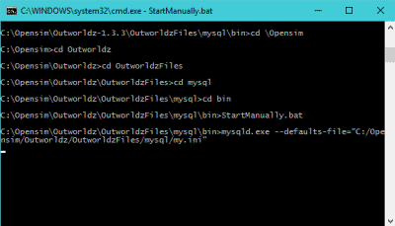

Any error message it prints may be helpful. If the above DOS window closes, a MySQL LOG file will be saved in OutworldzFiles\MySQL\data as a *.err file. That will give you a clue as to what to do.

## My database still did not start.

Try running Outworldzfiles\MySQL\bin\Repair_ISAM.bat. Start MySQL and wait until the Task manager in Windows shows that Mysqld.exe is at 0% CPU use.

Still not working? Delete the two 10 MB files, ib_logfile0, and ib_logfile1 in MySQL\Data and repeat the Repair_ISAM.bat and run "StartManually.bat" again and wait for the CPU to drop to 0%

## Starting Over with A Blank Database

You can wipe ALL data out and recreate it from OAR and IAR files. This WILL LOSE ALL DATA.

If you MUST wipe out the database and start over, there are two methods.

The easiest way is to unzip the provided blank database and replace (do not mix) the contents of MySQL\Data with it.

Method 2 is to delete the ib_logfile0, ib_logfile1 and ibdata1 file in OutworldzFiles\MySQL\data (leave the folders). Then delete just the contents of data\opensim\*. Leave the folder "MySQL\data\MySQL" alone.

Either method will make it start over at the very beginning and you need to re-enter your Avatar name and password and reload everything.

## Ports

Here is more detail about ports and the way the interact with the outside world such as www.canyouseeme.org and to my diagnostics tests.

Port 8001:

8001 is a TCP/HTTP port that is used for setting icons to the state of what Opensim is doing, and some other simple functions such as automatic updating teleport signs and the Partners prim. It is unique to Dreamworld.

Port 8002:

Opensim has a web server that web browsers understand, using the same protocol (TCP/HTTP) that tools such as www.canyouseeme.org support. Put simply, Robust listens to port 8002 and answers to http:// requests on 8002. Port 8002 is much like port 80, the default port for web pages. You can actually set Dreamworld's 8002 port to 80, and it will work. You can then drop the need to type :8002 at the end of your hyperlink. <http://hg.Osgrid.org> does this. There would be no need to type the :80, as literally http:// means "add a :80 to the end of it". So only 8002 works with web-based probe tools. If you do switch it to 80, then you must change the Apache port 80 to some other port. Only one program can listen to a port.

If Opensim is not running and your ports are open, it is as if you tried to connect to www.google.com's web server, but their web server is down. Nothing will happen, though your packets can get through the Google firewall because it is still open to traffic and is steering it to a dead server. You will get no answer. Similarly, if Opensim is not running, there is no web server to answer the request.

Port 8003:

This port is listened to by Robust so regions can chat to the server database for login, presence, and other services so people can teleport from one region to another. In Dreamgrid, just like OsGrid or any other remotely attachable grid, the regions can run on any machine anywhere in the world.

If you opened port 8003 to anyone on the web, you expose the internal database protocol to the web. Anyone with the right knowledge could attach a region to your sim. If you run a DreamGrid and host region outside your LAN, it is recommended you use firewall rules to only allow access from known IP addresses running approved regions.

Port 8004 and upwards:

The region ports (8004-upward) run both TCP and UDP. UDP is used for the viewer. UDP cuts the load on the server dramatically as there is no need to automatically always ACK every packet. As one example, no one cares if an audio stream gets briefly interrupted as you cannot hear it anyway, and it is too late to use it if it comes later in a retry. It just gets discarded.

## Running Manually

You can run Opensimulator without Dreamgrid. Dreamgrid sets up Opensim to run. Once it has run once, you can run Opensim without it.

When you click [Start], Dreamgrid looks for a MySQL listening on a specific Port. If it does not see one, it starts MySQL as a separate process. When you exit, it shuts MySQL down gracefully with *MySQL-admin.-u root shutdown*. Dreamgrid will detect Robust running on Port 8002 and just use it. If it does not see it, Dreamgrid starts up a Robust.

For running manually, MySQL can be used in two ways.

1) MySQL\bin\ StartManually.bat runs MySQL manually. Once the Command Prompt opens, this window can be closed manually, as MySQL will run by itself in another thread.

This is also useful for diagnostics and manual backups and running a Dreamgrid in folder A on a database in Folder B or C or D:\SomeWhereElse. But there is a significant issue: you need to shut down MySQL gracefully! This really needs to be done correctly to reboot or log out of Windows. The command is *MySQL\bin\mysqladmin.-u root shutdown*. There is a batch file in MySQL\bin named *StopMySql.bat* that will do this for you.

## Run as A Service

You can install MySQL as a Windows service. There is a batch file *InstallAsAService.bat* in MySQL\bin to set this up. MySQL will then start with Windows.

This batch file must be run once, as an Administrator. You type "CMD" in the search box, and then right click the Command Prompt and select "Run as Administrator". Use that DOS box to run *InstallAsAService.bat*. Then type in 'Services.msc” and use it to start MySQL.

You should also set the service to restart so MySQL restarts on any crash. Windows knows about services and will send signals to MySQL to shut itself off gracefully. The only danger is that power fails and you corrupt the database. I have set this MySQL to always flush data to the disk without saving it in RAM, which helps. If you are serious about running a grid, then a UPS is necessary.

You can start Robust manually, too. Outworldzfiles\RunRobust.bat assumes MySQL is running.

Go.bat starts a command prompt with an instance of Opensim in it (an instance is a set of sims). The batch file switches to the bin folder and launches Opensim with the settings it needs for the INI files and the Log file.

You can start it all with a batch file like this:

@remarkable batch file to start Dreamgrid manually.

cd MySQL\bin  
start startmanually.bat  
cd ..\..\opensim  
call runrobust.bat  
call go Welcome  
call go AnotherRegion

## How to Compile DreamGrid

The vast majority of this software is just Opensimulator and MySQL with edits in the INI files to allow auto-configuration by XML and INI editing.

The source code package "How_to_Compile.txt" explains how it is compiled, and what changes are made. You need Visual Studio 2015 or higher, and preferably 2019.

Vivox Voice Settings

Vivox powers voice for millions of players in many of the world's best games.

You must first ask for a free Opensim Vivox accoun. These accounts are free for non-commercial use. It can take a week to get a response, so please be patient and polite.

When you get the email, add your User ID and Password to this form and enable it. Restart the system and voice should work.

Links:

<https://support.vivox>

<http://www.hypergridbusiness.com/2011/12/free-vivox-for-all>

Who Got What Module

This Opensimulator Region module lets you send data from scripts to a comma delimited list in your Opensim\bin folder. With just a bit of LSL you can determine who touched, e.g. “Who Got What” prim, or what door they opened, or what they collided with, or who went where in a sim.

A Demo Form included in DreamGrid will help explain. Navigate in a web browser to <http://127.0.0.1:8004/diva/WhoGotWhat> on your server.

The data the module accepts can be an Avatar Name, the region the item is on, the object (prim) name, the Location, such as <127,128,22> and a Text string. This can be the description or some other text.

The system also requires a password that only you know. Your password is located in Settings->Hypergrid DNS name.



Pressing send will say “OK your object has been recorded.” And add this data to a Comma Separated (.CSV) file named WhoGotWhat.csv in Opensim\bin. You can open this file with a spreadsheet.

11/16/2020 10:43:04 PM,Fred,Test,Object,<128,128,22>,Prim Description

Setting Up WordPress with DreamGrid

Download WordPress from <https://wordpress.org/download/>

Extract the zip file into wherever you installed your Grid in the Outworldzfiles\Apache\htdocs\WordPress folder. Do not put a second ‘wordpress’ flder in there. If you do, just drag and drop the contents of the wordpress folder to the htdocs\ WordPress folder. It should look like this:



1. Go to DreamGrid settings -> Apache. Set the WordPress switch on.
2. Enable the Apache Webserver on port 80 to run as a service.
3. If you have not yet done so, install the necessary Visual C++ runtimes by clicking the button. **WARNING* This may suddenly reboot your machine, so save your work.
4. If it does reboot, make your way back the Settings Apache page and , install the necessary Visual C++ runtimes by clicking the button.
5. Stop the grid, exit the app, and start it again.
6. Using a web browser, navigate to <http://localhost>. You should see a language choice screen:



After choosing your language, use these settings to set up WordPress and then Click Submit:



You should get this screen:



After this WordPress will ask for your name, password and email. Please a very strong password you have never used before! It is extremely importatnt that this be a long, strong password.

You can now navigate to <http://localhost> to view your new web site.

DEBUG

The Help=> Debug screen contains some debugging tools. The “True” radio button enables the function, and “False” disables the function. The function occurs when you press Apply is True is set

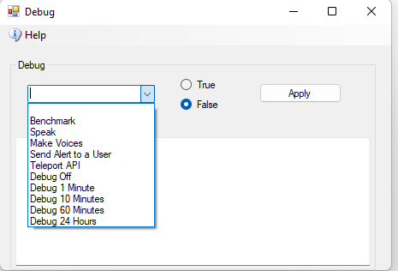

**Benchmark** – This saves internal benchmarks to a Benchmark.Log file. These have time stamps of internal actions. The one second timer starts the benchmark.

**Speak** – Uses the Text to Speech API to speak a test message.

**Make Voices -** Makes wav files in female or male voices. You add lines of text to the form. Set the function to True and click Apply. DreamGrid will save a wave file using the voice you selected in the Region Panel. If the line begins with F: this will use the female voice. A line beginning with M: will use the male voice.

**Send Alert** **to a User** – Prompts for an Avatar name and will then send an alert to that person, wherever they are.

**Teleport API** – Prompts for an Avatar name, locates the person, and send them to a region. Part of Smart Boot debugging

**Debug (off, 1 Minute …..)** – The system prints debug stats on each region every hour. You can speed this up or slow it down. Requires a region restart. The new setting is saved and will be used in the future.

# License Agreement:

DreamGrid does not use any ads, spyware, or other bad practices.

Outworldz follows the Microsoft Code of Conduct for Open-Source code.

<https://opensource.microsoft.com/codeofconduct/>

This code of conduct outlines expectations for participation in this open-source community, as well as steps for reporting unacceptable behavior. We are committed to supplying a welcoming and inspiring community for all. People violating this code of conduct may be banned from the community.

## Copyright

DreamGrid is Copyright 2011 by Outworldz, LLC under the GNU Affero General Public License (AGPL 3.0). The GNU Affero General Public License is a free, copyleft license for software and other kinds of works, specifically designed to ensure cooperation with the community in the case of network server software. All rights are irrevocable provided the stated conditions are met. This License explicitly affirms your unlimited permission to run the unmodified Program. <https://www.gnu.org/licenses/agpl-3.0.txt>

AGPL requires anyone who recodes or improves the DreamGrid application to make their changes Public. This prohibits ALL proprietary changes to the DreamGrid code, including those hidden behind firewalls. All changes to DreamGrid code must be made public and must pass along the AGPL 3.0 license. If you do not like this license, please do not use my DreamGrid code.

Anyone who thinks this means you must release changes to any other code, LSL, or mesh, Avatars, or OARS that runs on it or is executed by it are misinformed.  
The intent is to prevent anyone from benefitting exclusively from proprietary or private expansions of this DreamGrid code base.

Source code: [https://github.com/Outworldz/](https://github.com/Outworldz/DreamWorld)

Other open-source licenses apply to Opensimulator, and the libraries and other functions included herein. A list is provided in these folders:

* See \Licenses_to_Content
* See \Opensim\ThirdPartyLicenses
* See \Opensim\NOTES

## Data Collection Policy

Outworldz, LLC does not collect any personally identifiable information. No personal details of your site, such as Opensimulator passwords, usernames are other grid contents are sent to Outworldz, LLC. No Mesh, textures, inventory, or other items are sent to Outworldz, LLC.

## Publicity

If you check the Publish Grid button, the system will send public information about your grid, such as the web address, regions and names of items you or your residents have marked as "Show in Search" to be indexed in the Hyperica.com directory. This information is not shown if you turn your grid off or uncheck the box.

## DNS

The Free DYN DNS system stores public IP addresses and your domain name as is necessary to run the DNS system.

Anonymous data - A private, unique random identifier created at startup is stored both at Outworldz, LLC. to protect your chosen name. A small amount of anonymous data is stored which includes whether your software passes diagnostics, a hash of the Disk ID and Mac address to help me deduplicate grids, the revision level of the code, and whether it is on the Hypergrid. This is used for quality control purposes.

The Outworldz web server may also automatically collect and store routine information in Apache server logs. This may include details of how you used our service, such as your search queries or Internet protocol address, browser type, browser language, the date and time of your request and referral URL.